Studio day template  A guide to facilitating full-day science studios. | Abstract  Studio Days are a form of job-embedded professional development that take place during a school day. School teams develop a vision of “what is possible” in instruction and to take principled risks with practices. Multiple role-actors (classroom teachers, coaches, administrators and researchers) collaborate to provide real-time feedback within current lessons. Although Studio Days feature a wide variety of science content, the goal of each science studio day is the same: to support students in improving explanations, models and arguments of scientific phenomena. Prior to the studio the Coach or School Team Leader helps facilitate a common planning meeting with teachers from a school; they design a unit of instruction and lessons to be used for the following studio day. On the day of the studio, teachers and others attending studio days engage in multiple rounds of co-planning, co-teaching, and co-debriefing.  Jessica Thompson, Jen Richards, Karin Lohwasser, Christine Chew & Bethany Sjoberg

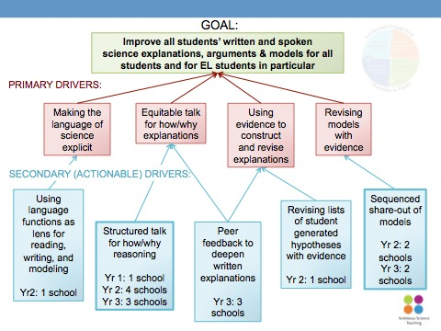
AST Annotated Studio Agenda - [School] - [Date]

Purpose:
- Network goal: Collaboratively investigate student learning in order to make instructional decisions, particularly about improving all students’ (including EL and special needs students’) construction and revision of scientific explanations and/or models.
- School goal (choose one): Structured talk for how and why reasoning, Sequenced share-out of models, Peer feedback to deepen written explanations, Revising lists of student generated hypotheses with evidence, Using language functions as lens for reading, writing, and modeling
- Studio goal for student learning: NGSS 3-D standards
- Studio goal for teacher learning:

Time | Agenda | Point People/Resources | Purpose
~15-30 min | Set the frame for the day  Notes to self:  - Studios focus on AST practices, data about student learning, & collaboration  - There is not a perfect studio -- studios should help teams develop a common language about practice and vision of ambitious and equitable instruction, schools will want to define progress for themselves.  Assign roles (suggested roles below)  - Facilitator (Coach and/or Lead Teacher)- focus the work on AST practices, data and collaboration. Watch time and adjust plan as needed.  - Lead Teacher- is responsible for describing how they are enacting AST practices and attending to student learning, they talk openly about and question “why are we doing particular teaching practices”  - Metalevel AST and teacher learning (Coach/UW support person), reflects to the group how they are supporting teacher learning. During classroom visits they identify teacher and/or facilitator time-outs.  - Note-taker/historian (complete the google log)  Review group norms (start on time, be flexible, be engaged, be prepared, have an action item for each meeting, equity of voices)  Orient team to practice focus and emphasis/flow of studio  - Overarching focus: Continued refinement of focal practice, i.e. peer feedback to deepen written explanations  - Specific focus on identified problem of practice: i.e. How to help students ask each other connected, meaningful questions that deepen reasoning?  - Quick review of relevant data and teachers’ aims for studio  - Quick review of anticipated agenda for studio day | Facilitator  Resources: PPT, focus on board, participant agenda, google log  Video: overview video of the studio model | To launch and reorient to joint collaborative work on science teaching practice
~45-60 min | Review focal lesson and anticipated measures  - Have focal teacher describe lesson, how situated in unit, and any relevant student ideas that have come up  Decision-point: Teachers may need time to grapple with the content of the lesson themselves. You will need to consider the team’s familiarity with the content and whether you want to engage them in some sense-making (e.g., drawing the model themselves, discussing results from the activity, writing a what/how/why rubric).  - Identify EL students in the class and their level. Come to consensus on any minor edits to plans and/or modifications for specific student populations. [Specify parts of the lesson you want to focus conversation on, and/or populations you want to explicitly consider based on the class you’re going into.]  - Identify and record instructional decisions your team made prior to the lesson, or during the studio based on the driver diagram.  - Revising models with evidence  - Using evidence to construct and revise explanations  - Supporting equitable talk for how/why explanations  - Supporting language development and making the language of science explicit  Decision-point: Decide how you would like to use the four quadrants of the driver diagram and the wisdom from other studios done in years past. You could focus on 1 or all 4 quadrants. You could highlight drivers at play in this particular lesson on the network driver or use chart paper with four empty quadrants (then add to the driver later).  Does anyone have any changes they would like to propose? How do these relate to our drivers?  Why might that change be beneficial?  Are there any adaptations that might enhance ELs’ access and learning?  - Review roles for classroom observation and measures/observation tools; make any minor edits necessary. [Describe the measures/observation tools you plan to use.]  Decision-point: There may be multiple measures that your team is considering, and you will want to decide which are necessary to discuss prior to going into the classroom. For instance, we use W/H/Y as a consistent measure on studios, but sometimes teams define and use this as part of their observation and sometimes they wait until after class and define it in conjunction with student work. | Focal teacher, facilitator  Resources:  Lesson plan  Lesson materials  What/How/Why rubric  Model Scaffold for the unit  Relevant artifacts from previous lessons  Measures/observation tools  Network Driver Diagram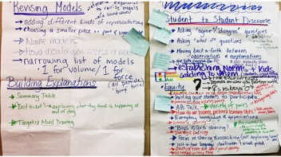 | To understand the content and plan in order to anticipate how students may respond; to build shared instructional ownership through collaborative planning; to prepare for data collection
~5-10 min | Prepare to move to classroom  - Make any agreed-upon edits to materials  - Transport materials and observation tools to classroom | Resources:  Lesson materials  Observation tools  Cameras | To update materials and help set up and prepare for students
 | Visit first class period & Coteaching  - Introduce the team to the students and frame the purpose of the studio to the students in terms of teachers learning from one another about how best to support students.  - Each participant observes [1 student, 1 pair of students, 1 group of students]  - Complete observation protocols or script parts of the lesson  - Take photos of classroom walls and student work  Why the observer role in classrooms? When we are trying out a particular instructional practice, we want to collect data on how that practice functions. Studios provide unique opportunities for close observation of many students at once. And if we want to know how the practice functions, we need to maintain the integrity of the practice (rather than making our own independent adaptations in the moment). | Resources: See above | To gather data to assess how the focal practice is supporting student learning/participation
~30 min | Debrief using observations and student work  - Optional Pause-Reflect-Capture  - Private time to assess student work and record on W-H-Y rubric  - If W-H-Y for lesson not already determined, have group turn and talk about possible indicators for W-H-Y. Chart responses on W-H-Y chart  - Each participant analyzes student work for W-H-Y and indicates level on chart (sticky note or x).  - Process W-H-Y chart by having participants turn and talk to a neighbor about trends and inferences in the data.  Why is that important? What evidence are you using to support that claim? Did you notice this for a particular subset of students? | Facilitator  Resources: student work and observation notes, W/H/Y on board, chart paper/markers for recording noticings and changes, P-R-C sheet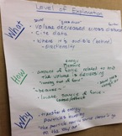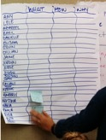 | To review evidence of student learning/participation in relation to practice and to make principled decisions about changes to instruction and focal practice.
~30 min | Tweak lesson  - Nomination of tweaks to lesson, focusing primarily focal practice  Decision point: You will need to decide on 1-2 high leverage changes to the lesson. Try to gain group consensus around changes that they can generalize to future implementation of the practice.  *Make changes to the lesson and materials.  - Include a chance for teachers to verbalize/explain each change to lesson and why we made that change.  - Invite teachers to record any personal learnings on Pause-Reflect-Capture sheet | Facilitator  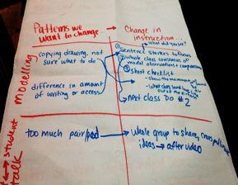 | To make data-driven edits to lesson
 | Lunch |  | To gain sustenance ;-)
 | Visit second class period  - Be sure each participant understands the instructional change being made.  - Remind participants to be observers and hold back on asking students’ questions. The goal is to test the instructional change.  - Each participant observes [1 student, 1 pair of students, 1 group of students] | Resources:  Lesson materials  Observation tools  Cameras | To gather data to assess how the focal practice is supporting student learning/participation  To build a common experience of an instructional change with a team
~45 min | Debrief and identify key instructional ideas  - Identification of key instructional ideas that were tested  - Private time to assess student work and record on W-H-Y rubric and make comparisons with learning from the first lesson.  - Chart responses on W-H-Y chart  - Each participant analyzes student work for W-H-Y and indicates level on chart (sticky note or x).  - Process W-H-Y chart by having participants turn and talk to a neighbor about trends and inferences in the data.  - Group discussion of important noticings/trends  - Engage in “chalk talk” reflection - posters with the following five questions are posted around the room. Each participant silently visits each poster and records responses to the question. Each participant should circulate at least 3 times to read and respond to previous posts.  - What did you learn from the data (CER, exit ticket, classroom discourse)?  - What part of the practice seemed to be working well for students? What did not? Which students?  - What is still puzzling you about this practice?  - What might you try next time to better support student learning (t-chart with suggested change and evidence to support change).  - What did you notice about how ELL students participated in the lessons?  - After 10 minutes, each person selects one idea from the posters to elevate to the whole group and which might inform next steps or changes to make to the practice. Each person shares out the idea they selected and explains why it is an important idea to think about.  - Invite teachers to record any personal learnings on P-R-C sheet  - Note-taker/historian guide the group in completing the google log | Facilitator  Resources: PPT, student work and observation notes, W/H/Y on board, chart paper/markers for recording key instructional ideas, P-R-C sheet  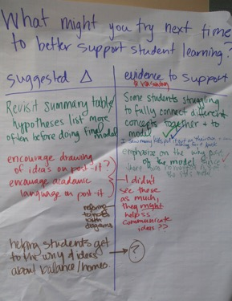 | To review evidence of student learning/participation in relation to practice and identify key aspects of instruction that were effective (for selves and network)
~30 min | Planning time  Decision Point - Select one of the following options (or a hybrid or alternative) for the group planning time.  Option 1: Whole-group planning to revise protocol/practice and/or tools  Option 2: Team planning time to implement focal practice in the next week in their own classrooms | Facilitator:  Resources: planning materials, calendars, | To plan for implementation in their own classes, in their current units of instruction; to develop concrete next steps
~15 min | Appreciations and evaluation  - Each participant shares something they appreciated about the day and/or the host teacher’s class. Share out in a “Whip” format  - Teachers fill out evaluation forms | Facilitator  Resources:  Evaluation forms | To articulate appreciation for the host teacher and others who made a particular impact; to provide feedback on the studio
After Studio  (Network Lead) | Fill out weekly log and a studio  Complete the Take Away and upload to your school folder in the google drive | Network lead | To keep a historical record of teacher and student learning and to request support.

Facilitating Teacher Learning within Studios: Learning Opportunities
Decision Point- As a facilitator you will need to assess student learning and teacher learning and decide how much time to spend on a particular conversation.
Discourse opportunity/ chance for participants to engage in sharing ideas. Consider how you will support teacher dialogue, assess equity of participation
Data Display and Discussions. Direct teachers to talk from the data and ask “Where do you see that in the student work?”
Back Pocket Questions. Plan questions and help focus the conversation on inquiry, data, practice, theories of how students learn, and team collaboration.

STUDIO DAY PREPARATION CHECKLIST

4-Weeks Prior Coach/Lead
- Asks for a teacher to volunteer to host a studio day.
- Update Studio Day location and time.
- Communicate with possible participants and see if they are available to attend the studio day.

2-Weeks Prior Coach/Lead
- Initial Check In With Teacher
  - What unit/topic will the teacher be covering?
  - When in the unit will the studio day occur?
  - Explain to the teacher what type of lesson will be most beneficial for the studio day.

- HOST TEACHER et al.: Connect with School Principal and make sure that there is a debrief/planning space during the studio day.

- Host Teacher: Prepare a “gapless explanation” for the lesson/unit.

- Email Unit Topic/Content and teacher’s “gapless explanation” to school team and others attending the studio.

1-Week Prior Coach/Lead
- Co-plan initial ideas for the studio day lesson with school team and others attending the studio.
- Send an update to facilitators

2-Days Prior Coach/Lead
- Co-plan initial ideas for the studio day lesson with school team and others attending the studio.
- Send an update to facilitators

1-Day Prior Coach/Lead
- Email host teacher…final check-in (they might be nervous…help calm their nerves!).

*Please CC facilitators on all communication so that they are kept in the loop!!

