**Funds of Knowledge Inventory Matrix**

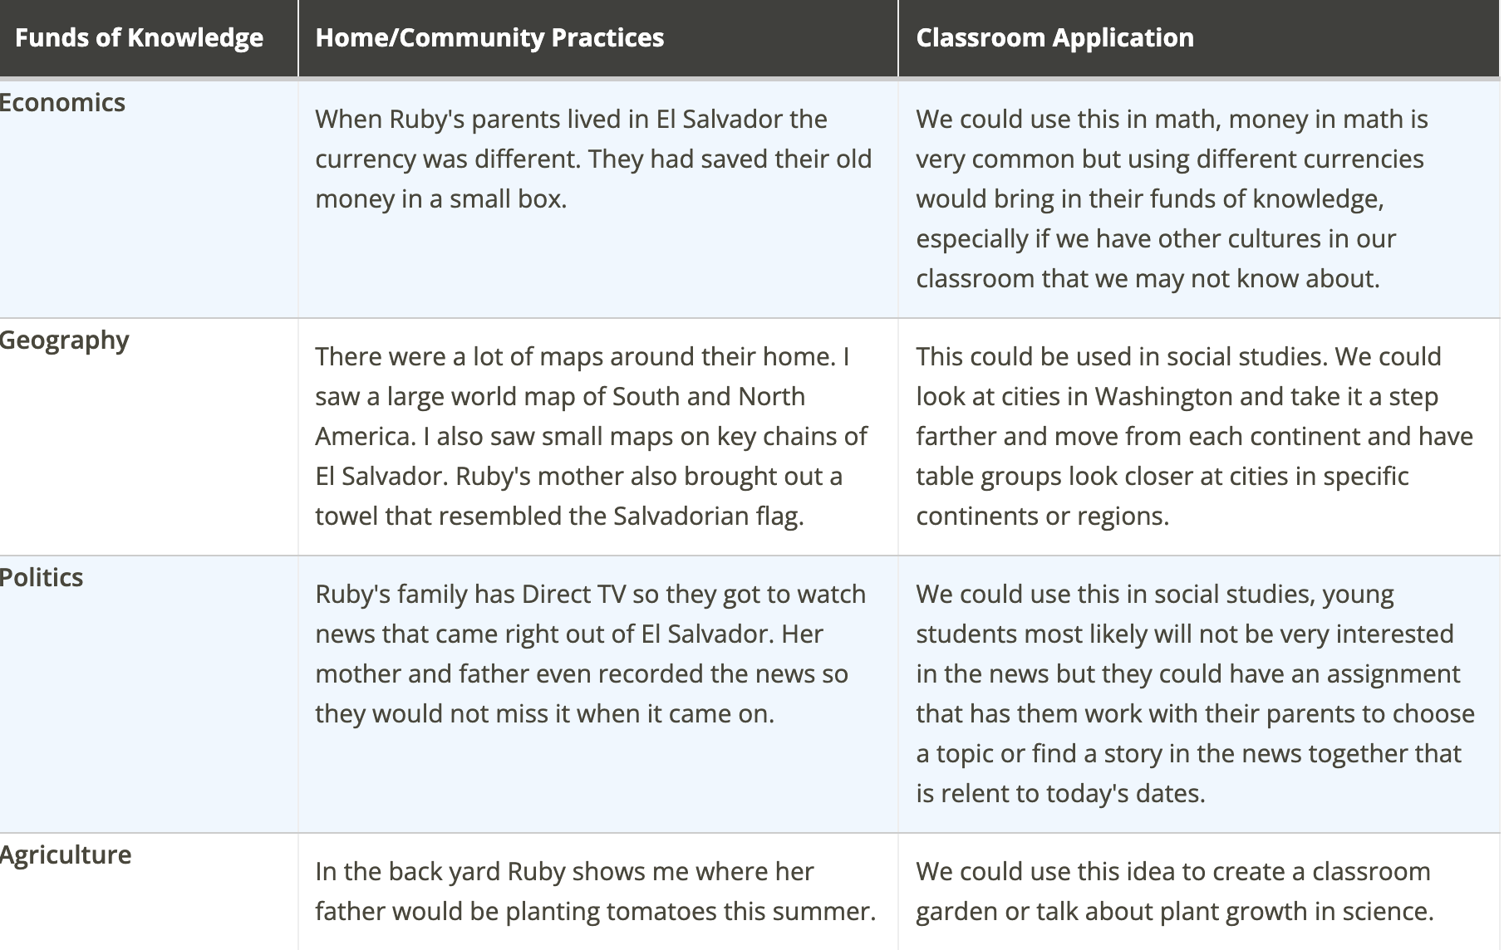

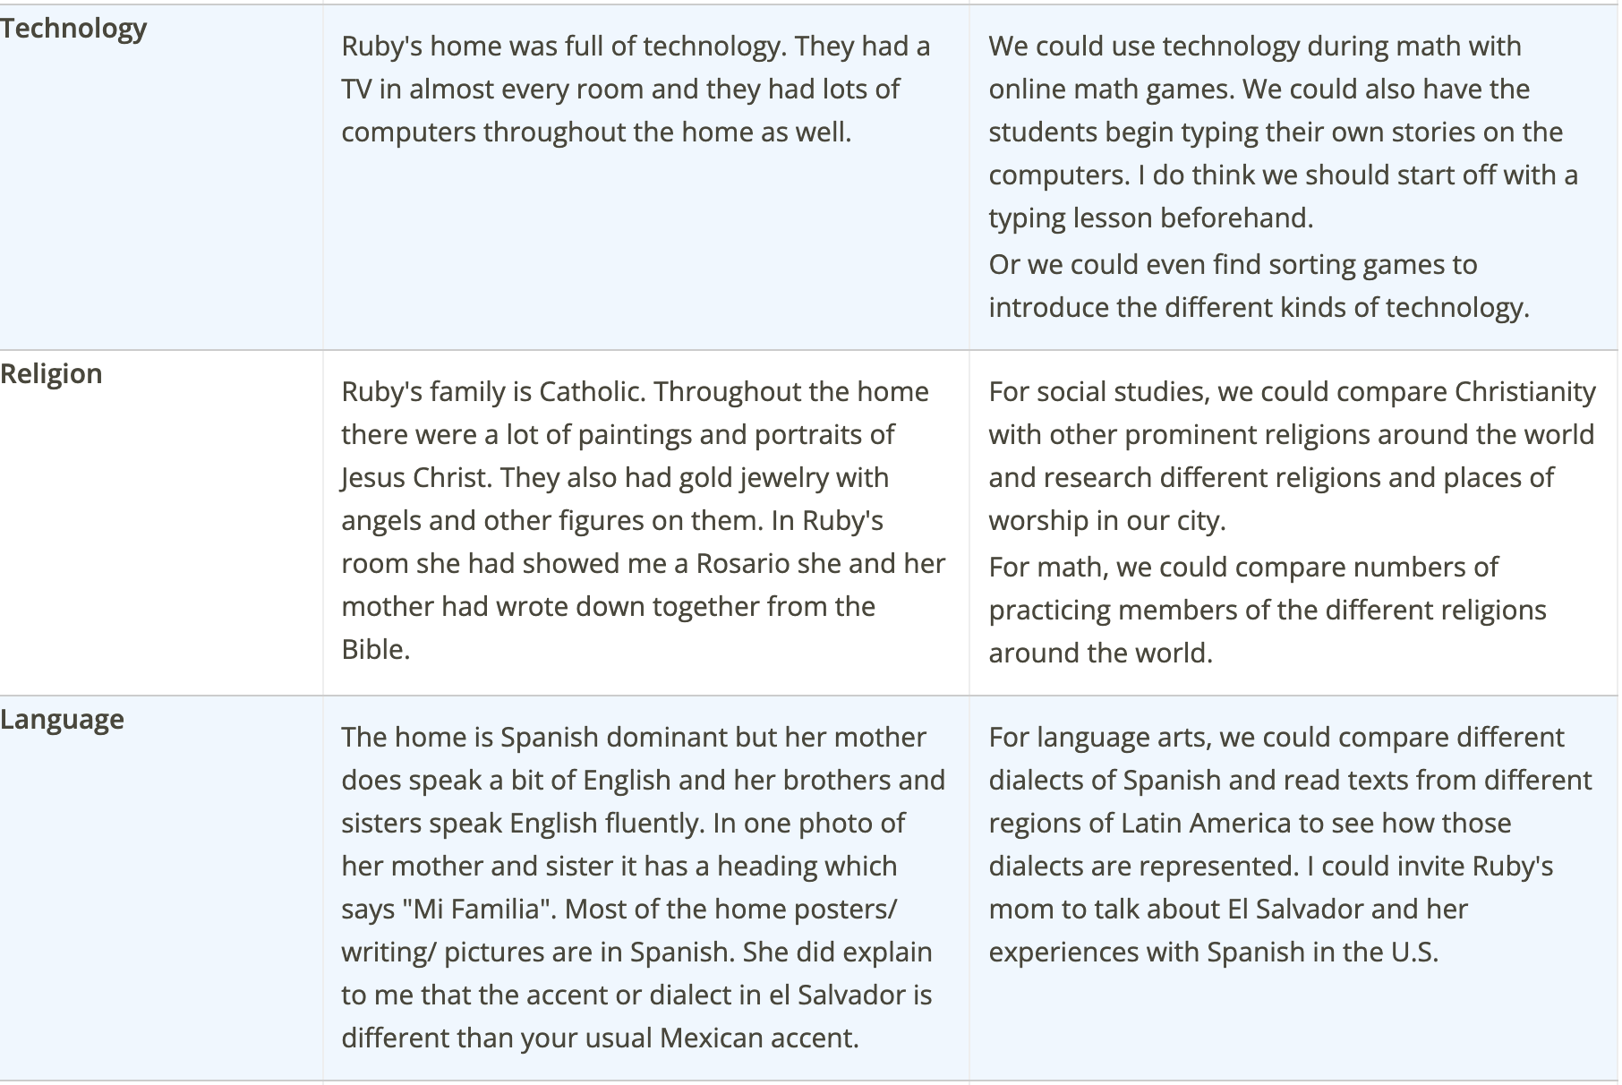

| ***Funds of Knowledge*** | **Home/Community Practices** | **Classroom Application** |
| --- | --- | --- |
| **Economics** |  |  |
| **Geography** |  |  |
| **Politics** |  |  |
| **Agriculture** |  |  |
| **Sports** |  |  |
| **Technology** |  |  |
| **Religion** |  |  |
| **Language** |  |  |
| **Health** |  |  |
| **Childcare** |  |  |
| **Art** |  |  |
| **Cooking** |  |  |
| **Entertainment** |  |  |
| **¿……………?** |  |  |

## References

González, N., Moll, L.C., & Amanti, C.. (2005). Funds of knowledge: Theorizing practices in households, communities, and classrooms. Mahwah, NJ: Lawrence Erlbaum Associates.

Hogg, L. (2011). Funds of knowledge: An investigation of coherence within the literature. Teaching and Teacher Education, 27, 666-677.

Johnson, E.J., & Johnson, A.B. (2016). Enhancing academic investment through home-school connections. Journal of Language & Literacy Education, 12(1), 104-121.

Rodriguez, G. (2011). Power and agency in education: Exploring the pedagogical dimensions of funds of knowledge. Review of Research in Education, 37(1), 87-120.

Vélez-Ibáñez, C.G., & Greenberg, J.B. (1992). Formation and transformation of funds of knowledge among U.S. Mexican households. Anthropology & Education Quarterly, 23(4), 313-335