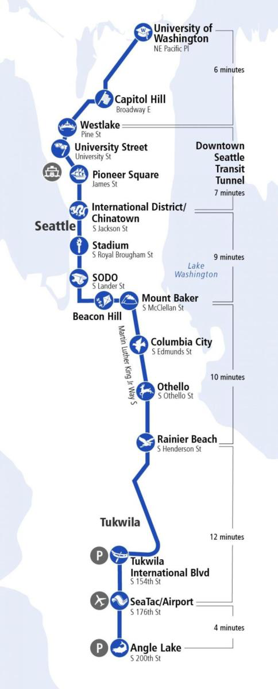
Name: _______________________________ Date: ________________

Thinking with Our Families about Local Transportation

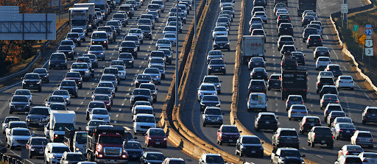
-Use the pictures below to talk with someone in your family/people at home about what they know about local transportation. Ask them to share their ideas on what works about our local transportation system and what doesn’t work.
-Tell each other stories about times you have used or heard about different forms of transportation. You can also imagine together the perfect transportation system for your family and discuss the details of this.
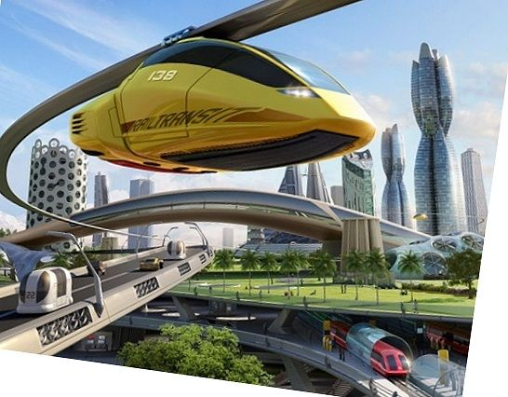
-Then ask family members to write down ideas or to draw pictures. In class, you will get to share your stories and about the benefits of your imagined transportation system as we begin our new science. unit.

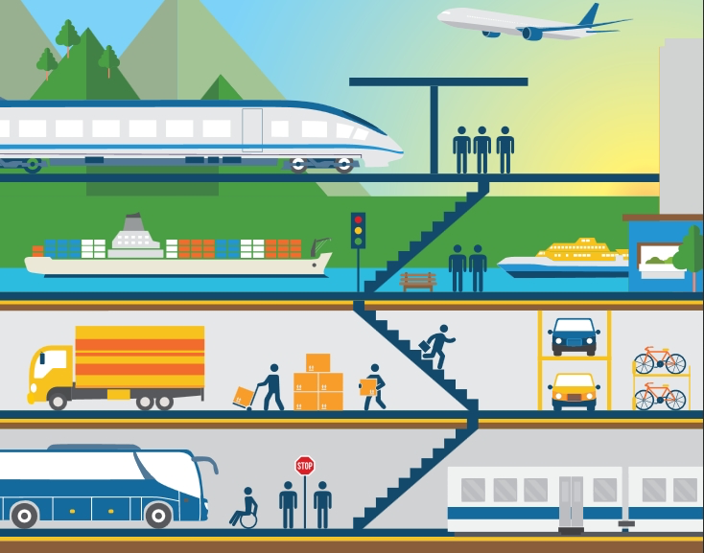

Write or draw your family stories, ideas or designs about transportation.

________________________________________________________________________________________________________________________________________________________________________________________________________________________________________________________________________________________________________________________________________________________________________________________________________________________________________________________________________________________________________________________________________________________________________________________________________________________________

