Editable Tool: Model-Based CER Sentence Stems

Here, we share a set of sentence stems that can support students in generating and articulating model-based claims, evidence, and reasoning. We describe and provide a 2nd-grade example of each kind of stem; the last page combines all stems into an editable tool for your use.

Generating Claims with Reasoning and Evidence

I claim that ___________ (claim) because ________________ (reasoning).

I think this because I observed/learned ____________________ (evidence) (in _________ activity).

Purpose? To help students generate claims backed by how/why reasoning and evidence

When to use? When we ask students to generate claims to answer scientific questions; could be at the unit level (e.g., about the overarching phenomenon) or at the activity level (e.g., about an investigation)

Example: Partner work after activity where students built and observed water flow with dams
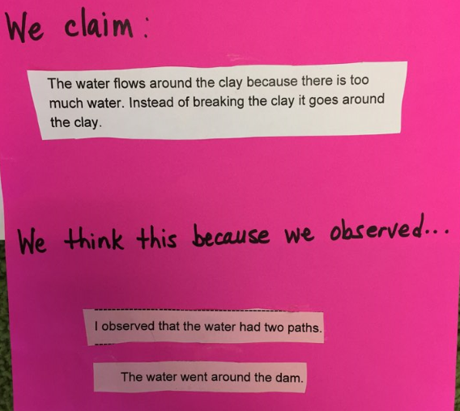

Considering Conditions

If ______ (condition), then __________ (claim) because _______________ (reasoning).

Purpose? To help students describe when and why claims hold true, consider particular causal relationships

When to use? When we ask students to consider conditions under which claims do or do not hold true

Example: Partner work after activity where students observed water flow through different earth materials (e.g., rocks, sand, etc.) and considered implications for what would happen depending on the composition of glacial moraine in a mountain

Adding Evidence and Reasoning to Claims

I know this (claim) because (in ______ activity,) I observed/learned ___________________________ (evidence).

This shows that _______________ (reasoning).

Purpose? To help students add evidence and how/why reasoning for claims

When to use? When we ask students to support their claims with evidence and reasoning; may be especially useful toward end of unit when students create final explanatory models

Example: Partner work at end of unit where students wrote explanations for phenomenon

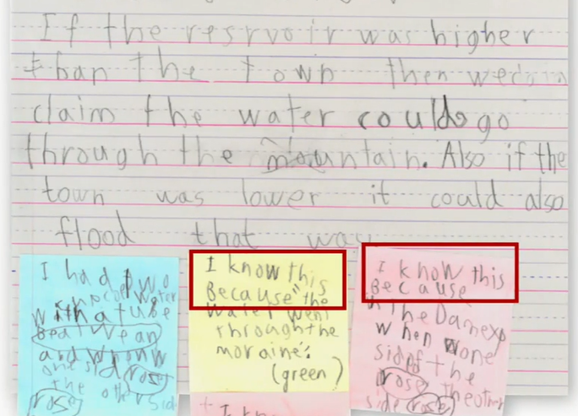

Editable Sentence Stems

I claim that _______________ because _______________.

I think this because I observed/learned _______________ (in ______ activity).

If _____________, then ______________ because _______________.

I know this because (in ______ activity,) I observed/learned _______________.

This shows that _______________.

