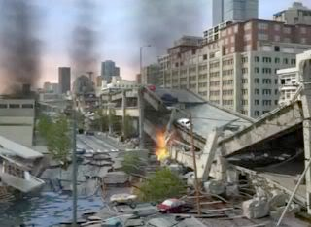
[Washington State Department of Transportation, 2009]

Earth Science: Earthquakes & Plate Tectonics
7th/8th grade
Brittney Lindsay
Lakota Junior High, Federal Way Public Schools

Anchoring phenomenon:
In Seattle, Washington the Alaskan Way Viaduct is a popular, and highly used, route for commuting. However, with the talks of “The Big One”, WSDOT discussed the problems the Alaskan Way Viaduct may cause. In their simulation they put out, it shows a collapsing Alaskan Way Viaduct.
Essential question about phenomenon/unit:

Why does the Alaskan Way Viaduct collapse?
Note Bene: The Viaduct has not collapsed yet, but it is predicted that it will potentially collapse in the event of a megathurst earthquake.

Scientific explanation:
Within Earth’s interior there is a core, mantle, and outer crust. All of these layers are density stratified based off composition, and they all have different physical properties. The core is composed of an inner and outer core. The inner core is solid, and the outer core is liquid. All the heat within Earth’s interior comes from the core, which then heats all the layers of the Earth. The mantle is composed of materials with different physical properties. The main parts of the mantle are the mesosphere and the asthenosphere. In the asthenosphere, the heat from the core heats the semi-ductile matter and thus create convection currents.
Convection currents are when the particles within the ultramafic/mafic material are heated, and these particles, due to density and temperature differences, rise. After these particles rise they then spread out because they are in a different state (semi-solid/ductile plastic material to a liquid), causing the particles to move along the surface of the lithosphere pushing the plates apart (these are the uppermost part of the mantle, and the continental and oceanic crust). As these particles rise and move along the lithosphere, they begin to cool and condense (come together). When materials cool and condense, asides from ice, they begin to sink. The particles within the mafic/ultramafic asthenosphere sink back deep into the asthenosphere, heat again, and begin rising to the surface towards the lithosphere again. As this process continues the plates also move and collide and rub against other plates.
These collisions are also known as plate boundaries. There are transform boundaries, divergent boundaries, and convergent boundaries. These different boundaries are based off the different plate densities. Oceanic plates are more dense and rigid, and are made of basaltic/mafic material. They are thinner, and also tend to make up the oceanic crust. The continental plates, which are comprised of the continental crust, are thicker, less dense, and are composed of granitic/felsic material. When plates collide they form convergent boundaries. When plates rub past each other these are called transform boundaries. When plates pull apart the boundary is called a divergent boundary.
The reason for the Alaskan Way Viaduct to potentially collapse is due to a convergent boundary between the Juan de Fuca and the North American plates with a speed of 7-11cm (3-4 inches) per year (CC: scale). This convergent boundary is also called the Cascadia Subduction Zone. The Juan de Fuca plate is an oceanic plate that is being pushed towards the North American continental plate. Since the continental plate is less dense, and the oceanic plate is more dense, it creates a subduction zone. Convection currents push the plates, and the more dense oceanic plate sinks beneath the less dense continental plate. Over time as the oceanic plate continually sinks beneath the continental plate it builds up stress, and this is from the continental plate bending as the oceanic plate being pulled down into the mantle. When the continental plate can take no more bending and stress, it releases back to its original state. This release of pressure and stress creates an earthquake. The earthquakes associated with subduction zones are high magnitude mega-thrust earthquakes. These earthquakes average about magnitude 8-9 on the Richter scale. Due to the poor structure and the geographic location of Seattle, the Alaskan Way Viaduct will collapse and give way to the water below. This is all because of the convection currents causing the plates to move towards each other.

NGSS Performance Expectations addressed in this unit:
Standard | PE | DCI | CCC
MS-ESS2-1: Develop a model to describe the cycling of Earth’s materials and the flow of energy that drives this process.
MS-ESS2-2: Construct an explanation based on evidence for how geoscience processes have changed Earth’s surface at varying time and spatial scales.

Summary Table of Activities in Unit

Activity #  Name of Activity | Learning Target | Evidence Students Could Gain | Connection to Phenomena
Activity 1:  Modeling and eliciting ideas about the collapse of the Alaskan Way Viaduct and the reasoning  Video: https://www.youtube.com/watch?v=_c9LIFOKRv4  SEP Focus: Modeling  CCC Focus:  Stability and Change, Cause and Effect | Learning target for students: I will be able to use observations and inferences to model why the Alaskan Way Viaduct will collapse.  Teacher asks probing questions to see what students prior knowledge about plate tectonics before having them begin initial models. Watch the video once before, probe, then model.  Students will see the Alaskan Way Viaduct and use the video to model pictorially the processes within Earth’s interior causing the earthquake to make the viaduct collapse. | The viaduct will collapse because of an earthquake.  Some students know about the Earth having tectonic plates, but many are unaware of the process of convection currents or the ductile asthenosphere. | Connection to the phenomena:  Student level:  Plate tectonics are moving either together, apart, passing each, or in some matter, to create an earthquake.  Teacher level:  The hot core is causing convection currents within the mantle. As the heat transfers energy to the ductile asthenosphere the particles of the mantle matter rise, pushing on the plates, causing them to collide and cause an earthquake to make the viaduct collapse.
Activity 2:  Test Tube Rainbow  SEP Focus:  Planning and carrying out investigations  CCC Focus:  Structure and Function, Patterns, Systems and System Models | Student learning target: I will be able to connect density and Earth’s interior through the observations of the test tube rainbow lab.  Teacher:  Using different liquids with highly different density students explore how the Earth’s interior has layers with different densities.  Liquids, or substances, with high densities will be found at the bottom of the test tube (Earth’s interior), and ones with the lowest density will be found at the top of the test tube (Earth’s interior). | The Earth has layers that are all different densities, and that is why they are broken down into different compositional layers (students need to be told about different compositions for them to understand that things like iron found in the core is denser than the silica crust).  Students also gain evidence that all different things have different densities, and they cannot be mixed without them then separating out in different layers. | The Earth has different densities, which is key in talking about the plate tectonics being the top part of the Earth, and the layers of the Earth below it are more dense as you reach the highly dense core.
Activity 3:  Density Calculation Lab - I used clear rectangular prisms with different foods to calculate density, and also to have a visual representation of what density looked like. The cubes have the same volume.  SEP - Planning and carrying out an investigation, Using Mathematics and Computational Thinking  CCC - Structure and Function, Scale Proportion and Quantity | Student learning target: I will be able to calculate the different densities of different substances to explain Earth’s layering.  Teacher:  This is what students begin their foundational understanding that density is not solely viscosity. It was done primarily as a clarifying, and in the moment teaching, but was beneficial in explaining the concept of density.  Students will also understand is how this connects to Earth’s layers, their composition, and eventually set them up for how other things influence density, such as temperature. | Primary evidence: Students will learn what density is, how to calculate it, and the chemical composition of the Earth is key to the differing densities.  Key factor: Students will observe that density is the particles of a substance, and the amount within. Density is not solely how thick something is, but what it is made of.  I.e.: When doing the lab, one cube was filled with rice. Each piece of rice was one particle, or atom depending on your student demographic, and the more atoms/particles inside of an area of object is how dense something will be. More atoms, more dense. | Student level: This is where some students begin thinking about how different interactions within the layers of the Earth might cause earthquakes. Some may begin to think that layers are sinking and shifting to cause earthquakes.  Teacher level and misconceptions:  Since this is one of the in the moment teaching activities, this was mostly to clarify what density is, and how it connects to the layers of Earth having different densities. The main thing is that this shows the lithosphere will have a lower density compared to the inner and outer core. Also, that the oceanic crust and the continental crust have different densities as well.
Activity 4:  Temperature and Density: Since the driving force between convection currents is temperature changes and density changes, this gives students a chance to observe how temperature effects density.  SEP:  Planning and carrying out investigations/Analyzing and interpreting data  CCC:  Cause and Effect, Patterns, energy and matter | Student learning target: I will be able to describe how temperature effects density through observations and collection of data.  Teacher:  By the end of the lesson students will observe the ways that temperature increases and decreases changes the density of water, or any substances. They will also be able to gather that as evidence and then describe what is happening. | Students will observe that as cold water is place in room temperature water it sinks to the bottom of a beaker, and is concentrated towards one spots. The opposite happens for hot water, it will rise and spread out. Things that are hot have a lower density and things that are cool have a higher density, causing them to sink. | Student level:  Somewhere within Earth the density is changing because hot things have a lower density and cold things have a higher density.  Teacher level and misconceptions:  Students are able to observe part of the process of convection currents that form the rising and sinking of material in the asthenosphere based on density. However, many students begin to believe layers of the Earth are really hot on the outside, or inside, and they are cooling and sinking into each other to make earthquakes happen. Common misconceptions were the the core was heating up and rising into the mantle to cause earthquakes, or things similar to that. This is when it was taught that it the core does not mix into the other layers like that, and that the outer layers were cooler compared to Earth’s interior.
Activity 5:  Density reading: This reading was done to summarize all that the students have done with density since the test tube rainbow.  SEP:  Obtaining, evaluating, and communicating information.  CCC:  Patterns | Student learning target:  I will be able to explain why atoms, density, temperature, and density changes are connected through density lab observations and readings.  Teacher learning target:  By the end of the lesson students will learn through the reading why temperature affects the density. The reading explains what happens to the atoms, and why it changes the density. Also, the reading refreshes what density is, and why the density of substances/objects are different. | Students will learn that all things have a density. As was observed in other labs this summarizes what they already learned. One thing that is pivotal to students is that when things are hot the particles rise and spread out, and when substances cool the atoms condense and sink. They also learn why things float with lower densities,and things sink with higher densities, but the aspect of things that have a large volume, like boats with a high density, will still float, is not relevant. | This was a clarifying lesson, and most likely done on a day that is meant to teach note taking strategies, substitute, or even a day that students need clarifying/refreshing.
Activity 6:  Tootsie Roll Lab - What is the asthenosphere?  SEP: Planning and carrying out investigations  CCC:  Structure and function, stability and change | Student Learning Target:  I will be able to explain what the characteristics of the asthenosphere and predict why it might cause an earthquake.  Teacher learning target:  By the end of the lesson students will explore what the asthenosphere is. A tootsie roll represents the asthenosphere, and as the manipulate the tootsie roll it bends and stretches like the ductile asthenosphere. It doesn’t break, but it bends and moves. | This is where students learn what ductile is. The tootsie roll bends and moves. Just like the ductile asthenosphere, the students can see that tootsie rolls bend and stretch as they heat. The tootsie roll doesn’t break into pieces like other things, that is because it is ductile. | Student level:  The asthenosphere is ductile, and moves under the lithosphere. The movement somehow causes an earthquake.  Teacher level:  Since the asthenosphere is ductile, there are density changes happening in the asthenosphere to make the lithosphere move. When the lithosphere moves on the ductile moving asthenosphere.  Misconception:  Many students used the word ductile as a noun instead of a descriptive word of the asthenosphere. They would have it stand alone, and not really explain what ductile mean. E.g.: “The asthenosphere moves because of ductile.”
Activity 7:  Phet Simulation /  Edible Plate Tectonics  SEP: Developing and using models, planning and carrying out investigations  CCC:  Systems and system models, structure and function | Student learning target:  I will be able to model the different plate boundaries to explain how earthquakes can happen.  Teacher learning target:  By the end of the lesson students will be able to describe the different plate boundaries. They will also to see that as plates collide they do different things, such as either create mountains, ridges, or subduction zones.  N.B. - The Colorado Phet simulation of plate tectonics has better visuals, without showing convection currents, what the different plate boundaries are like, and what landforms they create. Also, they demonstrate slow plate motion. At the time this lesson was done it was with the edible plates, but it was hard to see different plate interactions. | The evidence students should gain, along with the teacher explanation of where plate boundaries are found, that the collision of plates causes earthquakes, creates certain geographical features, and takes a long time to occur. | Student level:  As the tectonic plates shift around on the the asthenosphere, they spread apart, collide, and sink beneath each other. When this happens they cause earthquakes from the build up stress. Since we live in the Pacific Northwest, and the Alaskan Way Viaduct is in Seattle there is a subduction zone.  Teacher level:  In the Pacific Northwest we are along the Cascadia subduction zone. When the oceanic plate sinks beneath the continental plate then it will cause a megathrust earthquake. This happens when the oceanic plate builds up too much pressure from bending the continental plate. The density differences of these plates causes the bending of the continental plate from the oceanic plate that sinks down into the asthenosphere, eventually causing a release of built up energy. This release creates an earthquake.
Activity 8:  Currents in a jar  SEP:  Constructing explanations and designing solutions, developing and using models  CCC:  Structure and function, cause and effect, patterns | Student learning target:  I will be able to describe why heat causes density differences in rheoscopic fluid, and why this relates to the asthenosphere.  Teacher learning target:  At the end of the day students should be able to start piecing things together. Students will be able to say that as convection currents are moving within the jar, the material around the currents is also moving. As this material heated the density of the atoms (particles of mica powder) are rising and sinking in the same way as convection currents are. The heat causes the material to rise and spread out, and then as it cools, it condenses and sinks back down. | The evidence students will gain is what convection currents ae. This is a visual observation of what is going on in the asthenosphere. They will see the rising and sinking of material in the “circular” pattern as that occurs in the mantle. This is driven by the heat of a candle, like the heat of the core. | Student level:  Convection currents are happening in the asthenosphere. As the heat of the core, which we represented as a candle, heats the mantle material, represented by the rheoscopic fluid, it begins to rise. We know when the temperature of substances increases the density decreases. The particles of the rheoscopic fluid, like the material in the mantle, rises because the particles rise and spread out. After the rheoscopic fluid moves away from the candle it cools down, the atoms/particles condense and become more dense. When their density increases they sink. When they sink they go back towards the heat, and again rise forming a circular pattern.  Teacher Level:  The core emits heat, which radiates throughout the Earth’s interior. Once the heat reaches the asthenosphere, it becomes ductile. Ductile means that when the material in the asthenosphere heats up it becomes malleable and begins to flow like a semisolid material. Like the candle being the core it emitted heat that traveled to the asthenosphere, which was represented by the rheoscopic fluid. As the heat in the rheoscopic fluid increased it caused the mica powder to travel in a convection current powder. The liquid has increased in heat, and thus the density decreased. When this happens it rises, the atoms/particles within the fluid become less dense and spread apart. As is it spreads apart it diverges in the center of the current, and this is what causes the push of the tectonic plates. The heated material then cools, condenses, and the particles become dense, and sink. This repeatedly happens pushing on the tectonic plates, causing them to move, and eventually collide to cause earthquakes.

Resources:
- Layers of the Earth - Dinah Zike’s foldable from “Earth Science: Land Inside and Out” (can substitute for others, I use both physical layers and compositional layers).
- Alaskan Way Viaduct Video - https://www.youtube.com/watch?v=hos_uIKwC-c
- Rainbow test tube: I have a worksheet, based on this website http://www.stevespanglerscience.com/lab/experiments/seven-layer-density-column/
- Density Cubes - I used this worksheet, but modified it for the cubes that I had - http://www.middleschoolchemistry.com/pdf/chapter3/3.1_student.pdf
- Density of Earth’s layers - Went through and discussed the density of Earth’s layers with students, and made hypothesis and predictions about what was happening. Might also incorporate energy theater here, since at the beginning of the year I will teach energy transfer/transformation
- Temperature and Density Lab - http://www.middleschoolchemistry.com/lessonplans/chapter3/lesson6
- Density reading - www.middleschoolchemistry.com/pdf/chapter3/chapter3_student_reading.pdf
- Tootise Roll lab - This is something I informally did with the students, but would like to find/create a resources for this where they are actually writing things down (observations and what not). They just played with a tootsie roll.
- Plate Tectonic lab - any edible plate tectonic lab works, we use frosting, rice krispies, graham crackers, and water. Will look into using the PhET simulation dealing with tectonic plates: https://phet.colorado.edu/en/simulation/plate-tectonics
- Currents Lab - Jars filled with rheoscopic fluid (pearl fluid, shimmer water, the material in water wigglies), heated by a tea candle in the dark with flashlight. Self created worksheet, can email if you would like.

Own notes on resources:

Model Template [Best to be enlarged to fit a tabloid sized paper = 11 x 17 inches]

Name:____________________ Name:________________________ Date:________________

Why does the Alaskan Way Viaduct collapse?
0 seconds | 30 seconds | 60 seconds
Observations:  1.  2.  Draw and label what you can’t see that is making what you can see happening: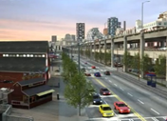 | Observations:  1.  2.  Draw and label what you can’t see that is making what you can see happening: 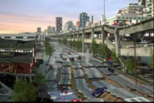 | Observations:  1.  2.  Draw and label what you can’t see that is making what you can see happening: 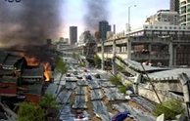 | Questions to ask yourself:  ü Did you include labeled diagrams for the before and during pictures?  ü What do you think is making the earthquake to create all of the shaking?  Lingering Questions about Alaskan Way Viaduct: ______ _____________________________________________  _____________________________________________  _____________________________________________  _____________________________________________
Use the layers of the Earth to draw and label what is happening beneath Seattle.
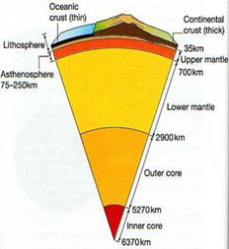

Additional Documents

Possible Calendar/Timeline of Events
(Do not need to start on a Monday, just days of the week for place holding purposes, and some of the summary table days can be combined or removed)
Monday | Tuesday | Wednesday | Thursday | Friday
Layers of the Earth | Layers of the Earth | Video and Alaskan Way Viaduct model | Rainbow test tube lab and intro summary table | Summary table  Class and individual
Density cubes | Summary table | Density of Earth’s layers | Temperature and Density lab. Begin summary table | Summary table and model revision
Density reading | Tootsie roll lab | Summary table | Plate tectonic lab | Summary table and model revision
Model revision, revisit video, and catch up day | Currents lab | Summary table | Model revision | Final product

Summary Table
Template:
What did we do? | What did we see?  (Observations) | What do we think is happening? (Inferences, Generalizations) | Why is this connected to the phenomenon?

Summary table on the wall:
Individual students created different letter-sized entries. Several entries for the same column/row are placed behind each other. The class voted on the entry with the most explanatory power to be put up front.
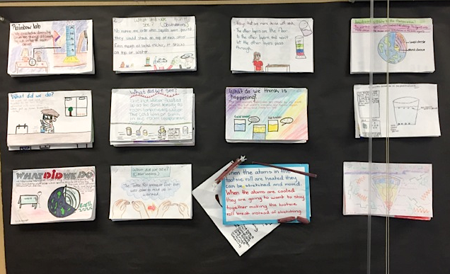
Individual entries – third row:

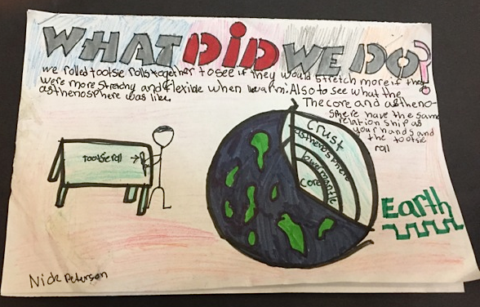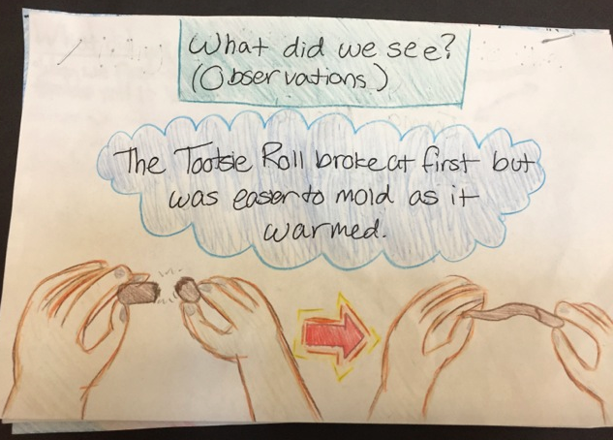

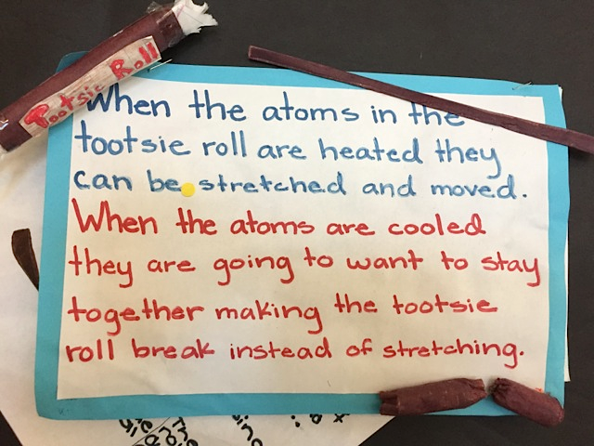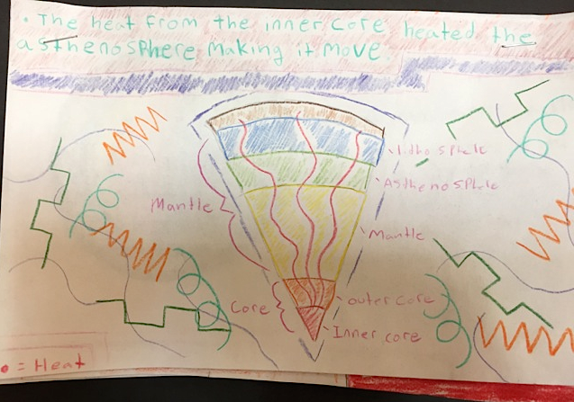

Second row, different examples:
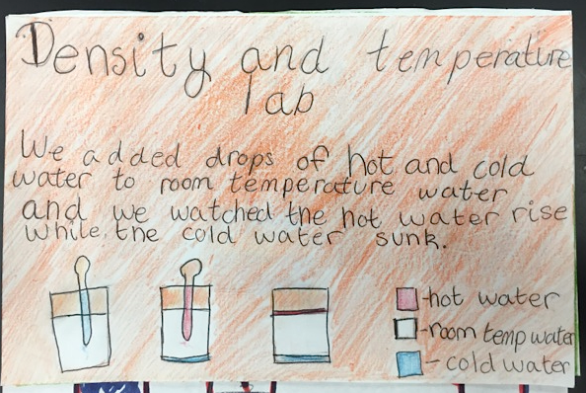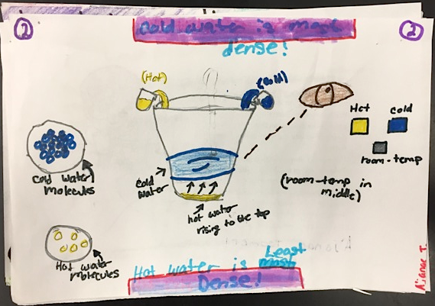
What did we do? What did we see?

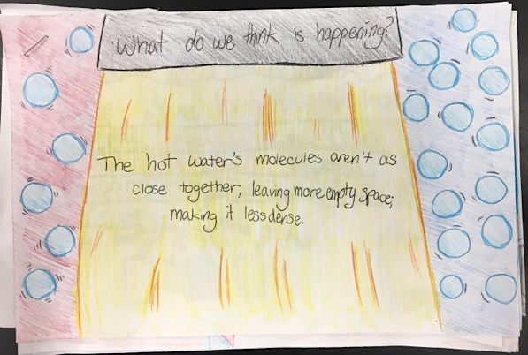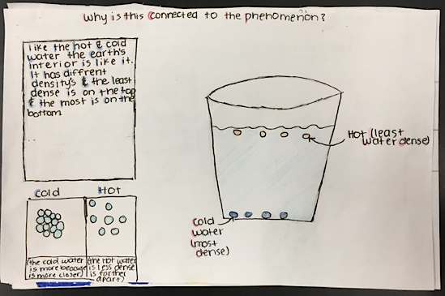
What do we think is happening? Why is this connected to the phenomenon?

Examples of student models with sticky-note comments from peers:
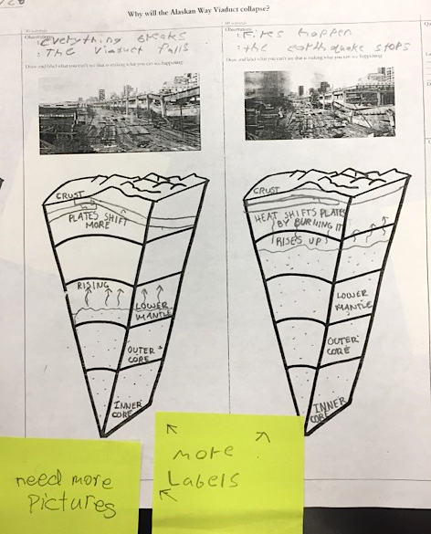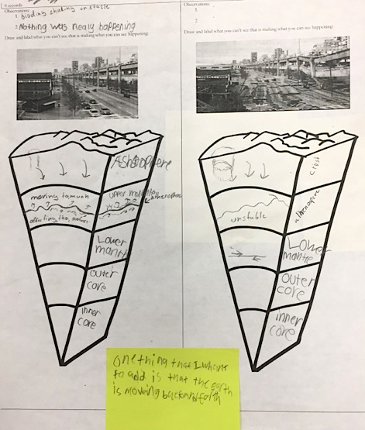
One thing I would add is that
the earth is moving back & forth

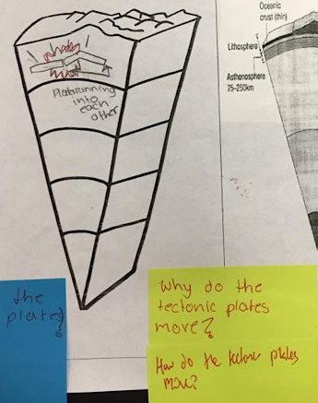

Assessment: End model with final explanation

