Curriculum Packet for Teachers

Harmful Algal Blooms and Climate Change

Grade Level: 6th-8th Grade

This module invites students to investigate the phenomena of harmful algal blooms on Washington state’s coast and around the world. Lessons integrate ideas from biology and chemistry in a marine context. Students build a conceptual model of harmful algal bloom occurrence and evaluate the socio-economic impacts of climate change on blooms.

The curriculum is written as four individual lessons which can take 1-3 weeks total to complete, depending on student comprehension level and time devoted to class discussion. The lessons are designed so that some can be dropped if needed due to time or resource limitations. The lessons involve PowerPoint presentations, worksheets, videos, readings, and hands-on lab activities. All worksheets, presentations, and documents are included.

This curriculum is written to meet Next Generation Science Standards MS-LS1-6, MS-LS2-1, MS-LS2-2, MS-LS2-3, and MS-LS2-4.

Lesson 1. Introduction to Phenomenon: Harmful Algal Blooms (HABs)
Students create a conceptual diagram and physically grow an algal bloom.

Lesson 2. Ecosystem Trophic Interactions
Students play a game (Trace the Toxin) to explore trophic level interactions and trace the flow of energy throughout the marine environment.

Lesson 3. HABs Case Studies and Links to Climate Change
Students analyze real case studies to learn the environmental factors that cause algal blooms and evaluate the impact of climate change.

Lesson 4. Plankton Identification, Scientific Drawing, and Conceptual Model Revision
Students use microscopes to look at plankton and practice scientific drawing. Students conclude by revisiting and revising their conceptual models.

This module was developed by Robin McLachlan*, Angie Boysen, Isaiah Bolden, and Christine Baker, all graduate students at the University of Washington, in conjunction with Jane Addams Middle School, with support from the IGERT Program on Ocean Change and the Program on Climate Change.
*mclachlan.rl@gmail.com
Background Information for Teachers

What are algae?
- Alga is a plant or plant-like organism of any of several phyla, divisions, or classes of chiefly aquatic usually chlorophyll-containing nonvascular organisms of polyphyletic origin that usually include the green, yellow-green, brown, and red algae in the eukaryotes and especially formerly the cyanobacteria in the prokaryotes. (www.merriam-webster.com)
- Algae are a diverse group of aquatic organisms that have the ability to conduct photosynthesis. Certain algae are familiar to most people; for instance, seaweeds (such as kelp or phytoplankton), pond scum or the algal blooms in lakes. However, there exists a vast and varied world of algae that are not only helpful to us, but are critical to our existence… Probably the most important contribution of algae to our environment and well-being is the generation of oxygen through photosynthesis. Algae are indispensable because they produce about half the oxygen in Earth's atmosphere. (www.livescience.com)

Harmful Algal Blooms (HABs):
Algal blooms occur when water conditions are ideal for phytoplankton growth. Therefore, blooms tend to occur when water is relatively warm and full of nutrients. Algal blooms become harmful when the phytoplankton produce toxins that cascade through trophic levels. The species Pseudo-nitzschia produces a neurotoxin called domoic acid. The toxin is concentrated as it travels through the food chain from phytoplankton to zooplankton to fish and so on. Human consumption of domoic acid can cause vomiting, diarrhea, cramping, and even death.

The 2015 HAB on the US west coast:
In 2014, a huge patch of ocean water that was anomalously warm (~4.5 °F warmer than normal) persisted off the west coast of the US. It was termed The Blob when its size reached 1,000 miles long, 1,000 miles wide, and 300 feet deep. The persistent warm water triggered a large bloom of Pseudo-nitzschia, a toxin-producing phytoplankton. The toxin was passed up the food chain to razor clams and crabs. In 2015, extremely high levels of domoic acid were detected in common fishery species, such as clams and crabs. In response, recreational razor clam harvests were closed in Washington and Oregon, and recreational and commercial fishing for Dungeness and rock crab were closed on the northern California and Oregon coasts.

Resources:
- An unprecedented coastwide toxic algal bloom linked to anomalous ocean conditions: https://agupubs.onlinelibrary.wiley.com/doi/full/10.1002/2016GL070023
- Harmful algal blooms and climate change: Learning from the past and present to forecast the future:
https://www.sciencedirect.com/science/article/pii/S1568988315300615
- Ocean warming since 1982 has expanded the niche of toxic algal blooms in the North Atlantic and North Pacific oceans: http://www.pnas.org/content/114/19/4975?ijkey=c9a9f3e1d90b1a1f5f6f97b05c515a418a7f798f&keytype2=tf_ipsecsha
Lesson 1

Introduction to Phenomenon: Harmful Algal Blooms (HABs)

Summary: Students will learn about the week, the phenomenon, and express their understanding of Harmful Algal Blooms (HABs) in the Pacific Northwest. Associated activities include making a conceptual diagram and beginning an experiment to grow an algae bloom.

NGSS
- MS-LS2-3 - Ecosystems: Interactions, Energy, and Dynamics Develop a model to describe the cycling of matter and flow of energy among living and nonliving parts of an ecosystem.
- MS-LS2-4 - Ecosystems: Interactions, Energy, and Dynamics Construct an argument supported by empirical evidence that changes to physical or biological components of an ecosystem affect populations.

Necessary Materials
- Pens/pencils
- Worksheets
  - Conceptual Diagram (1 per student or group)
  - Bloom Hypothesis Notecard (1 per student or group)
  - Exit Slip (1 per student)
- Let’s Grow A Bloom materials
  - At least 4 glass jars
  - Water sample from a lake, ocean, and/or fish tank.
    - The seattle aquarium will give out plankton samples “Please send your plankton sample request at: registration@seattleaquarium.org with “plankton request” as the subject line. All plankton requests should be sent with at least one week’s notice".
    - You can collect your own sample if you have access to a fish tank or lake with a lot of algae (the water will be green or brown). If the water source does not have a high concentration of algae, you can collect a sample with a plankton net. If you don’t have access to a plankton net, you can build your own: (https://sealevel.jpl.nasa.gov/files/archive/activities/ts3meac3.pdf).
  - Liquid algae fertilizer (e.g. Seachem Flourish)

Introduction:
Present the slides on the Lesson1.ppt to introduce the phenomenon.

Activity 1: HAB Conceptual Diagram
- For five minutes, instruct the students to write down/draw what they already know about HABs and to write down what questions they still have. [e.g.: what algae are, what a bloom is, what do you know about the Pacific Northwest marine ecosystems, what do algae need, how do they fit into the the food web]. Have them write down their thoughts in the “What do I know?” column.

- Break the students into groups. Instruct them to share what they know and what questions they still have. While students share, the others should write down things they learn and new questions that arise.

- As a group, the students will create a model on the Conceptual Diagram worksheet provided. This should include drawings and words.

- Discuss as a class. Before moving on to the next activity, make sure students agree that algae need warmth, sunlight, and nutrients to bloom.

Activity 2: Let’s grow a bloom!
This activity guides students through building real algae blooms in jars. Each jar receives a different combination of ingredients - light and nutrients. To expand this activity to include temperature as an ingredient, you can add heat lamps and ice baths. This activity can either be done as a class or as a “cooking show” style activity in which the process is discussed and then the premade jars are presented.
- Fill at least four glass jars with water that contains algae. Algae are naturally present in lakes, ponds, oceans, fish tanks, etc. Do not cap the jars.
  - Jar 1: place in a dark area such as a closet
  - Jar 2: place in a well-lit area such as a window
  - Jar 3: add liquid fertilizer and place in a dark area
  - Jar 4: add liquid fertilizer and place in a well-lit area

- Give each group or individual a notecard (BloomHypothesisNotecard) and assign them a jar. Ask them to write their hypothesis of what will happen to their jar on the notecard.
  - Questions to consider:
    - Will the algae grow to create a bloom?
    - What will the water look like? Why?
    - What will it smell like? Why?
    - How long will it take? Why?

Conclusion:
- Have students complete exit slips before leaving class.

Name:___________________________________ Teacher:_____________________________________ Period:__________________________________

The question we are answering: What processes caused the 2015 closure of razor clam fisheries in Washington?
Directions: 1. In each phase (before the bloom, during the bloom) draw and label what you can see and what processes are going on to connect the temperature, algae, and clams. Add in other things as needed to connect these things, and make sure to try to write, draw, or otherwise represent things that are happening but unobservable.
2. Remember there are many ways of representing things, so feel free to be creative, but we need to be able to understand one another's models, so add a key if needed.

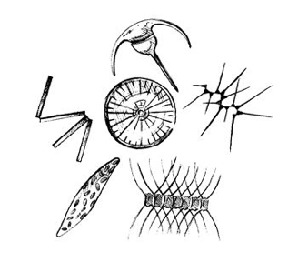
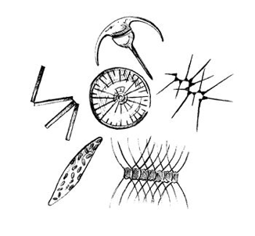
Before the Bloom: During the Bloom:
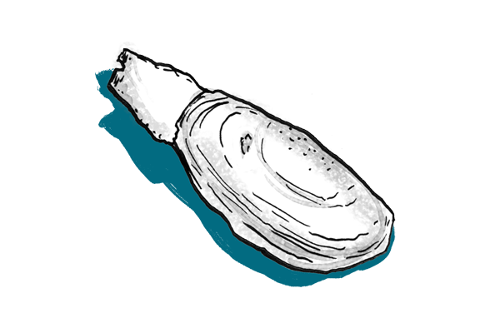

Puzzle Box: What questions are puzzling you about this? What would you like to know to improve your model for next time?

Names:  Ingredients: Sun Only  Bloom Hypothesis: | Names:  Ingredients: Nutrients Only  Bloom Hypothesis:
Names:  Ingredients: Sun and Nutrients  Bloom Hypothesis: | Names:  Ingredients: Nothing  Bloom Hypothesis:
Name:______________________
Teacher:_____________________
Class Period:_________________
Date:_______________________

Exit Slip
(please complete this worksheet before class ends)

- During class activities and group discussion today, which of the following did you try? (Check all that apply)
- I shared my ideas
- I listened to my partners’ ideas
- I agreed with my partners’ ideas
- I disagreed with my partners’ ideas
- I used scientific evidence to support my idea
- I asked a clarifying questions
- I could revoice my partners’ ideas
- My partners and I looked for similarities and differences in our ideas

- Explain one thing that you understand better or differently after talking with your partners today.

Lesson 2

Ecosystem Trophic Interactions
Based in part on the New York State Department of Environmental Conservation Freshwater Fisheries “I FISH NY” Program

Summary: Students will develop new and apply existing knowledge of marine organisms to trace the flow of energy throughout the marine environment. Associated activities include the construction of energy pyramids, food webs, and the exploration of trophic level interactions within the context of a coastal marine ecosystem.

NGSS
- MS-LS2-2 - Construct an explanation that predicts patterns of interactions among organisms across multiple ecosystems.
- MS-LS2-3 - Develop a model to describe the cycling of matter and flow of energy among living and nonliving parts of an ecosystem.

Necessary Materials
- Life cards (1 per student)
  - This version uses only zooplankton, small fish, seal, and shark cards
  - Class size may vary, but always have ≥ 55% of total organisms as zooplankton for standard rounds of play.
- Colored tokens
  - > 100 tokens
  - Plastic poker chips work well
  - At least 3 different colors with 1 color ≅ 30% of the total pool
- Cup/containers (1 per student)
- Exit Slips (1 per student)

Activity 1: Marine Food Pyramid and Food Web Brainstorming
- Prepare and deliver a brief (5 minutes maximum) presentation on the importance of energy flow and cycling within marine ecosystems, using Lesson2.ppt. Ask the students to think about where energy for a variety of marine organisms comes from, gradually working your way toward the sun as the main source and phytoplankton as primary producers in the marine food web. Define terms as necessary. Ask the students to consider which organisms constitute the next stop in energy flow, zooplankton, and that they represent primary consumers.

- Ask students to think about where energy flows from the primary consumers. Ask them to volunteer types of organisms beyond phytoplankton and zooplankton that are found in the marine environment. Write these on the board, asking the students to think about connections between each organism (who consumes whom?). Draw arrows that represent the flow of energy and nutrients between these organisms.

- After all of the arrows have been drawn, emphasize the intricacies of the web. Shift focus to filling in an energy pyramid. Ask the students to think about the arrows they drew and the fact that organisms that eat other organisms are in distinctly different levels of the pyramid to fill in the trophic spaces (secondary consumers through tertiary consumers) of the pyramid.
  - Primary producers: Phytoplankton
  - Primary consumers: Zooplankton
  - Secondary consumers: Small fish, etc.
  - Tertiary consumers: Large fish, crabs, seals, etc.
  - Quaternary consumers: Sharks, orcas, etc.

- Ask the students where they think humans may fit in on the trophic pyramid and the food web. Allude to the possibilities of feedbacks of human activities (overfishing, nutrient loading, etc.) on connections throughout the ecosystem.

- Draw attention to the fact that the energy diagram is shaped like a pyramid because there isn’t a lot of energy available for organisms the higher their trophic level. For example, relatively, there aren’t a lot of sharks but there are lot of phytoplankton. It also signifies that energy accumulates up through trophic levels, a fact that will be best demonstrated by the “Trace the Toxin” game.

Activity 2: Trace the Toxin
- Ask the students to stand and try to make a clear open space in the classroom by pushing the desks to the sides.

- Scatter colored tokens (at least 3 different colors with 1 color ≅ 30% of the total pool) throughout the classroom. These tokens represent phytoplankton. Designate one of these colors as a phytoplankton species that produces harmful toxins, but do not reveal this information to the students yet.

- Hand out a Life Card (attached) to each student. Students should quietly read their life card to themselves as it contains important information for what their role will be during each round of the game. Class size may vary, but always have ≥ 55% of total organisms as zooplankton for standard rounds of play.
  - Organisms on Life Cards: zooplankton, small fish, seal, shark.
  - ***After each round, keep a tally of remaining organisms in each trophic level on the board. This will be useful for conveying energy pyramid dynamics AND biomagnification.***

- Round 1 – Ask the students which organism(s) out of the 4 in play would most likely consume phytoplankton (zooplankton, which represent the primary consumer level of the marine energy pyramid and food web).
  - Hand out a food bag/cup to each of the zooplankton. These students will have 10 seconds to “graze” upon the phytoplankton tokens scattered throughout the classroom. In order to graze, students must bend down, pick up one token, stand up, and place it into their cup. All students must walk while doing this for safety reasons. Students are also not allowed to take whole handfuls of tokens at a time. Emphasize that students follow the instructions on their Life Card.
  - At the end of the 10 second period, stop the collection of tokens. Tally remaining organisms on the board.

- Round 2 – Ask the students which organism(s) out of the 4 in play is the next level of the food web and pyramid (small fish, which represent secondary consumers).
  - Zooplankton will continue feeding on phytoplankton tokens scattered throughout the classroom, but now, there are predators! If phytoplankton are tagged on the elbow, they must hand their food bag/cup to their predator and exit the game.
  - Small fish will have 10 seconds to “eat” zooplankton (tag them on elbow). Remind the students to follow their Life Card instructions for a reminder on how much they can eat.
  - After the 10 second period, stop the round. Tally remaining organisms on the board.

- Round 3 – Ask the students which organism(s) out of the 4 in play is the next level of the food web and pyramid (seals, tertiary consumers).
  - Remaining zooplankton will once again continue feeding on phytoplankton tokens while attempting to avoid small fish.
  - Small fish will continue consuming zooplankton (if their Life Card quota has not been met) while avoiding seals.
  - Seals will have the length of the round to “eat” small fish by tagging them on the elbow.
  - After the 10 second period, stop the round. Tally remaining organisms on the board.

- Round 4 – Ask students to verify the only remaining organism (sharks, quaternary consumers).
  - Remaining zooplankton will once again continue feeding on phytoplankton tokens while attempting to avoid small fish.
  - Small fish will continue to consume zooplankton (if their Life Card quota has not been met) while avoiding seals.
  - Seals will continue to consume small fish (if their Life Card quota has not been met) while avoiding sharks.
  - Sharks will have 10 seconds to “eat” seals by tagging them on the elbow.
  - After the 10 second period, stop the round. Tally remaining organisms on the board.

- Summarize the game, asking students why rounds became progressively more difficult and what it suggests about predator-prey interactions in the marine environment. What patterns did they see? What caused the patterns? Think about how much energy was needed at higher trophic levels and what the implications are of not being able to meet the quota on a Life Card due to competition. What would be the implications of human populations overfishing the small fish population on the rest of the web AND on nutrient loading sparking phytoplankton blooms? What has this got to do with the 2015 Blob? How else may humans impact the cycling of energy in marine ecosystems?

- Reveal the identity of the “harmful” token to the students. Explain that some phytoplankton produce harmful toxins that can be deadly to other organisms. Have the remaining students with food cups/bags count the number of tokens and the total number of harmful tokens within their entire trophic level. Write these values, along with the associated organisms, on the board, and calculate the average amount of toxic chips per trophic level.

- Wrap up with discussion of marine food webs and pyramids and general Q&A. Hand out exit slips.

Zooplankton
You came across an algal bloom
filled with phytoplankton and
it’s a feeding frenzy! You only
have limited time to graze before
the current causes the bloom to
dissipate. Grab everything that you can to get those needed nutrients!
Place the phytoplankton that you
find in your food bag.

Fish
You came across a swarm
of zooplankton feeding on
phytoplankton in an algal bloom.
You have just finished eating a few
small baitfish near the lily pads, so
you aren’t very hungry. You eat only 1 of the zooplankton.
Take the food bag of the
zooplankton that you caught

Fish
You came across a swarm
of zooplankton feeding on
phytoplankton in an algal bloom.
You feast on the zooplankton, eating 4 in one dive through the swarm.
Take the food bags of the
zooplankton that you caught.
Fish
You came across a swarm
of zooplankton feeding on
phytoplankton in an algal bloom.
Your hunt is successful and you are able to catch 3 zooplankton.
Take the food bags of the
zooplankton that you caught.

Seal
You came across a school of fish
feasting on zooplankton. You were a bit late in joining the hunt, and as a result you caught 2 fish – not bad for a snack.
Take the food bags of the fish that you caught.

Shark
You came across a group of seals
feasting on a school of fish. You were successful at catching one of them for your afternoon meal.
Take the food bag of the seal that
you caught.

Name:______________________
Teacher:_____________________
Class Period:_________________
Date:_______________________

Exit Slip
(please complete this worksheet before class ends)

- Explain one thing that you understand better or differently after talking with your partners today.

- Name two reasons food webs useful ways to explore energy transfer in marine ecosystems.

- How do you think humans can impact the cycling of energy in marine ecosystems?

- What are some concepts we learned about today that you think are important to help explain the question from the beginning of the week? (As a reminder the question was: What processes caused the 2015 closure of razor clam fisheries in WA?)

Lesson 3

HABs Case Studies and Links to Climate Change

Summary: Students will learn about recent Harmful Algal Blooms (HABs) around the world, the environmental factors that caused them, and predict the link with and impact of climate change.

NGSS
- MS-LS2-1 - Analyze and interpret data to provide evidence for the effects of resource availability on organisms and populations of organisms in an ecosystem.
- MS-LS2-3 - Develop a model to describe the cycling of matter and flow of energy among living and nonliving parts of an ecosystem.
- MS-LS2-4 - Construct an argument supported by empirical evidence that changes to physical or biological components of an ecosystem affect populations.

Necessary Materials
- Pens/pencils
- Worksheets
  - Entrance slips (1 per student)
  - Jigsaw Worksheets (1 per student)
  - Expert Jigsaw reading material (1 case study per student)
  - Exit Slips (1 per student)

Introduction:
After students have completed their Entrance Slip, present the initial slides on the Lesson3.ppt until the Jigsaw Activity.

Jigsaw Activity:
- Divide students into jigsaw groups (ideally 5 students per group)
- Divide the material into 5 case studies
  - Assign each student one case study to become an expert on.
  - Provide a worksheet for students to record information.
  - Case studies: West Coast, Great Lakes, Chesapeake Bay, Florida, Arabian Sea
- Allow students to individually read their case study and fill out the worksheet.
- Form temporary “expert groups” by having one student from each jigsaw group join the other student assigned to the same case study. Allow expert groups time to discuss the main point of their case study and prepare a short explanation that they can present to their jigsaw group.
- Bring students back into their jigsaw groups, ask each student to present their case study to the group, and then fill out the rest of the worksheet with an overview of each topic.
- Note: The structure of the reading and note taking will need to be tailored to class level.

Conclusion:
- Use Lesson3.ppt for classroom discussion.
- Have students complete exit slips before leaving class.

Name:______________________
Teacher:_____________________
Class Period:_________________
Date:_______________________

Entrance Slip
(please complete this worksheet before class stars)
What are the some examples of environmental conditions that can cause a harmful algal bloom?
________________________________________________________________________________________________________________________________________________________________________________________________________________________________________________________________________________________________________________
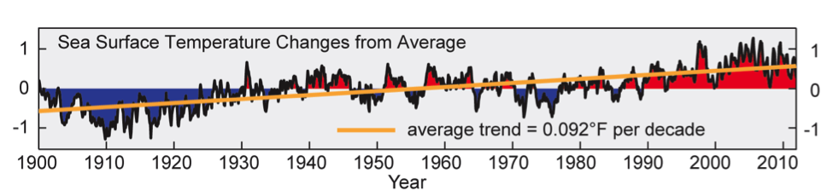
The figure above presents the sea surface temperature changes from average for the ocean surrounding the U.S. and its territories over the past century. What do you think is causing the change in average sea surface temperature? Do you think a similar trend is experienced in other oceans around the world?
________________________________________________________________________________________________________________________________________________________________________________________________________________________________________________________________________________________________________________
____________________________________________________________________________

How do you think the sea surface temperature change will impact harmful algal blooms?
________________________________________________________________________________________________________________________________________________________________________________________________________________________________________________________________________________________________________________
____________________________________________________________________________
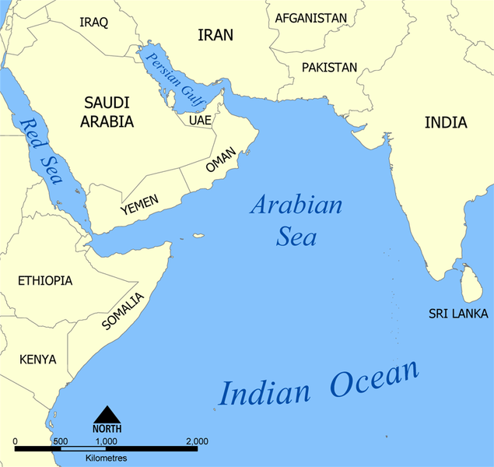
Arabian Sea Ongoing Bloom
Over the past decade, Harmful Algae Blooms (HABs) the frequency of harmful algal blooms in the Arabian Sea have increased dramatically.

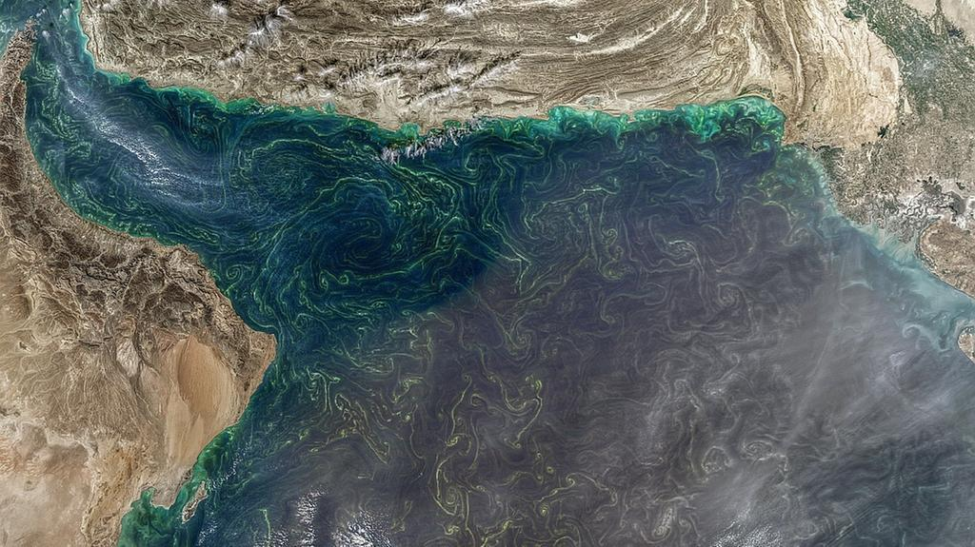
Ingredients: HABs in the Arabian Sea usually occur when there is high nutrient concentration. These nutrients can come from a variety of places:
- Dust: The Arabian Sea is generally surrounded by a very dusty region, with many sand storms. Dust contains a lot of iron, which can make phytoplankton grow faster, because many proteins need iron (We humans need iron too!).
- Water currents: When water is mixed up from the deep ocean it adds cold, nutritious water to the surface where phytoplankton grow.
Satellite images show an algal bloom (Jan 2018) in the Arabian Sea

- Human activities: Marshes, which normally trap pollutants, have dried out because of dams and other human caused landscape changes. Now more pollutants have made their way into the sea. Oil dumped into the Arabian Sea also changed the marine life. Desalination plants (factories that take salt out of seawater in order to make it safe for drinking) release hot and salty water that contains other chemicals like chlorine into the sea. Hot wastewater full of nutrients and pollutants is released from chemical plants and power plants.
Temperature also affects phytoplankton growth, but each phytoplankton species has a different optimal growth temperature. High temperatures typically increase growth rates until a ideal temperature is reached and then growth slows after that.

Effects: HABs in this area have had three main effects:
1) The death of lots of fish and shellfish in Kuwait (2001), Oman (2005), and UAE (2008).
2) Causing respiratory irritation in humans
3) Stopping the operation of desalination plants because of high toxicity level in the water surrounding the plants. These desalination plants are a major source of freshwater in the region.

In the news: Modified from The National (UAE), from May 14, 2018.
“Saadiyat Beach has been closed to swimmers after a harmful algal bloom was found in the sea surrounding the island. It is understood that the red tide — which is caused when a species of algae called dinoflagellates grow out of control — was discovered.

Dinoflagellates contain pigments that vary in colour from brown to red during the day — giving them their name “red tide”. There are thousands of species of dinoflagellates — and a few dozen can be extremely toxic to people and marine life. In 2008 and 2009, a red tide caused serious damage to the UAE’s marine life, damaging fish stocks, coral, and wiping out large populations of fish in Dibba Rock. Shark numbers in the bay are only now recovering.

A spokesperson from Saadiyat Rotana Resort and Villas said the Tourism Development and Investment Authority had instructed the beach area be temporarily closed until the red tide cleared. He said Environment Agency Abu Dhabi (EAD) took samples of the red tide on Saadiyat at the weekend. Tests are ongoing to establish the exact type of algae, but it is understood to be an irritant, rather than toxic. Residents on Saadiyat received an email on Sunday saying that the beach has been closed for swimming until further notice.

“It is confirmed by EAD that the red algae are not toxic, however, [they] can cause skin allergies. Further studies are still undergoing,” read the email. “Therefore, you are kindly requested to abide strictly by the recommendation of the EAD and refrain from swimming in the sea. We will keep you posted as to when the beach will be safe for swimming.”

Marine biologists say phytoplankton species are always around, but certain conditions enhance their growth. Red tides tend to occur more frequently as the temperature rises. This combined with the strong, dusty winds could be acting like a fertiliser, causing the algae to bloom, say scientists.

“If you have a lot of winds coming off the land it could be enhancing the amount of iron and allowing them [the algae] to bloom,” said John Burt, Associate Professor of Biology at NYU Abu Dhabi. “We have had winds for the past week coming off the land, so it is possible that we have this iron deposition going on that is enhancing things, along with the rising temperature. So when the winds turn around and start coming off of the sea again, we will see if it disappears or not. That would be a good indication of whether dust is involved.”

The Arabian Gulf is the hottest sea in the world, making it particularly susceptible to the phenomenon.”
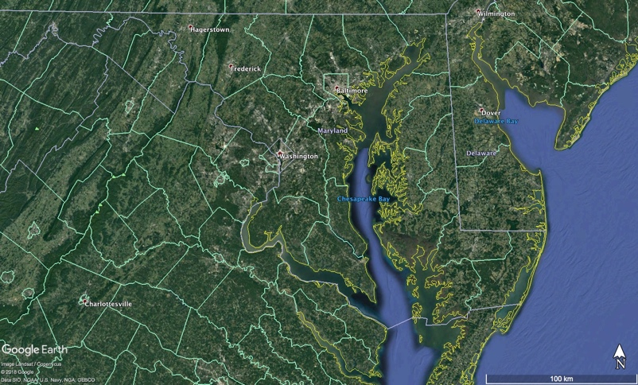
Chesapeake Bay
Disruptive HABs in the Chesapeake Bay have become more frequent in the last few decades.

Ingredients:
From 1991-2008, data provided by the Maryland Department of Natural Resources indicated large increases in the blooms of three contributing species to harmful algal blooms in the Chesapeake Bay: the dinoflagellate genera Prorocentrum and Kalrodinium as well as blue-green algae (cyanobacteria). Each of these organisms produce toxins and/or contribute to unfavorable water quality when abundant. The reported increase in blooms are in addition to observed, temperature-dependent blooms of these harmful species during the spring and summer. More blooms of Prorocentrum were found in late spring, while Kalrodinium blooms were more frequent in the summer months. Cyanobacteria blooms appeared to happen throughout the year. Over the same period, growing populations in the Baltimore-Washington, D.C. region may have contributed to excess nutrient runoff from land into Chesapeake Bay.

Effect:
The increases in bloom frequency from 1991-2008 has been implicated in fish-kill events in Chesapeake Bay as well as the failure of oyster spawning and development. Additionally, the decay of blooms by bacteria within the bottom sediments of the Bay consumes dissolved oxygen from the water and often results in seasonal “dead zones,” or areas which are so low in oxygen that neither fish nor any other animal can survive. As a result, there are growing concerns that the impacts of HABs will amplify into effects on food webs and energy cycling within the Chesapeake Bay.
The President of the University of Maryland Center for Environmental Science, Don Boesch, states “The increasing frequency and intensity of these harmful algae blooms will impact our ability to achieve the ultimate goal of restoring a healthy ecosystem in the Bay and put a premium on effective methods to reduce nutrient pollution.”
https://www.chesapeakebay.net/news/blog/the_abcs_of_habs_how_harmful_algal_blooms_impact_the_bay
https://www.sciencedaily.com/releases/2015/05/150511125219.htm

In the news: http://www.capitalgazette.com/news/environment/ac-cn-mahogany-blooms-20180508-story.html
8 May 2018 - E.B. Furgurson III
Annapolis area creeks and rivers have been hit with recent outbursts of algae blooms known as mahogany tides — with one report of a bloom running the length of the Severn River.
The species found in abundance, prorocentrum minimum, contributes to dead zones as the bloom dies and consumes oxygen in the water column. In high enough concentrations, it can cause fish kills although none have been reported this year. South River Federation staffer Nancy Merrill noticed the mahogany bloom off her dock in Church Creek. “It was an orange-coffee color,” Merrill said. “I know it was not good.” South Riverkeeper Jesse Iliff reported the mahogany tides in Pocahontas and Church creeks early last week. Samples were taken at both locations and sent to the Maryland Department of the Environment.

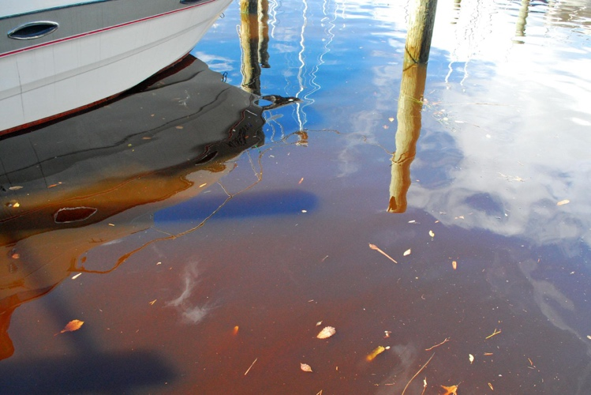
MDE reported Pocahontas Creek “contained a very large bloom with 104,040 cells per milliliter,” Maryland authorities consider a county of 10,000 cells to be worrisome and worthy of action. The sample also contained a species more toxic to fish and other water species, Karlodinium veneficum, finding 1,010 cells per milliliter. “A bloom of this biomass is something to watch,” the MDE report said. The Church Creek sample was worse — 113,686 cells of prorocentrum minimum and 1,616 of Karlodinium veneficum. MDE shellfish monitoring in the middle of the South River also found the two species. Though at lower levels they were concentrated enough to still constitute a bloom. The Maryland Department of Natural Resources has called Karlodinium the “fish killer” because it can produce five toxins. “Thankfully, no evidence of fish kills has surfaced on the South River so far,” Iliff said.

The blooms were noticed elsewhere. In the Severn River watershed the Severn River Association’s Tom Guay saw a heavy bloom in Chase Creek last week. “The waters are already murky,” he said. “This is so disappointing.”

Chesapeake Bay Foundation naturalist John Page Williams noted the NOAA buoy at the mouth of the Severn has reported blooms with seven chlorophyll spikes above 50 micrograms per liter in the past two weeks. He noted that the mahogany bloom is normal for this time of year, in May, but this is a particularly intense outbreak. On Thursday, Williams monitored an area of the river called the Winchester Lump. “It was fascinating to see what I interpret to be a bloom 20-feet deep,” Williams said. “I ran into a Natural Resources Police officer who told me he was seeing the bloom the full length of the river.”

Up on Meredith Creek near the Bay Bridge, other CBF staffers noticed Mahogany bloom last week but said it was worse two weeks ago. P. minimum tends to spike this time of year when rains wash excess nutrients into area waters, and the first warm days of the spring. According to DNR studies, May typically sees the highest number of mahogany outbreaks during the average year.
Scientific studies have noted the increase in algae blooms in recent years. The University of Maryland Center for Environmental Science underscored “more blooms, more often and lasting longer.” And not only in the Chesapeake Bay but worldwide. “In many places these trends are consistent with increased nitrogen levels,” said study author Pat Gilbert, a professor at UMCES Horn Point Laboratory. There are other sources of excess nutrients and not just from construction runoff, others note. This time of year homeowners are fertilizing lawns, and a rainstorm can wash excess nitrogen and phosphorus into creeks, rivers and the Chesapeake Bay. “There is enough nitrogen and phosphorus out there to keep these blooms fat and happy right now,” Williams said.
Florida’s Slimy Green Beaches
Large-scale harmful algal blooms (HABs) are becoming common on Florida coasts
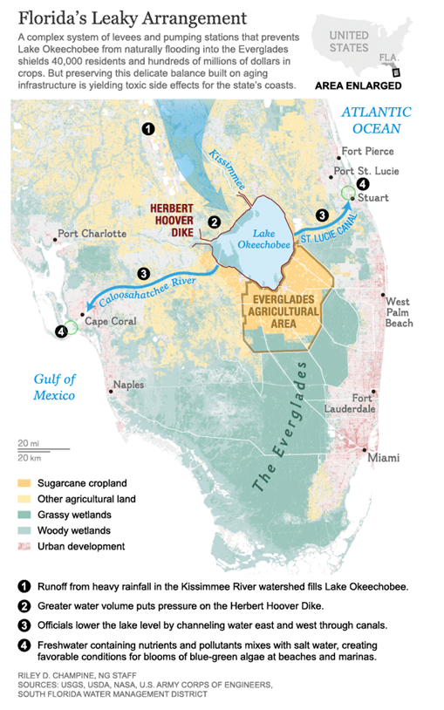
Ingredients:
Harmful algal blooms in Florida usually don’t originate in the ocean. They come from Lake Okeechobee. The lake absorbs agricultural runoff from cattle farms to the north and sugar cane fields to the south. This runoff is full of nutrients like nitrogen and phosphorous that fertilize the algae and nourish massive algal blooms. When heavy rainfall fills the lake with excess water, the only way to drain the lake and prevent flooding is to let the algal-rich water flow through rivers and canals towards Florida’s beaches. This creates favorable conditions for toxic algae blooms at the coasts.

Effect:
In 2013, the algal blooms in Florida were so bad, the event became known as Toxic Summer. In 2016, a HAB outbreak killed fish, shellfish, and at least one manatee. People who touched the sludge became sick. The blooms were so thick, they could be seen from space. State officials declared a state of emergency in four counties.
In the news:
National Geographic Story: Slimy Green Beaches May Be Florida's New Normal
https://news.nationalgeographic.com/2016/07/toxic-algae-florida-beaches-climate-swamp-environment
By Laura Parker. Published July 27, 2016

The green slime that washed onto Florida beaches earlier this month marks the eighth time since 2004 that toxic algae have fouled the Sunshine State’s storied coastline.
The algae blooms of 2013 were so severe the event became known as Toxic Summer. And this year’s outbreak has so thoroughly spread through delicate estuaries on both coasts that Florida officials declared a state of emergency in four counties. Toxic sludge has killed fish, shellfish, and at least one manatee and has sickened people who have touched it.
“This is absolutely the worst,” says Evan Miller, an environmental activist and founder of Citizens for Clean Water. Miller lives in the tourist town of Stuart, 110 miles (177 kilometers) north of Miami. “We’ve never seen algae so thick. You can see it from space. There are places in Stuart that are on their third and fourth cycle of blooms now.”

As the latest outbreak continues to play out with sporadic bursts of new algae blooms, dismayed Floridians are wondering if the recurring appearance of this tourist-repelling, fish-killing scum is their new normal. It may be.
Blue-green algae, also known as cyanobacteria, occur naturally and thrive in warm, calm water. Two conditions work against eradicating it: climate change and political inertia. ...
Florida, already confronting warmer and wetter days, will surely find itself battling more algae as the climate continues to heat up in the decades to come. But the guacamole-thick sludge that keeps appearing can be blamed more on political inaction. ...

Today, the lake is bordered by cattle farms to the north and sugar cane fields to the south, and it absorbs agricultural runoff from both directions. That helps make Okeechobee a perfect algae nursery. It is broad, shallow, and full of nitrogen and phosphorous—the kinds of nutrients that nourish massive algae blooms.

Lake Okeechobee is also a perfect launch pad for spreading green sludge to coastal beaches. The lake can gain two to three feet of rainfall during a normal wet season, and the only way to drain off excess water is to pump billions of gallons to both coasts through canals carved decades ago.
To get to the ocean, this algae-filled water must pass through the St. Lucie River Estuary and the Indian River Lagoon on the Atlantic coast and the Caloosahatchee River on the Gulf coast.
“They opened the gates and dumped it on us,” Miller says. “You could watch the algae moving down the canal.” …
Great Lakes Blooms
Harmful Algal Blooms (HABs) pose a risk to human and environmental health in the large freshwater Great Lakes.
Ingredients:
The Great Lakes have seen an increase in HABs since the mid-1990s. This phenomena is likely due to the elevated levels of phosphorus in the Great Lakes from urban and agricultural run-off, products containing phosphates, phosphorus and nitrogen in lawn fertilizer, and malfunctioning septic systems as presented in Figure 1.
Another contribution to the increase in HABs may be the invasion of zebra and quagga mussels. These mussels filter feed, eating non-toxic phytoplankton while releasing filtered toxic algae back into the ecosystem. A HAB in the Great Lakes may last several months and depends on the availability of sunlight, water and air temperature, bacteria levels, and water flow velocities [1].
Climate change may increase the frequency and severity of blooms due to rising water and air temperature along with reductions in winter ice cover in the Great Lakes. Additionally, climate change may increase the occurrence in severe spring storms. Rainfall washes runoff from agriculture into the water system which may contain high concentration of nitrogen.
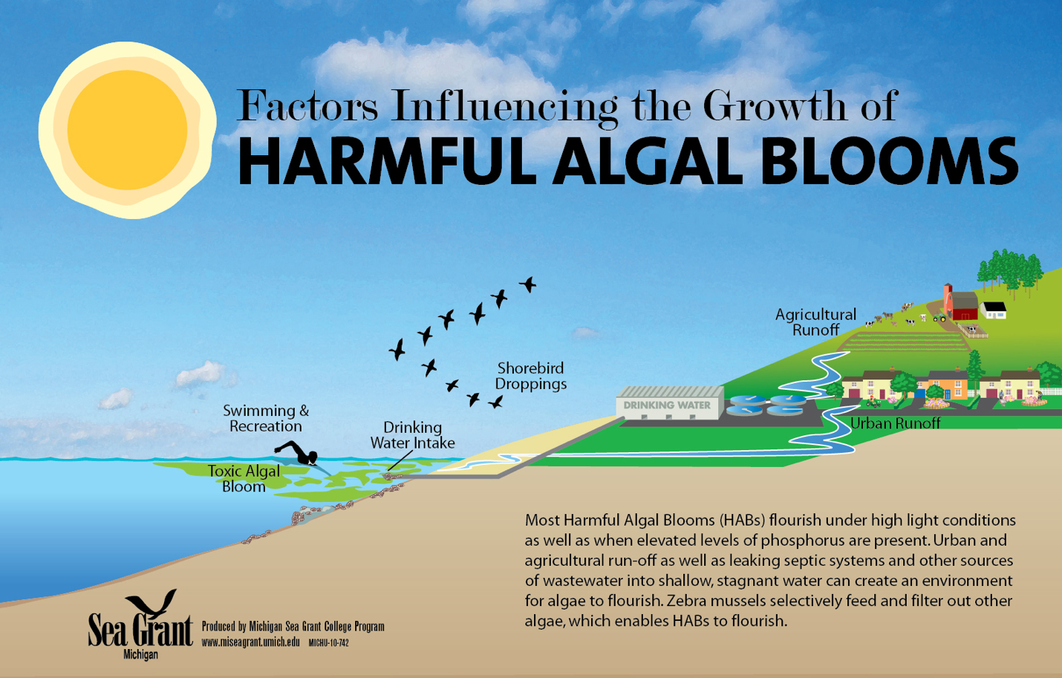
Figure 1: Schematic of factors influencing harmful algal bloom growth in the Great Lakes.

Effect:
HABs in the Great Lakes produce a wide variety of neurotoxins, cell toxins, liver toxins, and skin irritants. Consumptions of large amounts of these toxins by animals and humans can result in muscle cramps, nausea, vomiting, liver failure, etc. The most dominant form of HABs in the Great Lakes are Microcystis, a blue-green algae that produces Microcystin, a liver toxin and skin irritant.
Drinking water plants face challenges ensuring safe drinking water during extreme HAB events. Elevated temperatures over prolonged time periods, increase water usage, higher concentration of nitrogen and phosphorus from agricultural practices, and aging water treatment plant infrastructure increases the probability of toxins reaching consumer’s homes.

In the News: Predictions Come out for Lake Erie Algae Bloom in Summer 2018
http://www.news-herald.com/general-news/20180515/predictions-come-out-for-lake-erie-algae-bloom-in-summer-2018
By Richard Payerchin. Published May 15, 2018. Modified from The News-Herald on May 15, 2018

“Federal forecasters filed their first-of-the-spring harmful algal bloom projection for Lake Erie's western basin today, and the predictions for the summer are not optimistic.
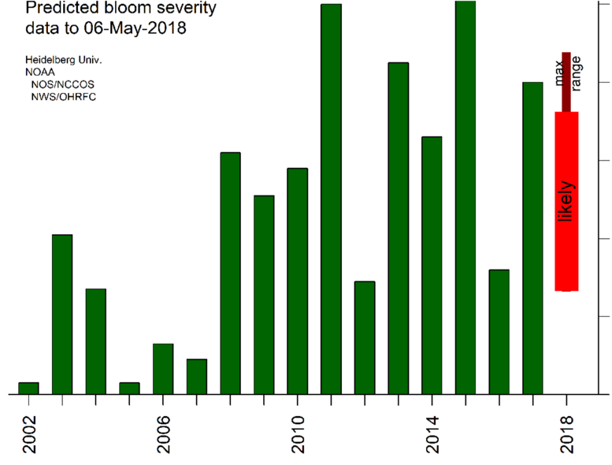
A wet early April combined with heavy rainfall last Wednesday produced slightly above average discharges of phosphorus runoff from the farm fields of Northwest Ohio into tributaries of the Maumee River, according to the National Oceanic and Atmospheric Administration.
Figure 2: Projected bloom compared to previous years. The wide bar is the likely range of severity based on data from the last 15 years. The narrow bar is the potential range of severity. Because the forecast uses modeled discharge for two months, there is a large uncertainty in bloom severity [3].
Phosphorus is primarily found in manure and fertilizer spread on the fields in spring, and is the primary source of algae-feeding nutrients to the lake's western basin.
Rainfall over the next several weeks is expected to be normal to slightly above normal, with a lower chance of major rainstorms that would cause significant additional runoff, the NOAA forecasters said.
The agency's prediction for the size of the algal bloom remains uncertain, ranging from slightly lower to significantly higher than last summer's bloom: the third largest on record, roughly the equivalent of the 2013 bloom, and trailing only the blooms of 2011 and 2015 in size.
"The phosphorus load to date is sufficient for some bloom to occur," the NOAA forecasters said in a prepared statement released this morning. " However, the uncertainty is quite large."
Lake temperatures and wind direction usually determine the spread of the bloom, the concentrations of harmful Microcystin bacteria and the date of the bloom's disappearance.”
References: [1]“Harmful Algal Blooms in the Great Lakes.” Michigan Sea Grant, 23 Feb. 2018. [2]Payerchin, Richard. “Predictions Come out for Lake Erie Algae Bloom in Summer 2018.” The News-Herald, 15 May 2018. [3]US Department of Commerce, and National Oceanic and Atmospheric Administration. Harmful Algal Blooms. 2018, oceanservice.noaa.gov/hazards/hab/.
“The Blob” West Coast Bloom
Large-scale harmful algal blooms (HABs) occurred off the West Coast during 2015.
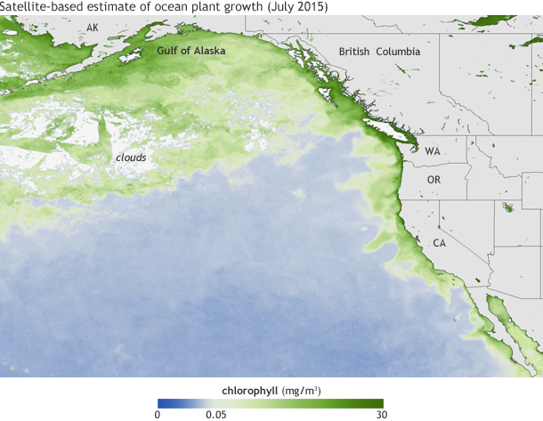
Ingredients:
High levels of toxic domoic acid were observed during a record-breaking Pseudo-nitzschia bloom, stretching from California to the Gulf of Alaska in 2015. Pseudo-nitzschia, a genus of phytoplankton, produces toxic domoic acid. There are many unknowns about why Pseudo-nitzschia algae succeed under stressful conditions (such as unusually warm or saline conditions) and outcompete other phytoplankton.
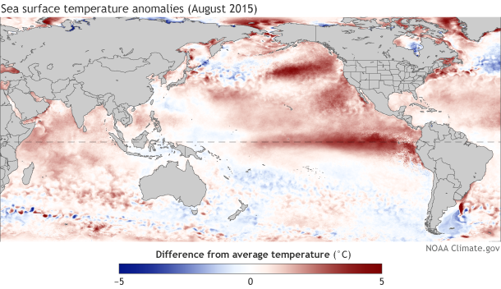
During the 2015 bloom, there was warmer-than-average ocean conditions in the tropical and North Pacific Ocean associated with the high levels of domoic acid in shellfish. The higher than average water temperatures started in 2013 when weak winds failed to mix and cool northeast Pacific Ocean allowing heat to accumulate and spread along the pacific coast until 2015. During this year, sea surface temperatures where up to five degrees higher than average, and at the bloom’s peak, 3.5 million square miles from Alaska to Mexico were warmer than average [1].

Figure 1: Concentrations of chlorophyll, a green pigment present in algae, in July 2015 (top). Differences in sea surface temperatures in August 2015 compared to the 1981-2010 average (bottom).

Effect:
The large-scale HAB resulted in deaths of many marine animals and closure of recreation and commercial fisheries in Washington, Oregon, and California. High levels of toxic domoic acid led to closures recreational razor clam harvests in the northwest and health advisories were issued to fisheries along the California coast. The death of >30 whales was attributed to the toxic bloom.
These closures were because digestion of domoic acid may pose to human life. The first human death from domoic acid poisoning was recorded in eastern Canada in 1987 when 100 people are contaminated mussels causing short-term memory loss and four deaths. “Amnesic shellfish poisoning” is a term for short-term memory loss experienced by humans exposed to high toxic levels. While this condition may be catastrophic to human life, the majority of people experience milder symptoms such as nausea and diarrhea [2].
In the news:
Oregon and Washington delay crab season because of toxin
https://www.seattletimes.com/seattle-news/washington-and-oregon-delay-crab-season-because-of-toxin
By The Seattle Time’s Associated Press. Published November 20, 2015

Oregon and Washington have joined California in delaying the start of their commercial crab seasons after dangerous toxin levels were found in the crabs.
Officials say elevated levels of domoic acid were found in crabs in all three states. The toxin is naturally produced by microscopic algae in the Pacific Ocean, but the massive bloom of algae caused by warming ocean conditions this year has led to more toxins produced and consumed by shellfish.

California had already delayed the Nov. 15 start of its season after finding dangerous levels of the toxin. Oregon on Friday delayed the Dec. 1 start along its entire coast, after testing in recent weeks showed higher toxin levels in the southern half of the state. Oregon Department of Fish and Wildlife officials said delay of the season will allow completion of additional testing to make sure toxin levels are safe. And in Washington, officials on Friday also said they’re delaying the season along parts of the coast where it starts on Dec. 1.

Tribal crab fisheries in Grays Harbor and the adjacent ocean area are open, and officials said the crab there is safe and toxin levels are lower. Crab seasons have been delayed in the past, but mostly because the crab were not full enough, said John Corbin, a fisherman whose company has two Dungeness crab boats in Warrenton, Oregon. Domoic acid has been found in crabs for decades, usually at very low concentrations that pose no risk, Corbin said. But elevated levels that are toxic to humans are only found every dozen years or so.

“This year they’re full enough, but we want to make sure the crab is good quality and safe for the public,” he said. “When things are right, we will go at it.”

Officials say crabs sold in stores and restaurants remain safe to eat. Some crab on the market now may have been harvested months ago and frozen for later, or sourced from other areas.
Domoic acid or amnesic shellfish toxin can cause minor to severe illness and even death. Cooking or freezing shellfish with high levels of the toxin does not destroy it and doesn’t make it safe to eat.

Because the toxin tends to accumulate in crab gut and in the fat inside the back of the shell, officials say even when the meat has been deemed safe people should remove all the fat and discard the gut before consuming the shellfish. Other shellfish affected by domoic acid include razor clams, which have been taken off menus in Oregon and Washington. Domoic acid has also been detected in mussels and oysters in the Puget Sound.

References: [1] “Scientists Link Toxic Algal Blooms along U.S. West Coast to Warm Waters in the Pacific | NOAA Climate.gov.” Global Warming Frequently Asked Questions | NOAA Climate.gov, 23 Jan. 2017. [2] Nicklen, Paul, and Tiffany Boothe. “The Blob That Cooked the Pacific.” National Geographic, 5 Apr. 2017.

Name ___________________________________________________________________________________________________
Date ___________________________________________________________________________________________________
Group Members __________________________________________________________________________________________

Expert Section
Your Case Study:

Notes:
Why did this bloom happen?

What were the repercussions?
Example discussion topics :
Name of Algae
Health Impacts
History of toxic events
Economic Impacts
Organisms Impacted
Impact of Climate Change

Group Member’s Case Studies:
Case Study:  Notes: | Case Study:  Notes:
Case Study:  Notes: | Case Study:  Notes:

Name:______________________
Teacher:_____________________
Class Period:_________________
Date:_______________________

Exit Slip
(please complete this worksheet before class ends)

- During class activities and group discussion today, which of the following did you try? (Check all that apply)
- I shared my ideas
- I listened to my partners’ ideas
- I agreed with my partners’ ideas
- I disagreed with my partners’ ideas
- I used scientific evidence to support my idea
- I asked a clarifying questions
- I could revoice my partners’ ideas
- My partners and I looked for similarities and differences in our ideas

- Explain one thing that you understand better or differently after talking with your partners today.

- What are two effects of harmful algal blooms on animals and/or humans?

- Pick two consequences of climate change and describe how they might impact harmful algal blooms.

Lesson 4

Plankton Identification, Scientific Drawing, and Conceptual Model Revision

Summary: Students will use microscopes to look at plankton and practice scientific drawing. Students will then revisit their conceptual models.

NGSS
- MS-LS2-1 - Analyze and interpret data to provide evidence for the effects of resource availability on organisms and populations of organisms in an ecosystem.
- MS-LS2-3 - Develop a model to describe the cycling of matter and flow of energy among living and nonliving parts of an ecosystem.
- MS-LS2-4 - Construct an argument supported by empirical evidence that changes to physical or biological components of an ecosystem affect populations.
- MS-LS1-6. Construct a scientific explanation based on evidence for the role of photosynthesis in the cycling of matter and flow of energy into and out of organisms.

Necessary Materials:
- Pens/pencils
- Worksheets
  - Entrance slips (1 per student)
  - Plankton worksheet (1 per student)
  - Exit slips, (1 per student)
- Plankton ID sheets (1 for each microscope group)
- Let’s Grow A Bloom from Lesson 1
- Microscopes, slides, droppers
- Zooplankton samples (either scooped from a pond, a net tow, or your local Aquarium)

Introduction:
After students have completed their Entrance Slip, recap as a class the results of the Let’s Build a Bloom activity. Did we build a bloom successfully? How can we tell? Why did it work? Or why not? Then, introduce HAB species on Plankton ID sheets.

Activity 1: Plankton ID
- Have students in groups at microscopes look at plankton from local water sources (ponds, rivers, etc.) and the bloom experiment.

- Can you ID any?

- Practice your scientific drawing. Think about scales (sizes). Think about how this fits with the activity we did on Wednesday.

Activity 2: Re-visit Phenomena Models
- Did anyone see any phytoplankton? Zooplankton? Which cause the problem?

- Generate a word bank from the previous days activities.

- What problems do humans feel from HABs?

- Revisit models. (Individually for 3 min sketch ideas, then 12 min in groups)

- In groups: have students with 'roles' so they stay on task. Someone to make sure we've got all the ideas from the word bank. Someone to make sure everyone is participating. Timer. Someone to re-state ideas. Someone to share out at the end (this person will come up to the front where we have the big drawing).

- Draw a big model on the board and have each group add to it with a different color.

- Share-out / conclude
  - Hear from each group about how they revised their original model from day one
  - Hear from each group about their connection between Climate Change and People's' actions
  - Group discussion - drawing up key ideas on the board for a group model

- Exits Slips To be completed before students leave class

Images:
https://askabiologist.asu.edu/images/plankton-gallery
http://cfb.unh.edu/cfbkey/html/begin.html

Name:______________________
Teacher:_____________________
Class Period:_________________
Date:_______________________

Entrance Slip
(please complete this worksheet before class stars)

Look at the bloom experiment we set up on day 1. Did any of the conditions grow an algae bloom? How can you tell? Which ones? Was anything about the bloom or lack of bloom surprising to you?

In class yesterday we studied different algae blooms around the world. What are some things that you think are important in determining whether or not a bloom happens?

What are some things that you think are important in determining whether a bloom is harmful or not?

Some Zooplankton you might see:
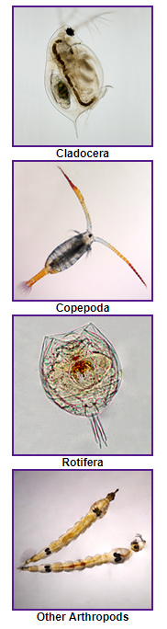

Cladocera (Approximately 1 mm long):

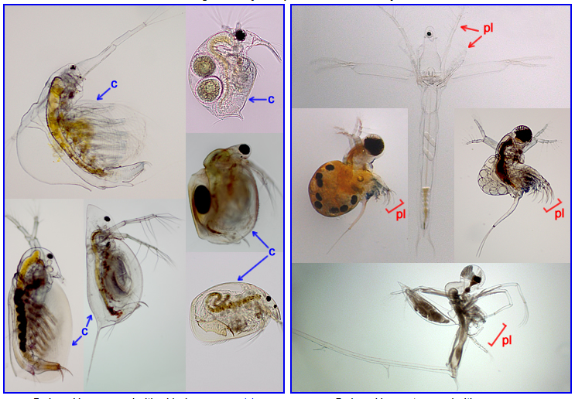

Copepod (Approximately 1-2 mm long):

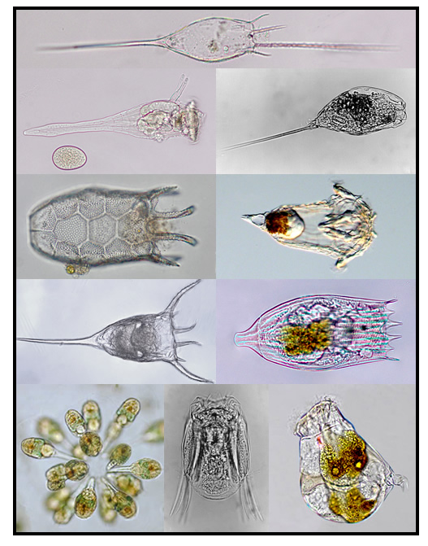

Rotifer (usually 0.1–0.5 mm, can be bigger):

Some phytoplankton you might see:

Centric diatoms (10s - 100s of μm): Pennate Diatoms (10 - 100s of μm,
can be in chains):
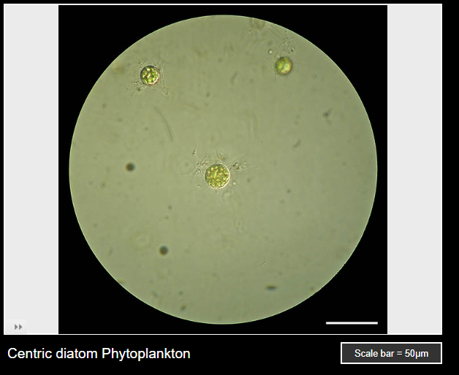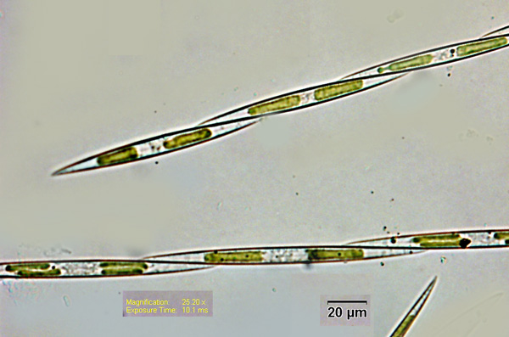
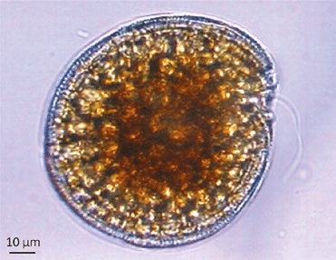
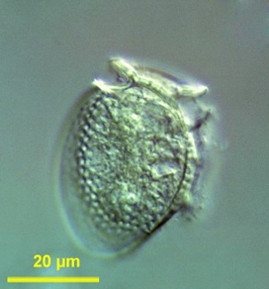
Dinoflagellates (10s of μm):
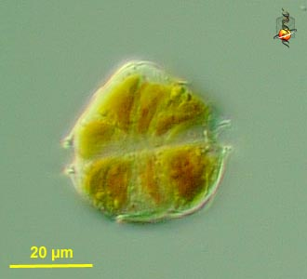

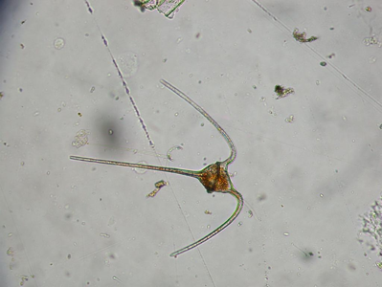

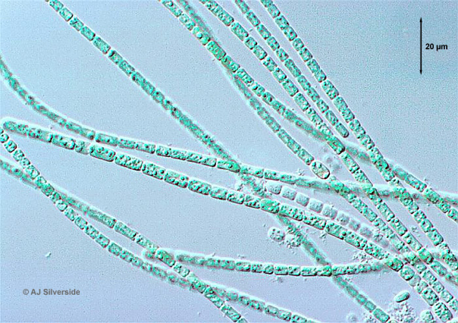
Blue-Green Algae (Cyanobacteria) (less than 10 μm, but can be in chains):
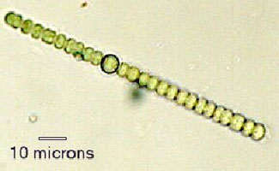
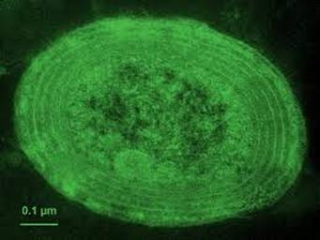
Plankton Microscope Lab:
In this activity you will explore the tiny watery world of plankton using only a piece of paper and a pencil. Sketches require scientists to focus on details and make keen observations that can be overlooked when taking a picture. It also allows them to detail particular areas or structures that are of interest.

Below is an image showing types of organisms in different size classes of plankton and the tools used to see them.
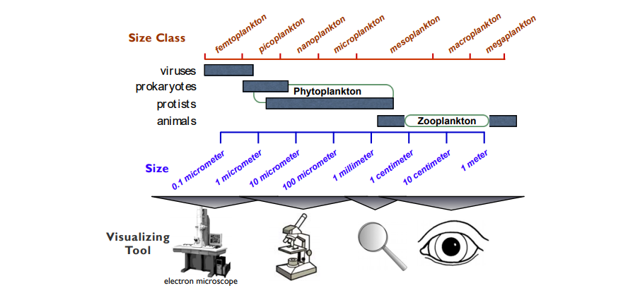

Today's activity:
Step 1: Find a partner to share a microscope with (there might need to be a few groups of three). One of you come to the front of the class get a slide for looking at plankton from the algae bloom experiment or the pond, the other come get a slide for looking at plankton from the Puget Sound or Portage Bay.

Step 2: Each partner take 1 minute to look through the microscope at the samples and try to find a few interesting organisms

Step 3: Each partner take 1 minute to count as many different organisms as you can see. The other partner keep time. You should count different samples.
Record your numbers on the board.
(Continues on other side if you have time)

Step 4: Pick an organism to sketch from samples or from the images in the ID guide. Think about the following questions. What shape is it? Is it one organism, or many? What color is it? Can I see any organs inside the body? How large is this organism?

Step 5: Before you start drawing think about how big you want to draw your organism. We want to be able to compare the sizes of different plankton. You will be sketching the plankton magnified and can use scale bars in your images to help others interpret your drawing.

Step 6: It is time to begin sketching! Below is a list of guidelines to follow.
- Don’t be intimidated.
- Pay close attention to detail and draw what you see.
- Start with the big stuff and then move on to fill in the details.
- Start sketching lightly. You can darken your drawing when you add the details.
- Don’t get frustrated, just do your best. Scientific sketching is a skill and you only get better at it if you practice!

Step 7: Compare with another microscope group to see if you had similar or different plankton in your samples.

Name:___________________________________ Teacher:_____________________________________ Period:__________________________________

The question we are answering: What processes caused the 2015 closure of razor clam fisheries in Washington?
Directions: 1. In each phase (before the bloom, during the bloom) draw and label what you can see and what processes are going on to connect the temperature, algae, and clams. Add in other organisms and processes as needed to connect these things, and make sure to try to write, draw, or otherwise represent things that are happening but unobservable.
2. Don't forget to include the concepts in the word bank on the board. Remember there are many ways of representing things, so feel free to be creative, but we need to be able to understand one another's models, so add a key if needed.

Before the Bloom: During the Bloom:

Directions: Now draw a new model based on what you think will happen in the future as our climate changes? Think about the ideas we discussed yesterday that are ingredients for a harmful algae bloom, and the impacts of climate change that might affect harmful algae blooms.

Impacts from climate change:

Write about what you think causes harmful algae blooms (Use evidence from a class activity or other experiences/knowledge you have to support one of your ideas):

What is some information you could collect during or before a harmful algae bloom to see if your understanding is correct?

How can people change their behavior to decrease harmful algae blooms or reduce the impacts of harmful algae blooms?

Name:______________________
Teacher:_____________________
Class Period:_________________
Date:_______________________

Exit Slip
(please complete this worksheet before class ends)

Answer the following questions by circling a single number for each:
- How included did you feel during the group work activities this week?
I did not feel included 1 2 3 4 5 I felt very included

- How much did you learn in the following activities?
Trace the Toxin
I did not learn much 1 2 3 4 5 I learned a lot

Groups reading and discussing about HABs yesterday
I did not learn much 1 2 3 4 5 I learned a lot

Plankton lab: Microscopes and scientific drawing
I did not learn much 1 2 3 4 5 I learned a lot

Drawing your models
I did not learn much 1 2 3 4 5 I learned a lot

- What was something you really enjoyed this week?

- Do you have any additional feedback?

