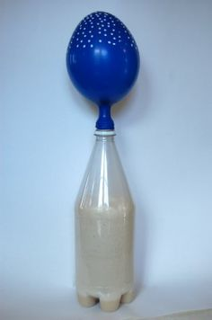

***Designing a study – The mystery of the yeast, flask and balloon***

Yesterday we had two hypotheses for why the balloon filled up:

1: The yeast gave off some type of gas that filled the balloon

2: The warm air from the flask rose and filled the balloon

Your task today is to design a study that can help support one of these hypotheses.

Check the one you want to do:

☐We want to do a study that would test whether the yeast gave off some gas that filled the balloon.

☐We want to do a study that tests whether warm air rising from the water in the flask was what caused the balloon to inflate.

Draw a picture here of your experimental set-up (flasks, balloons)

Write a procedure that includes all the steps you would use to set up the materials, and to describe how you would collect data. You’ll likely need several steps. The steps should be written clearly enough so that another group of classmates could conduct exactly the same study by reading your set of procedures.

Step 1.

Our materials list

We think this invesitgaiton will tell us something important because if we get this outcome: _________________________________________________________________________________________________________________________________________________________

it would mean that: ____________________________________________________________________________________________________________________________________________________________________________________________________________