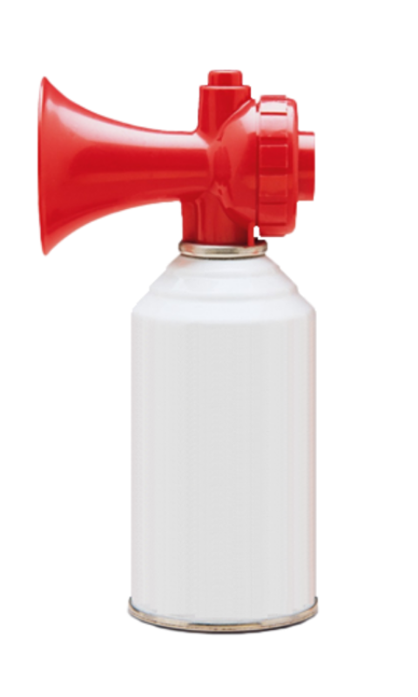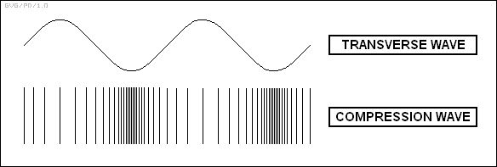

Data Table

1. What are we interested in finding out? Write two full sentences please. ______________________________________ ______________________________________________________

_____________________________________________________

_____________________________________________________

_____________________________________________________

Designing an investigation

|  |  |  |
| --- | --- | --- |
|  | | |
|  |  |  |
|  |  |  |
|  |  |  |
|  |  |  |
|  |  |  |

6. What questions are we left with?

________________________________________________________________________________________________________________________________________________________________________________________________________________________________________________________________________________________________________________________________________________________________

4. Procedures: Here’s what we’ll do, step-by-step. Write in detail so someone else could read this and reproduce your experiment. Include materials. _______________________________________________________

_______________________________________________________

_______________________________________________________

_______________________________________________________

_______________________________________________________

_______________________________________________________

_______________________________________________________

_______________________________________________________

_______________________________________________________

__________________________________________

3. How will we collect data in a systematic way? Write two full sentences please. ____________________________________________________________________________________________________________________________________________________________________________________________________________________________________________________________________________________________________________________________________

What we think happened that we could not directly

observe. Draw and label.

5. What do we think we know as a result of our experiment and the experiments of our classmates? ________________________________________________________________________________________________________________________________________________________________________________________________________________________

________________________________________________________________________

________________________________________________________

________________________________________________________

2. What will the results tell us about our model of the singer and glass? Write two full sentences please. ________________________________________________________________________________________________________________________________________________________________________________________________

________________________________________________

__________________________________________

____________________________________________________________________________________