Circuits Unit Revision
Pairs with STC Electric Circuits Kit

Grade 4
Contents of this file:

- Information about Ambitious Teaching Practices
- Teacher Content Primer
- Curriculum Lesson Guides
- Next Generation Science Standards

Unit Synopsis:

Students investigate a phenomenon of a flashlight that stops working when it’s accidentally left on. Readings and videos support students in making sense of data they collect during hands-on investigations. Students learn about how each part of the circuit works as well as how energy is transferred and transformed within a circuit system. Throughout the unit, students have multiple opportunities to create and revise their own scientific models about the flashlight phenomenon in light of evidence they collect from activities. Ultimately, the model and explanation students create is of the flashlight phenomenon; however, knowing the big science ideas behind this system allows students to explain multiple related events.

Ambitious Science Teaching Framework

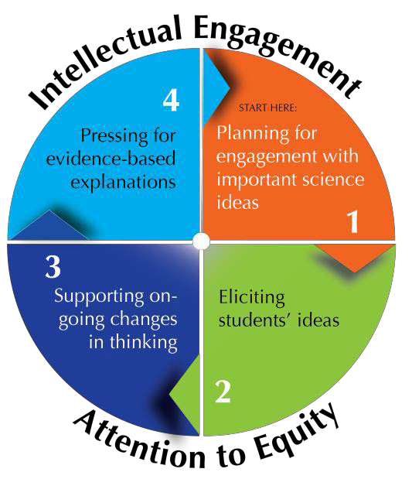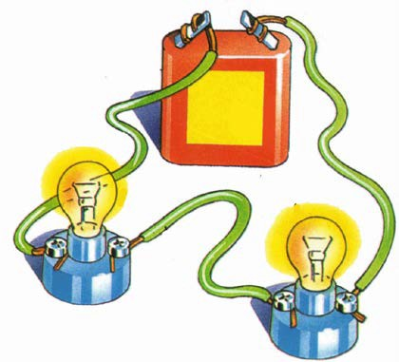

Except where otherwise noted, this work by Tools for Ambitious Science Teaching, University of Washington, is available under a Creative Commons Attribution-NonCommercial International 4.0 License. All logos and trademarks are property of their respective owners. Images in this work are used with permission and not included in the open license.

© Tools for Ambitious Science Teaching, University of Washington, 2015 AmbitiousScienceTeaching.org

Ambitious Science Teaching

We provide here a vision of ambitious teaching—teaching that is effective, rigorous and equitable. But more than that, we provide a framework of research-based teaching practices that are consistent with this vision and a wide range of tools that can transform how students learn in your classroom. The vision, practice, and tools will furnish a common language about teaching for a group of science educators committed to the improvement of teaching. You will be able to identify “what we will get better at” and how to get started.

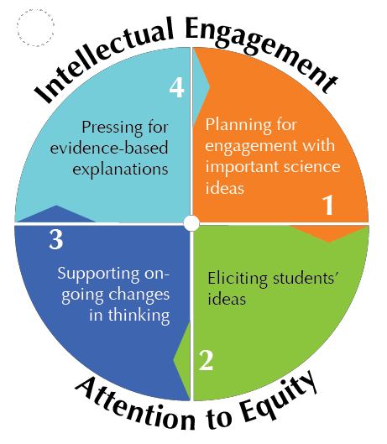
Ambitious teaching aims to support students of all racial, ethnic, and social class backgrounds in deeply understanding science ideas, participating in the talk of the discipline, and solving authentic problems. This teaching comes to life through four sets of teaching practices that are used together during units of instruction. These practices are powerful for several reasons. They have consistently been shown through research to support student engagement and learning. They can each be used regularly with any kind of science topic. And finally, because there are only four sets of practices, we can develop tools that help both teachers and students participate in them, anyone familiar with the practices can provide feedback to other educators working with the same basic repertoire, teachers can create productive variations of the practices, and everyone in the science education community can share a common language about the continual improvement of teaching.

The four Ambitious and Equitable Science Teaching Practices are summarized in the below.

Practices | What does it LOOK like?
Planning for engagement with important science ideas | - Planning a unit that connects a topic to a phenomena that it explains (Chemical Reactions – Bike Rusting, Photosynthesis – Seed Becoming a Tree)  - Teaching a topic within a real-world context
Eliciting students’ ideas | - Asking students to explain HOW and WHY they think a phenomena happens (How did the bike change? Why did it change? What is happening at the unobservable level?)
Supporting on-going changes in thinking | - Using ALL activities/lessons to explain the phenomena.  - Giving students opportunities to revise their thinking based on what they’re learning
Pressing for evidence-based explanations | - Allowing students to create a final model or explanation about the phenomena  - Pressing students to connect evidence to their explanation

Many teachers want to know what their classrooms should look like and sound like—they want to understand how to interact with their students about science ideas and students’ ideas. This is especially true now that the Next Generation Science Standards are being used in many states.
As a result of the last 30 years of classroom research, we know enough about effective instruction to describe in clear terms what kinds of teaching practices have been associated with student engagement and learning. This research tells us that there are many ways that teachers can design and implement effective instruction, but that there are common underlying characteristics to all these examples of teaching that can be analyzed, described, and learned by professionals. These practices embody a new form of “adaptive expertise” that EVERY science educator can work towards. Expert teaching can become the norm, not reserved for a select few. Ambitious teaching is framed in terms of practices that any teacher can learn and get better at over time. What would we see if we entered classroom of a science educator using ambitious teaching? To give you a sense of what ambitious teaching looks like, we have described below some features common to all science classrooms where ambitious teaching is being implemented (listed on right). These features address everyday problems with learning and engagement that teachers face (listed on left).

Common problems in supporting student
engagement and learning
The problem: Students don’t see how science ideas fit together. Each day is perceived by students to be the exploration of ideas that are unconnected with previous concepts and experiences.

The problem: An oversimplified view of what it means “to know.” Science ideas perceived to be straightforward and learnable within a lesson—either you get it or you don’t.”
The problem: Lack of student engagement. Students’ experiences and interests not elicited or seen as relevant. Student ideas treated as “correct” or “incorrect.”

The problem: Students reluctant to participate in science conversations.
Teachers dominate the talk, ask primarily for right answers, get brief responses from students.
The problem: Some students have little support for accomplishing tasks that would otherwise be within their grasp. Little or no guidance for students’ intellectual work. Giving “clear directions” is seen as enough to ensure participation in activities.
The problem: Invisibility of student ideas and reasoning. Teacher does not know what students think—their heads are a black box. Cannot then work on students’ ideas.
Students cannot take advantage of the ideas or ways of reasoning by their peers.
What you’d see in a science classroom where
ambitious teaching is the aim
At the beginning of the unit, students are focused on developing an evidence-based explanation for a complex event, or process. Students know that throughout unit, most of the activities, readings and conversations will contribute to this explanation.
An idea is never taught once and for all, but revisited multiple times. Students’ science explanations are treated as partial understandings that have to be revisited over time to become more refined and coherent.
Students’ ideas and everyday experiences are elicited and treated as resources for reasoning; students’ partial understandings are honored as a place to start. They are made public and built upon.
Teachers use a varied repertoire of discourse moves to facilitate student talk. Guides and scaffolds for talk help students feel comfortable interacting with peers.

There is scaffolding that allows students to participate in science-specific forms of talk, in group work, and in science practices.

Students’ thinking made visible through various public representations (tentative science models, lists of hypotheses, question they have, etc.). The teacher can see how students think and how that thinking could change over time. Students benefit from seeing and hearing the reasoning of others.

The problem: Illusion of rigor. Students reproduce textbook explanations, lean on vocabulary as a substitute for understanding. Talk of evidence and claims are rare.
The teacher presses for complete, gapless explanations for unique real-life events or processes, and press for the use of evidence to support claims.

As you will see, ambitious teaching is not a “method,” and the teaching practices are not scripts. It is a set of principled practices that must be adapted to your classroom needs. Coaches and other teachers can work with you to do this ambitious work.



TEACHER BACKGROUND

Science Content Primer & Explanation of Phenomenon
Read through the explanation provided in the next few pages. Jot down questions or uncertainties.
Consult internet resources to answer your questions, ask colleagues, and work together as a team to grow your own understandings of the science content and the phenomenon itself. This knowledge primes you to better listen and respond to student ideas in productive ways. Please feel free to revisit this explanation throughout the unit to revise and improve your own understanding of the science content.

Except where otherwise noted, this work by Tools for Ambitious Science Teaching, University of Washington, is available under a Creative Commons Attribution-NonCommercial International 4.0 License. All logos and trademarks are property of their respective owners. Images in this work are used with permission and not included in the open license.

PLANNING FOR ENGAGEMENT WITH IMPORTANT SCIENCE IDEAS

UNIT QUESTION: Why would a flashlight eventually stop working if it were accidentally left turned on for a period of time?

PHENOMENON: [Mr./Ms.Teacher] accidentally shoves the flashlight in a desk drawer and the switch gets flipped on. The flashlight stays on inside the desk for a whole month (30 days). When [Mr/Ms. Teacher] goes to use the flashlight it doesn’t work anymore. What happened? What caused it to stop working? What’s happening inside the flashlight or parts of the flashlight that might cause it to stop working?

UNIT GOALS: By the end of the unit, students will combine some or all of the following ideas to explain the flashlight phenomenon or other related events.
• Structure and properties of matter (DCI PS1.A)
- Matter is made of particles too small to be seen, which give the material certain properties such as electrical conductivity.
• Energy can be moved or transferred. (DCI PS3.A)
- Energy is present when there is sound, light, or heat. Energy can be moved (transferred) from place to place through sound, light, or electric currents.
- Electric currents are in wires and are evidence for the presence of energy (the flow of electric current through a device).
- That energy has been transferred from place to place (e.g., a bulb in a circuit is not lit until a switch is closed and it lights, indicating that energy is transferred through electric current in a wire to light the wire filament).
• Energy can be transformed and is conserved. (DCI PS3.B)
- Identify a device by naming how the energy will be transformed (e.g., a light bulb to convert electrical energy into light energy, a motor to convert electrical energy into motionenergy.)
- Energy can be transferred from place to place by electric currents, which can then be converted or transformed to produce motion, sound, heat, or light.
- Electric currents in a circuit may have been produced by transforming another form of energy such as chemical or motion into electrical energy.
- The presence of electric currents flowing through wires can be causally linked from one form of energy output (e.g., a moving object) to another form of energy output (e.g., another moving object; turning on a light bulb).

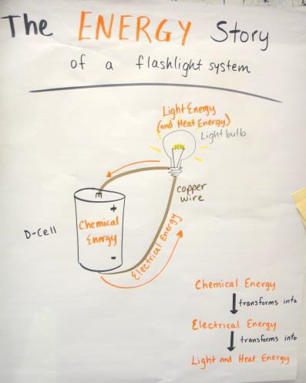
TEACHER CONTENT EXPLANATION:
(This is at a deeper level than what students will know by the end of the unit. Students have deeply complex ideas about how circuits work and it is helpful to prime content knowledge to be ready to listen to students)

A big idea for this circuit system is the transformation of energy from chemical (inside the battery) to electrical energy (inside the wire or metal pathway) to other forms such as light energy (light bulb), heat energy (toaster), or motion/mechanical energy (fan or motor.) But these energy transformations cannot happen unless the pieces are connected. A circuit is a system made of interconnected and

dependent subsystems. Without properly functioning subsystems and proper connections made between the subsystems, the circuit will not perform its function (i.e. light a bulb, spin a fan, rotate a motor, make a sound, etc.). In this case, we will explain a simple circuit powered by a battery to light a small bulb. The subsystems of this circuit are the battery and light bulb (wire is not a subsystem, but it is a pathway.)
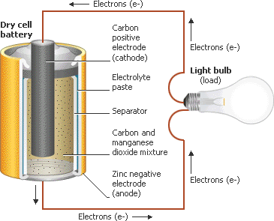First, the battery contains stored chemical energy for the circuit. Inside the battery there is a chemical reaction happening (between acids and metals) which produces a difference in charge between the positive and negative terminals of the battery. When the chemicals in the battery have completely finished reacting then the battery is dead because it no longer is creating the difference or imbalance in charge between the terminals. During the chemical reaction there is a buildup of electrons near the negative terminal of the battery.
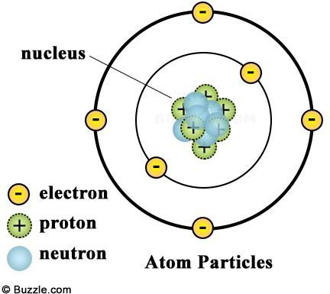These negatively-charged electrons push away from other negatively-charged electrons and try to spread out because negative charges repel each other. There is a barrier or separator inside the battery that keeps the electrons from moving towards the positive terminal. If this barrier or wall has holes in it (from poor construction, dropping the battery, degradation over time), then the battery stops working because the electrons can all spread out evenly and there are no electrons that build-up on one terminal of the battery.

When a wire or other conductor connects one terminal of the battery to the other, the electrons are free to bump into and repel the electrons that are in the wire. These electrons in the wire bump into and repel each other all around the wire until the electrons bump into the positive terminal of the battery. If the battery is left connected to a bulb for a long time then the build-up of charges from the chemical reaction eventually evens out as the chemical reaction runs out of each kind of chemical in the battery. When there is no chemical reaction, there is no more buildup of electrons; therefore, there is no electron “flow” through the circuit because there is no longer an imbalance in charge.

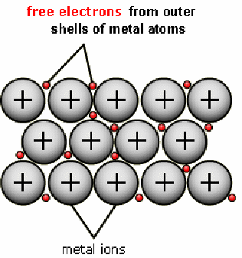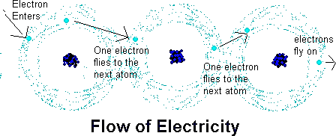Copper wire is typically used as a conductor to connect the battery with a light bulb. The copper wire has millions of electrons that are free to bump around inside the wire. “Free” electrons means there is an available outer valence electron in each atom in the wire. Copper, silver, and gold each have one free valence electron. The negatively- charged electrons in each atom are evenly paired up with the positively charged protons in the nucleus of the atom and so spend their time attracted to and zooming around the nucleus. However the outer valence electrons are farthest from the positively-charged nucleus and are more likely to be bumped or repelled out of place by an incoming electron from a previous atom. Although the bumping of electrons only proceeds slowly (one individual electron only moves about 5.5 inches per hour), the energy transfers at light speed. This is like the billiard ball analogy where several balls are in a row and one ball hits the end of the row pushing the ball at the far end out. Although the individual balls in the row do not move much or very far, the energy is transferred through them very quickly.
Plastic (like is used to wrap wire) or glass (like the ball inside a light bulb) do not allow electricity to pass through them easily because of how the electrons are arranged in the outer valence (insulators typically have 5 or more outer valence electrons as opposed to the 3 or fewer found in conductors.) In insulators, the electrons are tightly held to the atom, there are no free electrons available bump and transfer energy.

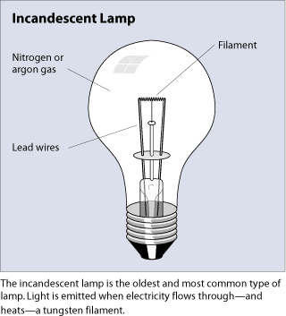When connected properly, the electrical current flows through the support wire, through the smaller filament wire and then out the other support wire to leave the light bulb in order to balance the charge difference created in the battery. The thin filament wire glows because it is a smaller wire (higher resistance) than the previous wire and the electrons that are bumping all are trying to bump and repel each other through the smaller wire which results in something like friction that converts some of the electrical energy into heat and light. Light and heat are emitted from the glowing wire because of how the electrons transfer energy and bump through the thin wire.

Circuits only perform transformations of energy when the subsystems of a circuit are connected in a particular way that allows the flow of electrons to move from the negative battery terminal to the positive battery terminal alleviating the imbalance in charge created by the chemical reaction in the battery. When connections are improper the circuits will either not work, or damage subsystems in the circuit system (like short-circuiting the battery).

ADDITIONAL BACKGROUND KNOWLEDGE RESOURCES:

Electricity & Charged Particles – “Electricity and Circuits” by ScienceOnline - Teacher background reviewing atomic structure and charges and different circuits. This is not a focus for students in this unit; however, students may wondering about why current flows a certain way. This information will help you. https://www.youtube.com/watch?v=D2monVkCkX4 (8 mins 32 sec)

- What is a circuit? - “Explaining an electrical circuit” by Region 10 ESC – Provides basic info: https://www.youtube.com/watch?v=VnnpLaKsqGU (2 min 26 sec) – This is basic knowledge for teachers but this video could also be used with students after they learn about conductors and electrons in lesson 6.

- How batteries work (2 min 07 sec) – How the chemistry inside a battery works in an entertaining candy cartoon. https://www.youtube.com/watch?v=CJK2kwF6Am4 (Students don’t need to know the names of all these chemicals but it does describe the electron story.)

ADVANCING STUDENT THINKING

LEVELS OF EXPLANATION WHAT-HOW-WHY

The next pages feature a what-how-why rubric around core science ideas in this unit and some ways of tracking this at a class level and at an individual level. It shows examples of how these ideas can be described at different levels of depth. Use talk moves to help push students to think beyond a “what” level and try to explain how and why particular things happen during the activities in this unit. Students can also identify what information or experiences they need to help them explain the science at a deeper level.

LEVELS OF EXPLANATIONS: ADVANCING STUDENT THINKING
What are what-how-why levels?

These levels indicate a depth of explanation.

• WHAT - Studentdescribes whathappened. Describes, summarizes, restates a pattern or trend in data without making connection to any unobservable components.
• HOW - Student describes how or partial why something happened. Addresses unobservable components but not deeply.
• WHY - Student explains why something happened and can trace a causal story for why a phenomenon occurred or ask questions at this level. Uses important science ideas that have unobservable components to explain observable events.
Students may have a blend of what-how-why depending on which concepts they best understand. Ultimately, students are pressed to develop a ‘why’ level explanation. However, ‘why’ level is the most challenging to achieve because it requires wrestling with unobservable mechanisms.
How to use these trackers?

• Examine artifacts of studentwork (such as model scaffolds, notebook writing entries) to keep track of students progressing understanding over time.
• You do not have to fill this in every lesson, but only at key points in the unit. For example, the initial model, mid-point model revision, and final model are good places to do this.
• Use different colored pens/pencils to indicate different dates of assessment.

Whole Class and Individual Tracking

The whole class tracker will give you a sense of where to go with instruction at a lesson level. This information may also indicate that additional lessons about particular concepts need to be added to the unit. This information can help tailor instruction to aim for ‘how’ and ‘why’ levels of understanding.
• The individual student trackers can identify which students can move from what to how and which ones to be pushed from how to why. Plan back-pocket questions for particular students (or groups of students) to target moving thinking forward.
• Make enough copies of the individual student tracker for each student in your class.

Circuits Unit Expectations: Whydoestheflashlighteventually stop working?
• Students final explanations will be a blend of what, how, and why levels.
- The grade-level explanation is that students master ideas contained in the ‘what’ and ‘how’ columns; however, lessons in this unit also target the why level to help students explain what is going on that they can’t see that makes the flashlight work or stop working. The ‘why’ level targets 5thgrade and middle school concepts. Students should be expected to include and explain ‘what’ and ‘how’ ideas in their models and explanations by the end of this unit.

Examples of a class tracker and individual tracker show more about how to use this tool. Blank templates are also provided to track your students.

(This page intentionally left blank.)

CLASS EXPLANATION TRACKER – EXAMPLE

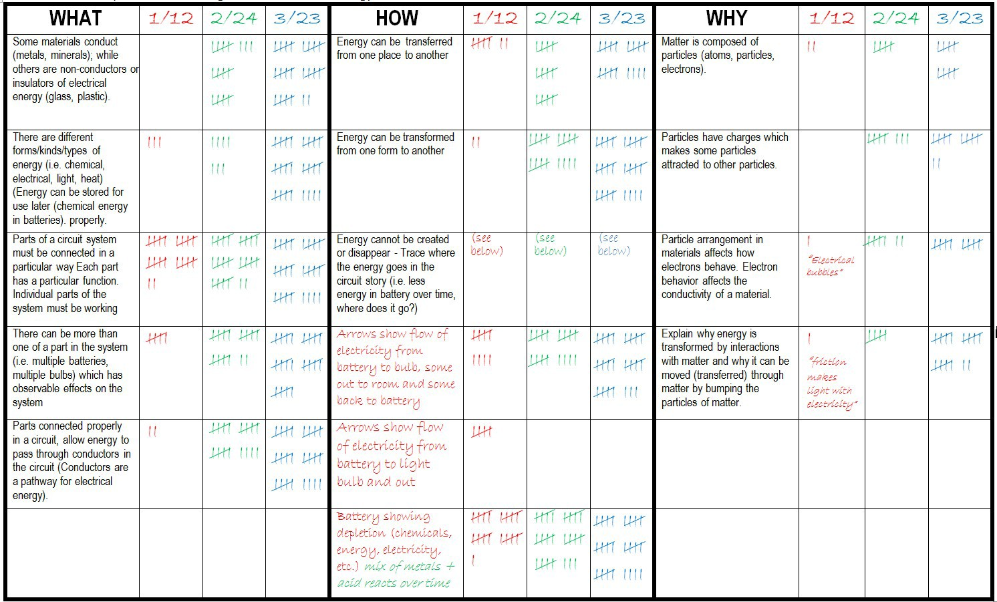The teacher tracked how many students were including the ideas below at different parts in the unit using data from the initial model (red), mid- point model revision (green), and final model (blue). The final model is completed a few days before the unit ends so the teacher could re-teach or provide additional experiences if needed to close any significant gaps.
This teacher added additional ideas to the “how” column as she noticed that students were showing the energy flow in different ways in the initial model and wanted to know how many students were representing it in these different ways.
Overall, this tracker shows over time that more and more students were including more ‘what’ and ‘how’ level ideas in their models and explanations. A few students were able to explain more in-depth about the ‘why’ level over time; however, because the ideas in the ‘why’ level are 5th and middle school standards, it is not expected that all 4th grade students reach mastery at a ‘why’ level .

INDIVIDUAL STUDENT TRACKER - EXAMPLE

The teacher used check marks to indicate which concepts or ideas the student included or addressed in her model at different points in time over the unit - at times including a quote or note to remember how the student did this. These quotes/notes can be helpful in pairing students or grouping students to help them learn from each other about how our flashlight system works and would stop working.
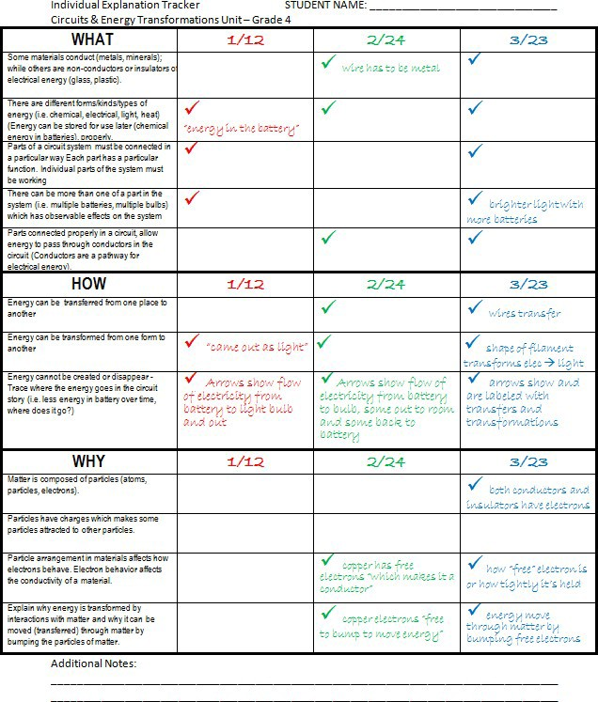
There is space for additional notes at the bottom. Other things to consider tracking when looking at models could be how the student is progressing using modelling conventions or if/how they are using evidence to justify changes to parts of their model. Focusing on modelling and evidence correspond with Next Generation Science Standard (NGSS) science and engineering practice (SEP) of developing and using models and constructing evidence-based explanations.

Class Explanation Tracking Sheet: Circuits & Energy Transformations Unit – Grade 4
WHAT |  |  |  | HOW |  |  |  | WHY
Some materials conduct (metals, minerals); while others are non-conductors or insulators of electrical energy (glass, plastic). |  |  |  | Energy can be transferred from one place to another |  |  |  | Matter is composed of particles (atoms, particles, electrons).
There are different forms/kinds/types of energy (i.e. chemical, electrical, light, heat) Energy can be stored for use later (chemical energy in batteries). |  |  |  | Energy can be transformed from one form to another |  |  |  | Particles have charges which makes some particles attracted to other particles.
Parts of a circuit system must be connected in a particular way Each part has a particular function. Individual parts of the system must be working |  |  |  | Energy cannot be created or disappear - Trace where the energy goes in the circuit story (i.e. less energy in battery over time, where does it go?) |  |  |  | Particle arrangement in materials affects how electrons behave. Electron behavior affects the conductivity of a material.
There can be more than one of a part in the system (i.e. multiple batteries, multiple bulbs) which has observable effects on the system |  |  |  |  |  |  |  | Explain why energy is transformed by interactions with matter and why it can be moved (transferred) through matter by bumping the particles of matter.
Parts connected properly in a circuit, allow energy to pass through conductors in the circuit (Conductors are a pathway for electrical energy).
Explanation Tracking 4th Grade Circuits
© 2015, AmbitiousScienceTeaching.org

(This page intentionally left blank.)

Individual Tracker Circuits Unit – Grade 4 NAME:
WHAT | Date: | Date: | Date:
Some materials conduct (metals, minerals); while others are non- conductors or insulators of electrical energy (glass, plastic).
There are different forms/kinds/types of energy (i.e. chemical, electrical, light, heat) Energy can be stored for use later (chemical energy in batteries).
Parts of a circuit system must be connected in a particular way Each part has a particular function.
Individual parts of the system must be working
There can be more than one of a part in the system (i.e. multiple batteries, multiple bulbs) which has observable effects on the system
Parts connected properly in a circuit, allow energy to pass through conductors in the circuit (Conductors are a pathway for electrical energy).
HOW
Energy can be transferred from one place to another
Energy can be transformed from one form to another
Energy cannot be created or disappear
- Trace where the energy goes in the circuit story (i.e. less energy in battery over time, where does it go?)
WHY
Matter is composed of particles (atoms, particles, electrons).
Particles have charges which makes some particles attracted to other particles.
Particle arrangement in materials affects how electrons behave. Electron behavior affects the conductivity of a material.
Explain why energy is transformed by interactions with matter and why it can be moved (transferred) through matter by bumping the particles of matter.
Additional Notes:

(This page intentionally left blank.)

Revised Circuits Unit Overview – Grade 4
Lesson | Connection with Kit | Lesson Title | Suggested Time*
1 | LESSON 2  What Can  Electricity Do? | Pre Unit Assessment: Developing Models to Explain the Flashlight Phenomenon | 60-75  mins
2a | ADDED | Building a Simple Battery | 45  mins
2b | ADDED | Testing Battery Recipes  **Just-in-time instruction: testing variables | 45-60  mins
3 | ADDED | Learning about Chemical Energy  Just-in-Time instruction: chemical energy | 45-60  mins
4 | ADDED | The Power of Multiple Batteries  Just-in-Time Instruction: Adding volts | 75-90  mins
5 | ADDED | Revising Models with Evidence | 60-75  mins
6 | LESSON 7  Conductors and  Insulators | Testing Conductors and Insulators  Just-in-Time Instruction: Electrons | 75-90  mins
7 | LESSON 4  What’s inside a light bulb? | What’s inside a light bulb?  Just-in-Time Instruction: Light and heat energy | 45  mins
8 | LESSON 8  Making a  Filament | Making a filament  Just-in-Time Instruction: Energy and energy transfer/transformation | 45  mins
9 | ADDED | Telling the Energy Story in a Flashlight Circuit and Revising Models | 45-60  mins
10 | ADDED | Writing the Evidence-Based Explanation for the flashlight phenomenon | 75-90  mins
11 | LESSON 12  Learning about  switches | How do switches work? | 30-45  mins
12 | ADDED | Using circuits to communicate  Just-in-Time Instruction: Morse code | 90+  mins
* Suggested times can span across multiple science class periods. For example a 90 minute suggested time would take two 45- minute class periods or three 30-minute class periods. Depending on the culture of student talk, lessons initially may require more time as students get used to talk routines. These times are approximate and suggestions. Lessons typically span multiple class periods to allow students time to learn about particular concepts over multiple exposures.

** “Just-in-time Instruction” topics are content pieces students need in order to continue reasoning about how and why the phenomenon happens. These are suggested in each lesson but may need to be supplemented or expanded based on your students’ questions and ideas.

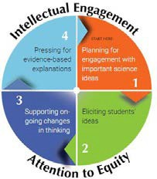
NGSS abbreviations: PE=Performance Expectation; DCI = Disciplinary Core idea; CCC = Cross-Cutting Concept; SEP = Science & Engineering Practice

CIRCUITS UNIT OVERVIEW – 4TH GRADE
Initial Models for 4th Grade Circuits Unit – Eliciting Student Ideas (Lesson 1)
Begin by eliciting students initial ideas about a circuit system. This pairing of lessons will take 2 or 3 class sessions but provides students with an initial hands-on experience that helps them develop their models and enough time to add to their models to explain not just what happens but how/why they think it happens.

Activity/Lesson Observations Learning Connectiontoflashlight
phenomenon
Next Generation Science Standards (NGSS)

Lesson 1, Part 1

Four ways to make a light bulb circuit work (or not)
Students will draw and label 4 different ways to light up a bulb using a battery, wire, and bulb. Also draw 4 ways that don’t work.
Where parts must be touching to make it work (or not work); Circuits can be made in different ways as long as parts touch in a complete pathway
Hands-on “observation-level” experience of making a flashlight sets them up for making initial model of what’s happening inside the circuit they can’t see that is making it work. Also they’ve thought about reasons for why the failed circuits don’t work which is
PE: 4-PS3-2.Make observations to provide evidence that energy can be transferred from place to place by sound, light, heat, and electric currents.

DCI: PS3.D: Energy in Chemical Processes and

Lesson 1, Part 2

Creating initial models
As a closing, with students, create a public record of these observations and learning that students can refer to in part 2 when they develop their models.

Using observations from part 1, students are asked to explain the causes behind what they observe: Why does the bulb light up? What might keep it from working? What’s happening inside the battery, wire, and bulb that we can’t observe/see but we think might be happening? Having physical materials available helps students explain ideas to each other before putting them on paper.

Create a public record of students’ hypotheses about what makes the flashlight stop working when it’s accidentally left on. This could be done before working on models to get them started thinking and added to after they make their models OR can be
created after making their models to capture the 5-6 major hypotheses
productive in adding to their model about why a flashlight would stop working after being left on.

This initial model shows students’ current thinking about the observable and unobservable parts of a simple circuit and their initial causal explanations about why a flashlight would stop working after being left turned on.

Students may say the battery “died” or “lost energy” and/or that the bulb “broke” or “went out”. Prompt students to say, write, and draw about how they think these events happen

not just identify
that they happen.
Everyday Life - The expression “produce energy” typically refers to the conversion of stored energy into a desired form for practical use. (4-PS3-4)

CCC: Energy and Matter Energy can be transferred in various ways and between objects.

SEP: Developing and Using Models Modeling in 3–5 builds on K–2 experiences and progresses to building and revising simple models and using models to represent events. Develop a model to describe phenomena. (4-PS4-2)

NGSS abbreviations: PE=Performance Expectation; DCI = Disciplinary Core idea; CCC = Cross-Cutting Concept; SEP = Science & Engineering Practice

Summary Table of Planned Activities – Attending to On-Going Changes in Student Thinking
These activities do not have to be taught in this order, though this order does show one possible pathway through the unit. Respond to students’ ideas/questions to make instructional decisions. Additional lessons may be added at the teacher’s discretion to address student questions/ideas. Decide when to have students do a mid- point model revision with evidence from activities they’ve completed so far. In the proposed unit pathway, students do model revisions during lesson 5 but could be move after the conductors and insulators activity happening between lessons 6 and 7 instead.
 | Lesson | Observations | Learning | Phenomenon Connection | NGSS
Batteries & Chemical Energy | Lesson 2 Building a Battery (investigation) | - Pattern of zinc, copper, and vinegar-soaked paper must be in the right order to work  - Wire ends from LED must touch either end of our stack to work  - More “sandwiches” make the LED brighter. (It won’t light up with less than 4.) | - There are metals like zinc and copper and also acid (vinegar or lemon juice) inside a battery. This combo makes it work (somehow).  - Batteries are made of multiple cells (each “sandwich” is a cell to make a whole battery – the more cells the more power) | - The flashlight battery is likely has metals an acids inside  - The flashlight stops working if the battery dies.  - It might die because the acid dried up - Like our battery didn’t work if it wasn’t wet enough with acid. | PE: 4-PS3-2. Make observations to provide evidence that energy can be transferred from place to place by sound, light, heat, and electric currents.  SEP: Carrying Out Investigations  - Make observations to produce data to serve as the basis for evidence for an explanation of a phenomenon  DCI: PS3.A: Definitions of Energy - Energy can be moved from place to place by electric currents.  DCI: PS3.D: Energy in Chemical Processes and Everyday Life - The expression “produce energy” typically refers to the conversion of stored energy into a desired form for practical use.  DCI: PS3.B: Conservation of Energy and Energy Transfer - Energy can also be transferred from place to place by electric currents, which can then be used locally to produce heat and/or light.
 | Lesson 3 Learning about Chemical Energy (readings & video) | - Mixing baking soda and vinegar is a chemical reaction  - It went fast and bubbled  - It eventually stopped | - “Batteries” as we commonly use the word are actually just one cell (D-Cell, AA-cell, etc.) but has metals and acids inside.  - Chemicals store energy.  - Batteries have different strengths measured in volts. Most battery cells we use (AA, AAA, D) are 1.5 volts. A car battery is 12 volts. | The battery in the flashlight stores chemical energy (because of the chemicals inside it like metals and acids).
 | Lesson 4  How do multiple batteries affect the brightness of a bulb? (investigation) | - Using the brightness meter,  we observed a pattern that as more D-Cells were added to the circuit the light bulb increased in brightness.  - For example, 1 D-cell had a brightness of 4 but 5 D-cells had a brightness of 12. (8 D- cells made the light bulb “pop” and break). | - Light bulbs have a limit to how  much power (volts) they can “take” before they break.  - More power causes more brightness  - More power means more chem. energy | The flashlight might go out  because it doesn’t have enough power left in the battery light up the bulb.  (Possible student question: Where does the power go? How does it “get out” of the battery?)
 | Additional lessons may be added if students have questions about how batteries discharge, re-charge, and are made. You could decide to insert these lessons here or wait until after students learn more about conductors/insulators, electrons and light bulbs before revisiting batteries to have richer discussions once students have more info.

NGSS abbreviations: PE=Performance Expectation; DCI = Disciplinary Core idea; CCC = Cross-Cutting Concept; SEP = Science & Engineering Practice

 | Lesson | Observations | Learning | Phenomenon Connection | NGSS
Conductors, Electrons , Electrical Energy | Lesson 6 Conductor or insulator? Testing materials | - Metals such as coins, paperclips, and foil make the circuit work(light turns on)  - Plastic and glass do not make the circuit work (light bulb does not turn on) | - Conductors allow electric current to pass through them. Metals are conductors because they let current flow through them.  - Non-conductors (also called insulators) block or stop electric current. Plastic and glass are Non  Conductors | A flashlight case can be made of metal or plastic. If made of metal it is important not to have it touch exposed parts of the flashlight circuit or it might short circuit. Plastic makes a better case because it’s light-weight,  cheap. and a non-conductor. | PE: 4-PS3-2.Make observations to provide evidence that energy can be transferred from place to place by electric currents.  DCI: PS3.A: Definitions of Energy Energy can be moved from place to place by electric currents.  SEP: Asking Questions.- Ask questions that can be investigated and predict reasonable outcomes based on patterns such as cause and effect relationships.  CC: Energy and Matter  Energy can be transferred in various ways and between objects.
 | Lesson 6 (continued) Why do some materials conduct electricity? | - Electrons bump to move or transfer energy (like when we bumped in the circle, the energy moved around but we – the electrons – did not)  - Metals have one free electron to bump around and hop from one atom to another which is why the current can flow through them.  - Non-conductors (insulators) do not have any free electrons so there is no bumping or moving current so they do not conduct electrical energy |  | Electrons are in everything, all materials. Materials like the wire and the filament are made of metal so they let current go through them because there are free electrons to bump and move/transfer the energy.
Heat & Light Energy | Lesson 7 Looking inside a light bulb | - There are 2 thick wires going up to support a curly wire  - There is a glass, plastic. or glue-like thing between the two thick wires  - One thick wire (support wire) connects to the base of the bulb the other (support wire) is connected to the metal ring (This explains why you must touch the  bottom of the base and the side of the base) | The lightbulb has a system of parts that work together to make the lightbulb work. If one part is disconnected or breaks it won’t work. (Students hypothesize about what might cause a part of the bulb to break or stop working - i.e. filament gets too hot and pops) | The flashlight lightbulb has the same parts as the big bulbs we observed. Similarly if any of these parts stopped working or became disconnected then the flashlight would stop working. | DCI: PS3.A: Definitions of Energy Energy can be moved from place to place by electric currents. (4-PS3- 2),(4-PS3-3)  DCI: PS3.B: Conservation of Energy and Energy Transfer - Energy can also be transferred from place to place by electric currents, which can then be used locally to produce heat and/or light.  SEP: Asking Questions.- Ask questions that can be investigated and predict reasonable outcomes based on patterns such as cause and effect relationships.  CC: Energy and Matter  Energy can be transferred in various ways and between objects
 | Lesson 8 Making a filament | - The filament glows and gives off heat when the bulb is on  - The filament is made of tightly coiled wires of tungsten | The filament glows which transforms or changes the electrical energy in the wires into light and heat energy.  Students may know about how/why this works using knowledge of electrons and friction) | The flashlight lightbulb has a filament, much smaller than the one in the large bulb. Students may hypothesize smaller filaments break more easily than big ones because of size

NGSS abbreviations: PE=Performance Expectation; DCI = Disciplinary Core idea; CCC = Cross-Cutting Concept; SEP = Science & Engineering Practice

Final Models & Pressing for Evidence-Based Explanations of the Flashlight Phenomenon
Lesson | Description of Task | Connection to  phenomenon | NGSS
Lesson 9 Telling the Energy Story in a Flashlight Circuit and Revising Models | Students synthesize what they’ve learned about batteries, wires, and light bulbs to explain how the electric current flows in a closed circuit system, what energy transformations happen and where they think they happen within the circuit system. Students include a diagram as well as writing to explain their claims and evidence. | Students use specific evidence from individual activities to justify additions or revisions to their model in order to explain the flashlight phenomenon. | CC: Energy and Matter  Energy can be transferred in various ways and between objects.  SEP: Developing and Using Models Modeling in 3–5 builds on K–2 experiences and progresses to building and revising simple models and using models to represent events. Develop a model to describe phenomena. (4-PS4- 2)  SEP: Constructing Explanations  Use evidence (e.g., measurements, observations, patterns) to construct an explanation.
Lesson 10 Writing the Evidence-Based Explanation for the flashlight  phenomenon | Students use sentence frames to connect evidence from activities to their claims about why a flashlight would stop working. Written explanation will attend to different parts of the circuit as well as how the system functions as a whole.
Engineering Task: Using Circuits to Communicate
Lesson | Description of Task | NGSS
Lesson 11 How do switches work? | Students will create a switch to easily turn the circuit on and off using what they know about conductors and insulators which they will need to use in lesson 12. | SEP: Constructing Explanations and Designing Solutions Apply scientific ideas to solve design problems  DCI PS3.B: Conservation of Energy and Energy Transfer - Energy can be transferred from place to place by electric currents, which can then be used locally to produce motion, sound, heat, or light. The currents may have been produced to begin with by transforming the energy of motion into electrical energy.  CCC Energy and Matter - Energy can be transferred in various ways and between objects
 | Students apply what they’ve learned about circuits to create a device that allows for communication over distances.  - Students learn about ways to transfer information across distances (such as Morse code using light or sounds).  - Students design and build a circuit and communicate messages to their peers using an established code or a system they create.  - Students compare their solutions and provide feedback. | PE 4-PS4-3. Generate and compare multiple solutions that use patterns to transfer information.
Lesson 12 Using circuits to |  | [Clarification Statement: Examples of solutions could include drums sending coded information through sound waves, using a grid of 1’s and 0’s representing black and white to send information about a picture, and using Morse code to send text.]  SEP Constructing Explanations and Designing Solutions - Generate and compare multiple solutions
communicate |  | to a problem based on how well they meet the criteria and constraints of the design solution DCI PS4.C: Information Technologies and Instrumentation - Digitized information can be
 |  | transmitted over long distances without significant degradation. High-tech devices, such as
 |  | computers or cell phones, can receive and decode information—convert it from digitized form to
 |  | voice—and vice versa. (4-PS4-3)
 |  | DCI ETS1.C: Optimizing The Design Solution - Different solutions need to be tested in order to
 |  | determine which of them best solves the problem, given the criteria and the constraints. (4-PS4-3)
 |  | CCC - Patterns of change can be used to make predictions

(This page intentionally left blank.)

Circuits Unit Overview 18 4th Grade Circuits
© 2015, AmbitiousScienceTeaching.org

Curriculum Guide
Lessons & Activity Guides

Ambitious Science Teaching Framework

This curriculum guide follows the four core teaching practices of the Ambitious Science Teaching Framework. This model- based inquiry approach to science teaching leverages students’ existing personal experiences and current understanding about causal mechanisms in their world to revise their own explanations of specific, contextualized scientific phenomena.

Except where otherwise noted, this work by Tools for Ambitious Science Teaching, University of Washington, is available under
a Creative Commons Attribution-NonCommercial International 4.0 License. All logos and trademarks are property of their respective owners. Images in this work are used with permission and not included in the open license.

Lesson 1: Developing Models to Explain the Flashlight Phenomenon

This lesson introduces students to the new unit about circuits allowing them to make connections to their prior experiences with battery-powered devices (i.e. cell phones, tablets, toys, etc.) by creating a simple circuit and explaining why they think a circuit works and why it might would stop working.

OBJECTIVES & OVERVIEW
  - Students share observations about the circuits they create.
  - Students develop models to explain what might cause a flashlight to stop working.

CONNECTION TO KIT


See Lesson 2: What can electricity do? Pgs 7-13
NOTE: Students do NOT need to learn the vocabulary in figure 2-2 on pg 8 at this time.

NEXT GENERATION SCIENCE STANDARDS (NGSS)
4-PS3-2. Make observations to provide evidence that energy can be transferred from place to place by sound, light, heat, and electric currents.
Science and Engineering Practices (SEP):  Developing models - Collaboratively develop and/or revise a model based on evidence that shows the relationships among variables | Disciplinary Core Ideas (DCI):  PS3.A: Definitions of Energy - Energy can be moved from place to place by moving objects or through sound, light, or electric currents. (4-PS3-2)  PS3.B: Conservation of Energy and Energy Transfer - Energy is present whenever there are moving objects, sound, light, or heat. Energy can also be transferred from place to place by electric currents, which can then be used locally to produce motion, sound, heat, or light. PS3.D: Energy in Chemical Processes and Everyday Life - The expression “produce energy” typically refers to the conversion of stored energy into a desired form for practical use | Cross-Cutting Concepts (CCC):  Cause and Effect – Mechanism and explanation. Events have causes, sometimes simple, sometimes multifaceted. A major activity of science is investigating and explaining causal relationships and the mechanisms by which they are mediated. Such mechanisms can then be tested across given contexts and used to predict and explain events in new contexts.  Energyand Matter - Energy can be transferred in various ways  and between objects

Part 1

MATERIALS
For the class demonstration:
  - Battery-operated item (flashlight, board game, cell phone, etc.)
Per student:
- 1 wire, D-cell, small light bulb
- Science notebook
- Colored pencils (optional)
Part 2
For the class demonstration:
- 1 large flashlight Per student:
- 1 wire, D-cell, small light bulb Per individual (or partner):
- 1 model scaffold
- Colored pencils (optional)

Part 1 of 2 (45 minutes)

PROCEDURE

Introduce the lesson: Whole Group
- Gather students on carpet area and show them the battery-powered item such as a cell phone, hand-held game device, board game like Operation, etc.)
- Tell students to make some observations about the device. Show them how the item works (don’t say anything verbally), just show turning it on and off). Think-Pair-Share with a partner about these questions:
What do you see or hear happening? What does this item need to work properly?
- Explain that in this upcoming science unit we will be learning more about how circuits work like this [insert name of item used in step 2 here] and in our emergency bucket flashlight (hold up emergency flashlight and turn in on and off).

Circuit-making task: Individuals or Partners
Back-Pocket Questions

Reminder:
- I see you found a way that did/didn’t work.
Remember to sketch it in your notebook.
Observations:
- I see you got it to light up. How did you have to have the pieces arranged to make it work?
Hypothesis:
- What do you think makes the bulb light up?
- Why do some ways not work and others do?
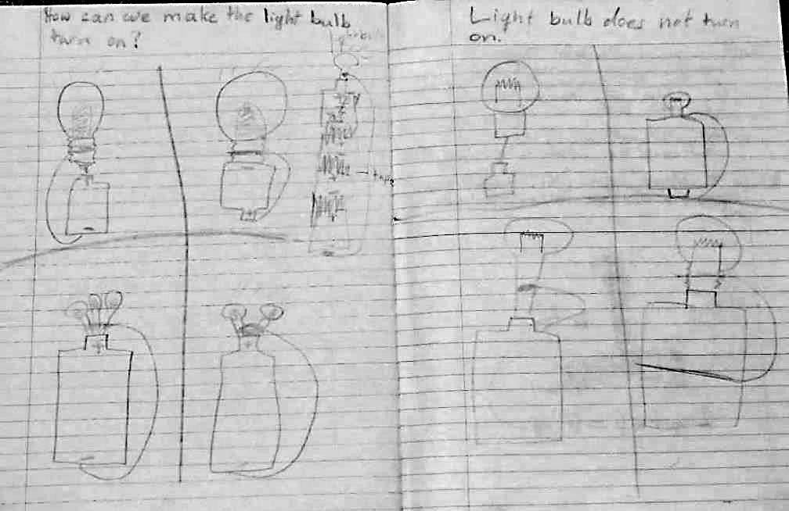 |  | SAFETY ALERT!    If materials begin to feel hot or warm, put down the materials and disconnect the pieces.  This happens when students make a short circuit by connecting the wire to both ends of the battery with no bulb connected.

- Tell students that they will each have a small wire, battery, and a light bulb. Their challenge is to come up with 4 different ways to put these items together to make the bulb light up and also 4 ways that do not work. Draw these in the science notebook.
- Have students gather materials and begin.
- As students work, circulate to observe and encourage them to help each other. Questions you could ask students as they work are suggested in the box at right.
- As you circulate, select 2-3 students to share one of their sketches and explain what they did to make it work (or not). Near the end of the exploration time, prepare them to share under the document camera by telling them which part you want them to explain or describe.
Here is a photo of what a student’s notebook might look like at the end of this circuit explorationtask. This student combined materials with othersatthe tablegroup and also noticed that multiple batteries made the bulb brighter and one battery could light up multiple bulbs but they were dimmer.

Making a List of Observations: Whole Class
- Have 2-3 students share one of the ways they found that the circuit worked or did not work. Ask other students if they found these ways or similar ways. Invite other students to ask question or comment on different configurations that work or ways that do not work
- Create a class chart with at least 4 different ways that work (using just one wire, bulb, and battery), and 4 ways that do not work.
- Capture students’ observations on a public chart about how to make the bulb light up at the bottom of the chart. Questions to use during this part of the lesson:
  - What do we notice about all the ways we found that make the bulb light up? [Possible responses: both ends of the battery are touched by something metal; it’s connected in a circle, all metal things are touching, the metal thing at the bottom of the light bulb has 2 places that have to be connected: the bottom and screw part]
  - What do we notice about the ways we found out that didn’t work? [Possible responses: it was in a line, it wasn’t connected to both ends of the battery, it wasn’t connected to the side and bottom of the metal thing on the light bulb]

The photo below shows a student reviewing ways the class found to light up a bulb using just one wire, one battery, and one bulb.
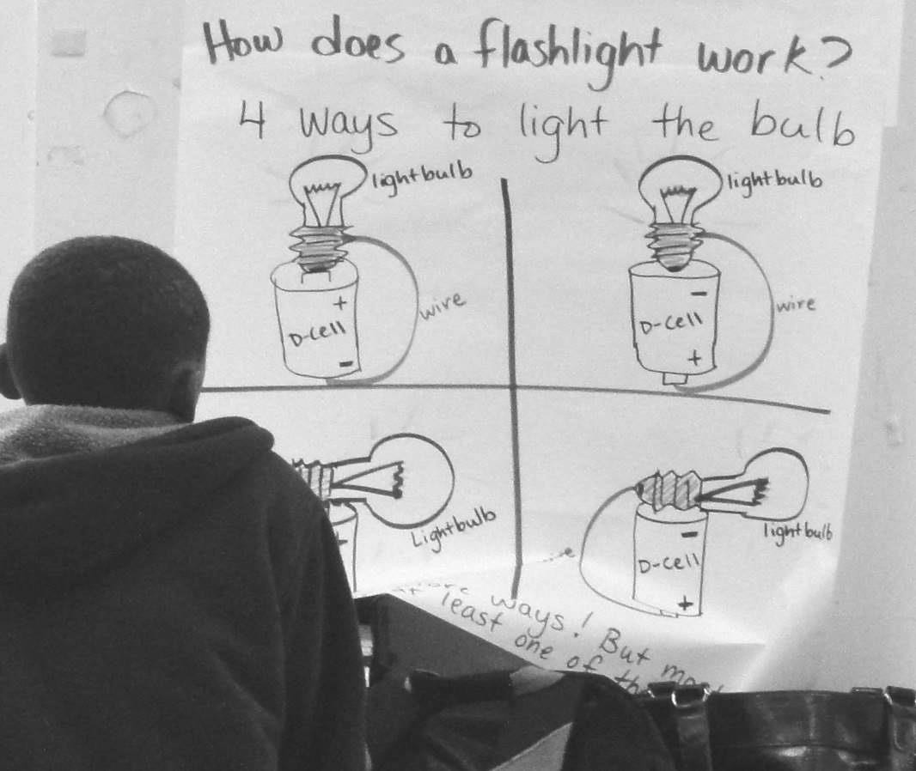

Science vocabulary note: At the end of this part of the lesson, introduce the word ‘circuit.’ Tell students that today they each made a circuit that lit up a light bulb. Circuits can do lots of different things but for the next few weeks we are focusing on circuits that are designed to give us light. (In future lessons it may be useful to create a chart with characteristics of circuits but it is not necessary or advised at this point in the unit.)

Part 2 of 2 (45 minutes)

Introduce the phenomenon: Whole Group
- Take out the large flashlight and show it to the class. Tell the following story: Explain that one day you shoved it away (in a cabinet or drawer) and it was accidentally left on. The next time you went to use it, it didn’t work. You turned the switch on and off and nothing! Have students think-pair-share about what they think could have happened to make the flashlight stop working properly. They may make connections to experiences they’ve had where some battery-operated device stopped working. Questions to ask:
  - What are all the possible reasons that this flashlight would stop working?
  - 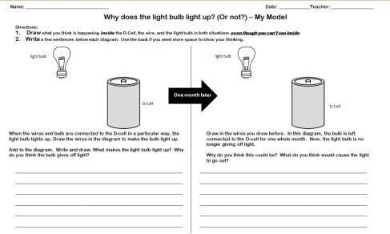What would cause that to happen?

Model Scaffold - Copy on ledger paper 11"x17"
- Introduce the model scaffold sheet (see right). Tell students that they will have all this space to draw and write first on the left side about how a flashlight works and then what happened that a month later the same flashlight would stop working on the right side. Emphasize the following:
  - Students can redraw and cross out any parts of the pre-drawn drawing they don’t like or find confusing.
  - Include observations. Remember what we did yesterday. How do the wire, battery, and bulb touch to light up the bulb? (This goes on the left half of the paper).
  - Include what you think is happening inside the parts of the circuit. Pretend you can see inside the battery, inside the wire, inside the light bulb – what might be going on in there to make a flashlight work (left side)? or not work (right side)?
  - Allow students access to the materials they used in part 1 at their table groups so long as they aren’t distracting to others in order to check their ideas as needed.

Students develop their own models: Individual Work
- Each student gets a model scaffold sheet and

Back Pocket Questions

begins to write and draw about how and why they think a flashlight works and what might happen that we can’t see that would make it stop working. You could encourage partner talk, it does not need to be silent.
- As you circulate, look at student drawing and writing and ask for clarification if something isn’t labeled or explained. Have them add their response to the drawing or writing on their model.
  - If students are having difficulty drawing the parts refer them to the chart from yesterday, the materials themselves, or the drawings in their notebooks.
  - If students are drawing and writing about their ideas about the unobservable parts of what could be going on, try some of the back-pocket question suggestions at right.
Prompts if nothing is on the drawing:
- Where does the wire and bulb need to be drawn so the bulb lights up?

- What might be going on inside the battery/wire/bulbthat wecan’tseeto make it work? or stop working?

Examples of ways to respond to student ideas:
- I see you drew inside the battery.
What happens to that when the flashlight stops working? Where does it go?

- You said the battery makes the bulb light up. How does it do that?

- I see you showed that curly part of the lightbulb is broken. What might have happened to make that break?

- As students work, look for different ways students represent what’s inside the battery, wire, and light bulb. Prepare students to share out these ideas in the next part of the lesson to generate a list of hypotheses about what is going on that we can’t see that could cause the flashlight to stop working.
- During this time students can talk to each other and the teacher about their thinking, but each student records their individual thinking on their own paper.

Listing Hypotheses & Questions: Whole group
Why would a flashlight stop working?
Our initial ideas

- The switch was left on so the battery drained and there isn’t enough left to turn on (it might flicker or get lower and lower light)

- The battery ran out of energy, got low on juice, used up its “energy ball”, lost its fuel (like a car)

- bulb broke because it overheated

- bulb broke because I could have slammed the drawer too hard

- something got disconnected because I slammed the drawer shut too hard

- there are electric cells in the wire that move the energy around and maybe they ran out through the light bulb
- Have students you’ve selected share one piece of their model. Have students compare and share the different ways they are representing what they think is going on inside the battery, wire, and bulb.
- After a few students share and engage in some student-to-student talk about these ideas create a list of initial hypotheses about what might go wrong that makes the circuit stop working. (The list at right is an example of what this list might look like.)
- This list should be revised over time after students engage with investigations so leave space around or between the ideas for changes later.
- Create a list of questions – this can be done as a whole group or have students write questions on sticky notes and stick them on a ‘Questions’ chart. These questions and students’ initial ideas will help guide how the unit unfolds.

EXAMINING STUDENT WORK

  - Use a Rapid Survey of Student Thinking to take notes about students’ ideas looking across your class set of models. Pay careful attention to partial and alternative ideas students have that could be related to energy transfer and transformation. The next few pages show some examples of student work from this initial model lesson to give you a sense of what kinds of ideas your students may bring up and represent.

  - Save the set of students’ initial models as a formative assessment. Use the models to fill out the What-How-Why Levels of Explanation trackers. When students do model revisions and final models later in the unit both you and they can identify how their thinking has changed and students can justify why they want to revise particular ideas.

The summary table of activities in the unit is in 3 chunks: batteries, wire, lightbulb. This order presented in the overview and summary table would be fine to follow and students are likely most curious about what’s happening inside a battery so that may be a good place to start. You could elect to change the order or add in additional lesson(s) if your students have other questions about circuits.

PLANNING NEXT STEPS

RECOMMENDED LESSON EXTENSION
See kit guide Lesson 3: A Closer Look at Circuits (pgs15-19) if you can give students more hands-on time with the wire, bulb, and d-cell. Pass out copies of activity sheet 1 on pg 19 and circuit materials. Have students use materials to follow each drawing to see if each configuration will turn the bulb on or off. This does not need to be a whole-group lesson. It could also be at a science station or during a shorter science block (about 20 minutes).

4th/5th Grade Circuits Unit – Initial Model Example– Student A
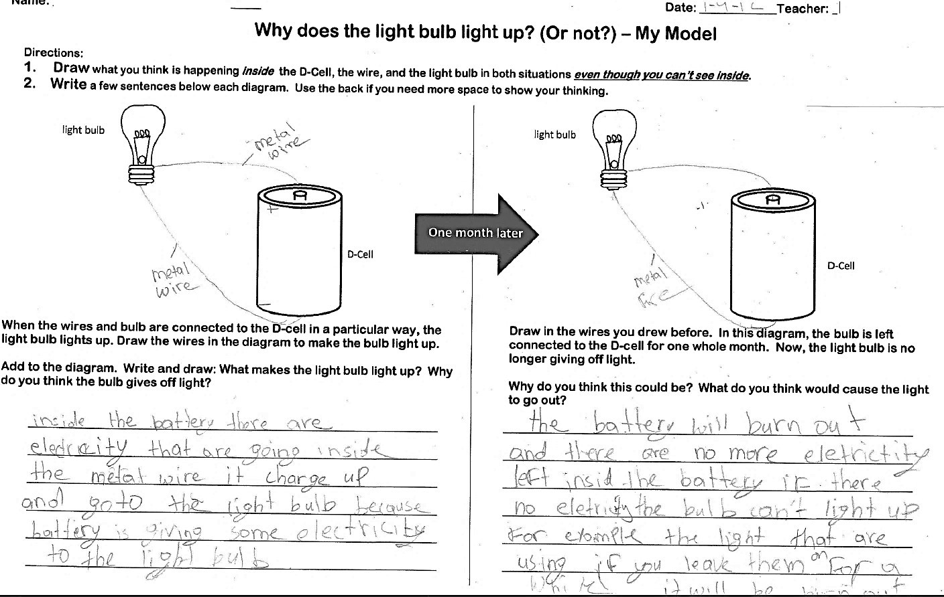

4th/5th Grade Circuits Unit – Initial Model Example– Student B
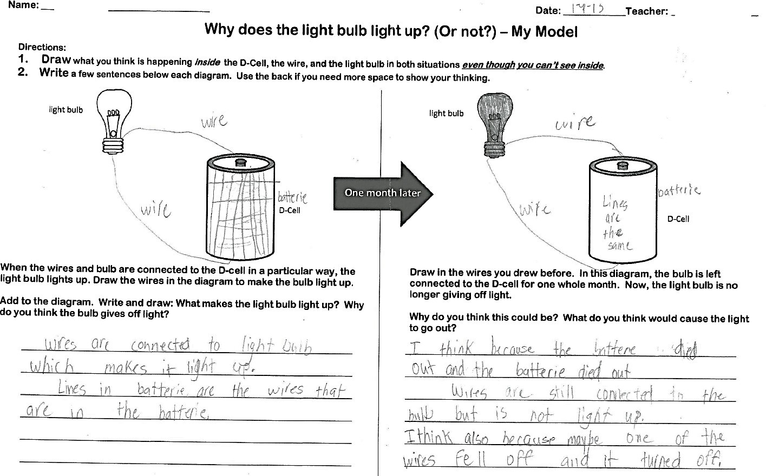

4th/5th Grade Circuits Unit – Initial Model Example– Student C
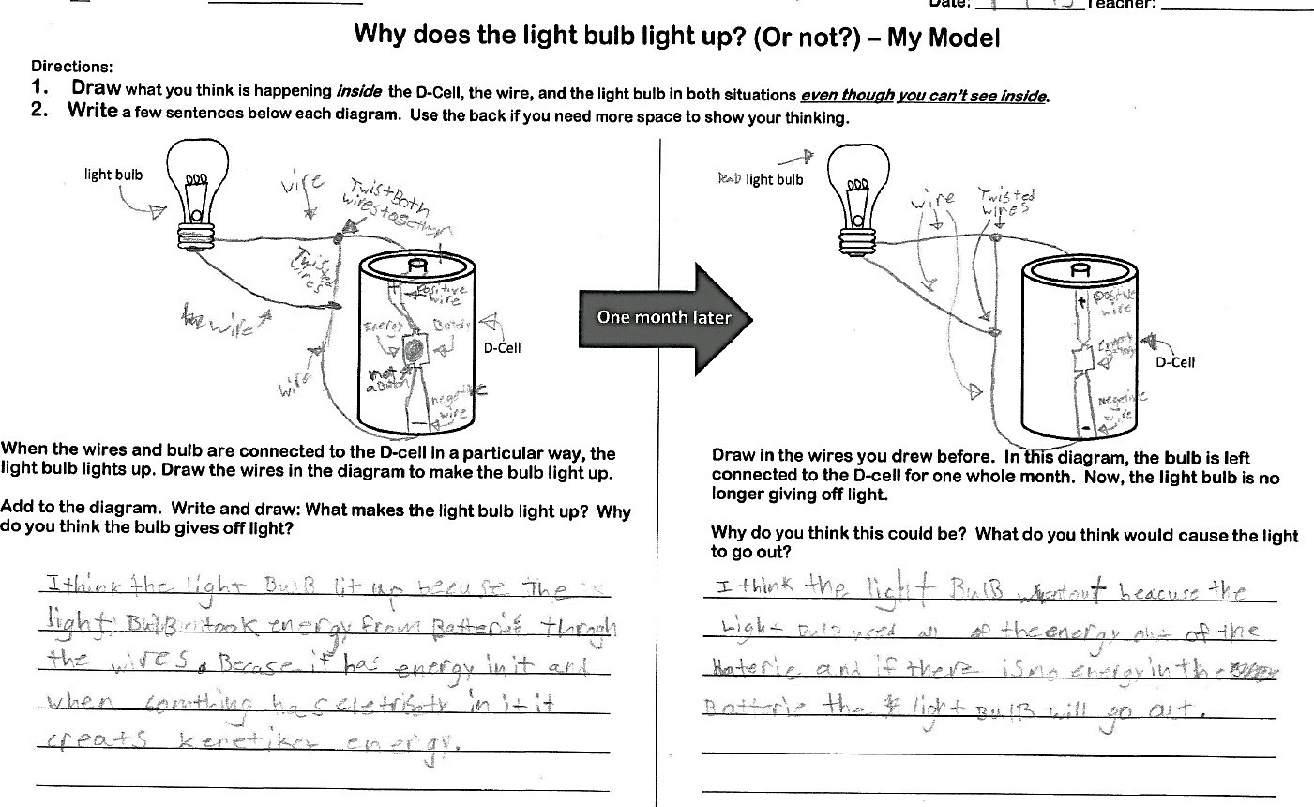

4th/5th Grade Circuits Unit – Initial Model Example– Student D
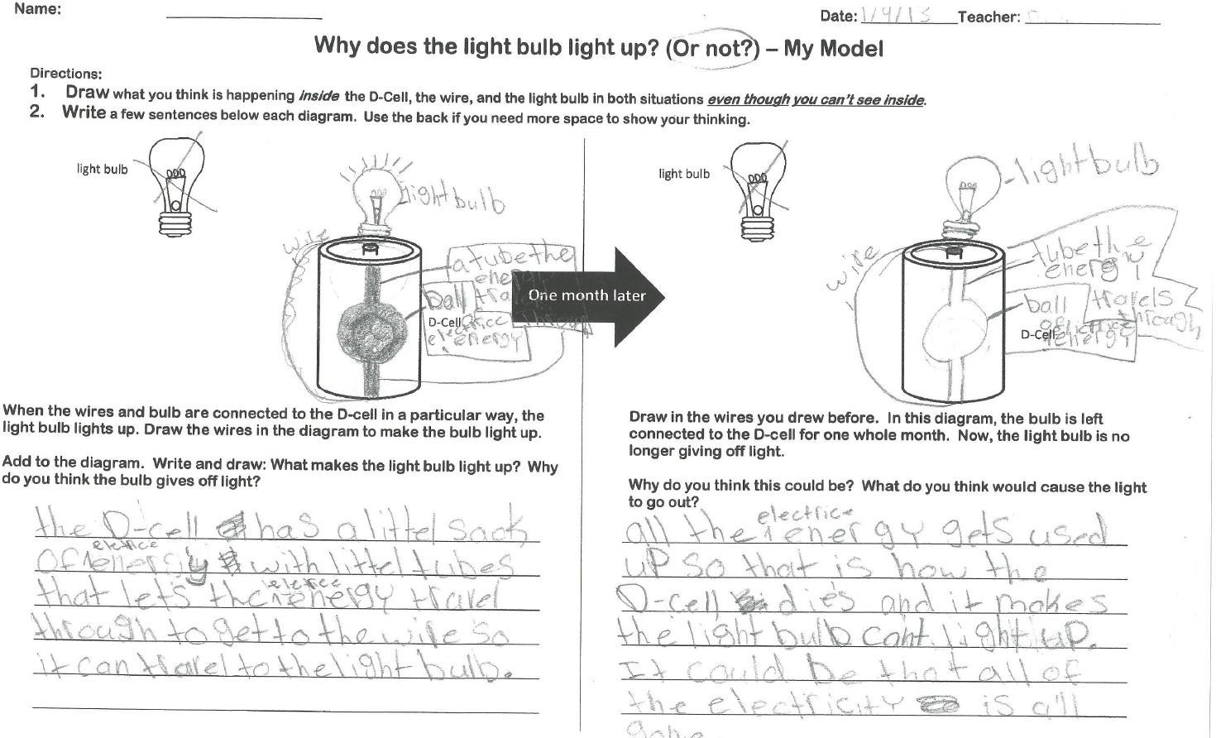

4th/5th Grade Circuits Unit – Initial Model Example– Student E
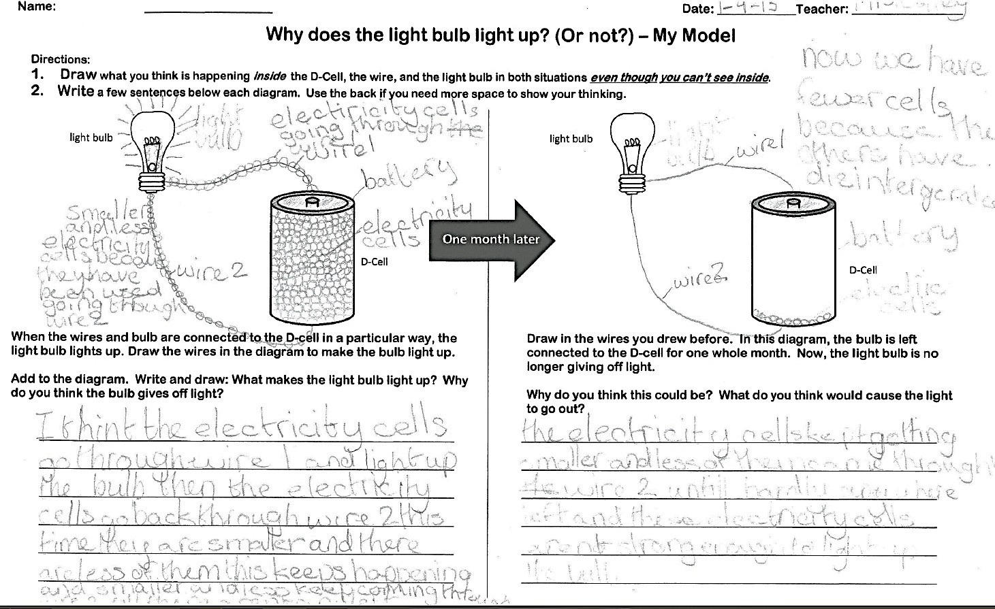

(This page intentionally left blank.)

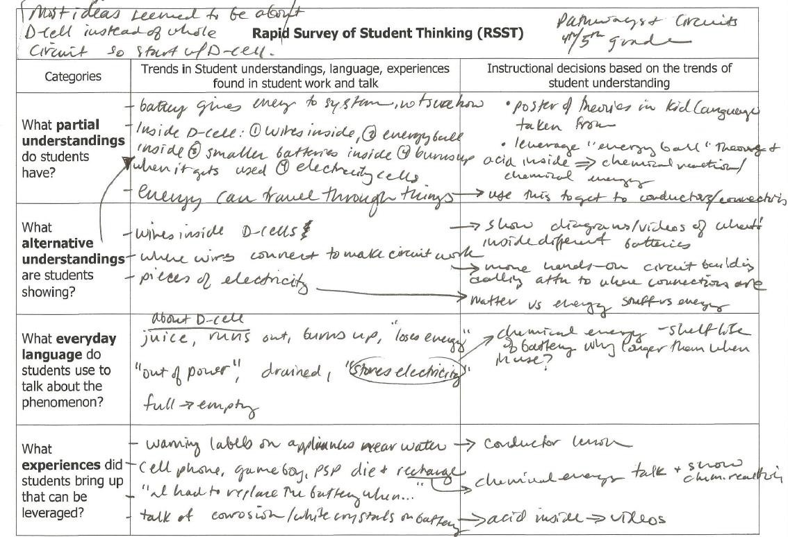
Example Rapid Survey of Student Thinking (RSST) from a 4th/5thgrade class using data from student models and classroom talk

(This page intentionally left blank.)

Rapid Survey of Student Thinking (RSST)
Categories | Trends in student understanding, language, experiences found in student work and talk | Instructional decisions based on trends on student understanding. How do student ideas, experiences, and language connect to upcoming lessons?
What partial understandings do students have?
What alternative understandings are students showing?
What everyday language do students use to talk about the phenomenon?
What experiences did students bring up that can be leveraged?

(This page intentionally left blank.)

Lesson 2: Making a Simple Battery

OBJECTIVES & OVERVIEW
This lesson is the first in a series to help students better understand what’s going on inside a battery that we cannot directly observe. Many students’ initial models may have shown something inside a battery and how it might change over time. In this lesson, students will create a voltaic pile (small, simple battery cell) to light an LED.
    - Students share observations about the voltaic pile (battery cell) that stores chemical energy.
    - Students begin to make generalizations about what all batteries likely have inside that makes them work (and hypothesize about what might happen to make it stop working).

NEXT GENERATION SCIENCE STANDARDS (NGSS)
4-PS3-2. Make observations to provide evidence that energy can be transferred from place to place by sound, light, heat, and electric currents.
4-PS3-4. Apply scientific ideas to design, test, and refine a device that converts energy from one form to another
Science and Engineering Practices (SEP):  Planning and Carrying Out Investigations  Make observations to produce data to serve as the basis for evidence for  an explanation of a phenomenon [phenomenon in this lesson: how a battery works] | Disciplinary Core Ideas (DCI):  PS3.A: Definitions of Energy - Energy can be moved from place to place by moving objects or through sound, light, or electric currents. (4- PS3-2)  PS3.D: Energy in Chemical Processes and Everyday Life - The expression “produce energy” typically refers to the conversion of stored energy into a desired form for practical use | Cross-Cutting Concepts (CCC): Cause and Effect – Mechanism and explanation. Events have causes, sometimes simple, sometimes multifaceted. A major activity of science is investigating and explaining causal relationships and the mechanisms by which they are mediated. Such mechanisms can then be tested across given contexts and used to predict and explain events in new contexts.  Energy and Matter - Energy can be transferred in various ways and between objects

MATERIALS

For the class demonstration: 1 lemon clock kit
1 lemon Per pair of students:
Direction for making a voltaic pile 5 zinc washers
5 copper pennies (pre-1984) 5 small squares of white paper
1 LED holiday light with stripped ends Small cup of vinegar
Science notebook and pencil Disposable gloves (optional)
Required materials that may not be in kit:
- 1 lemon
- Small bottle of vinegar or lemon juice
- Squares of paper(5 perpair)
- pre-1984 pennies (5 per pair)
- Paper towels

PROCEDURE

Prior to the lesson: Reread the teacher background knowledge at the beginning of this unit guide about what is going on inside a battery.

Introduce the lesson: Whole Group
- Gather students on carpet area.
- Show them some student models from lesson 1 that show a variety of ideas about what might be going on inside the battery that we can’t see. (See below of samples from 4th graders, select models from your students.) Today students will be learning more about what might be going on inside the battery to make it work.

Focal Question: What is inside a simple battery?
- Show students a lemon clock and name the parts of the clock to introduce vocabulary like acid (lemon juice) and metals (copper and zinc- the same metals students are using today.
- Explain that today they will follow a simple recipe to make a simple battery. Show students the direction card and what materials look like briefly. If desired, you can make one ahead of time and show students what it looks like and that it will light the LED. Provide the safety alert about vinegar as a weak acid.

SAFETY ALERT!

Vinegar (or lemon juice) is a weak acid. Remind students not to touch their face or eyes during class. Wash hands after the activity.

Examples of 4thgrade student models zoomed-in on what they think might be going on inside the battery. Showing some student examples to launch this lesson sets a purpose for why students are building a battery – to see if it is similar or different than our ideas and what can we learn from this to add to our understanding.
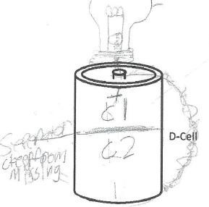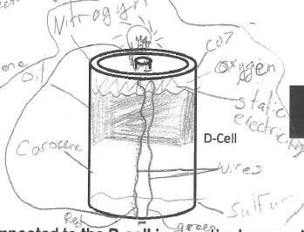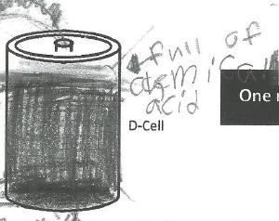

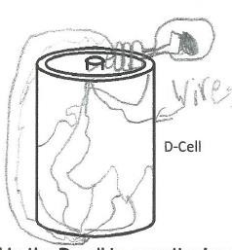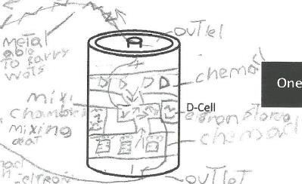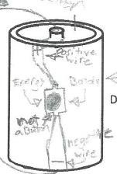

Making-the-battery task: In Partners
Back-Pocket Questions

Observations:
What did the stack have to look like in order to work? What are the materials that make up our battery?

Hypotheses:
What happens if the paper is too dry? Why do you think the vinegar is important?
What happens if the stack is out-of-order? Why do you think that matters?
- Have partners follow the directions on the student directions page to make the battery. Prompt pairs to work together in their groups and help each other if needed. Some common issues that prevent the battery from working:
  - Pattern not followed carefully, double check
  - Papers not saturated, add more acid (vinegar/lemon juice)
  - LED wires need to be reversed on each end the stack
- As students work, circulate and help troubleshoot issues so that all partners can be successful in lighting an LED.
- When students are successful lighting the LED, have students sketch it on the student recording sheet.
- Clean up materials. Rinse off pennies and washers. Wash hands. Throw away vinegar-soaked papers. Return LEDs, rinsed and dried pennies and washers to materials table.

Creating a Summary Table of Activity: Whole Class
- OBSERVATIONS: Reconvene as a whole class and summarize what they just did to make a battery. This can be on a large piece of butcher paper in a row called “Making a Battery” and fill in observation box together.
- Show students the lemon clock again. Ask students to compare the lemon clock and the battery they just made. Students will notice that both have copper-colored and silver-colored metals and some kind of acid (lemon juice or vinegar). Think-Pair-Share:

➔ Based on these two batteries, what might be inside most if not all batteries?
- LEARNING: Add comments from the think-pair-share about what they think is inside the battery to the “Learning” column of the summary table row. This may have a question or two students could add on sticky notes that may be answered in lessons 3 and 4.
- CONNECTION: In our flashlight phenomenon, it stopped working. Think-Pair-Share:

→ Whatmighthave happenedinsidethe batterytomake the batterystop working?
Write some ideas in the summary table under “connection to phenomenon.”

The summary table row below may be similar to what the summary table row looks like from the class discussion. Students may have additional questions about batteries as this is just the first lesson in the series. Have students write Q’s on sticky notes and stick them on the ‘Questions’ chart or on the summary table. Check in with their questions during subsequent lessons to see if we have answers yet.

Name of Activity | Observations | What have we learned so far? | Connection to Phenomenon
Making a Simple Battery  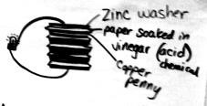 | - Our battery had acid (vinegar) and metals (zinc, copper)  - We had to follow a pattern to make it work  - It had to have enough acid (vinegar) to work | Both our battery and the lemon clock used acids and metals  Do all batteries have acids and metals? | The flashlight stops working if the battery died.  It might die because the acid dried up - Like our battery didn’t work if it wasn’t wet enough with acid.

Science vocabulary note: Students should now be familiar with (but not yet fully proficient with) the following terms: circuit, battery, acid, metals

PLANNING NEXT STEPS
    - Reflect on students’ ideas, experiences, and questions you heard in class about what students brought up about what they know about batteries as they were making one. Note questions you heard them ask and look ahead in the unit guide to see if they will find answers in upcoming lessons. You may decide to add in an additional lesson about chemical energy or batteries to help students answer their questions.
    - Revisit ideas pertaining to energy and what’s going on inside the battery in the teacher background at the beginning of this unit guide.

READING CONNECTION

A short reading is included in this lesson about the first batteries. Read it as a class or have students read it on their own and compare what the reading says about the parts that make up a battery and the ‘recipe’ we used – what’s similar? What’s different? What questions do they have?

After reading this, some students may want to try a battery submerging the metal pattern/stack into an acid instead of using the acid-soaked papers. This is something they could try in lesson 2b.
READING INTEGRATION

Short reading about the first electric batteries.

Student Directions for Making a Simple Battery

Materials:

- 5 copper pennies
- 5 zinc washers
- 5 squares of paper
- 1 LED light
- Small cup of vinegar
- Eye dropper (optional)
- Paper towels for clean-up
- Disposable gloves (optional) Directions:
  - Use the eye dropper or place paper in cup to soak 1 square of paper with some vinegar.
  - Make a “sandwich” with 1 penny, 1 piece of vinegar-soaked paper, and 1 zinc washer.
  - Repeat steps 1 and 2 until you have 5 “sandwiches.”
  - Next, stack 5 “sandwiches” on a strip of aluminum foil like the drawing below shows.
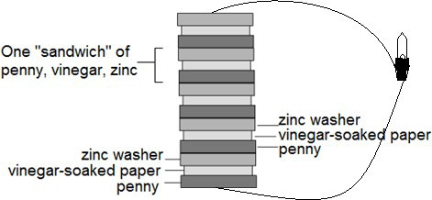
  - Connect the wires of the LED to the top of the stack and the aluminum base.

LED
Light Emitting Diode

Doesn’t work? Try this!

Does the LED light up? Reverse the wires of the LED to opposite sides of the stack.
- Does the LED light up now? If not, double check your pattern of sandwiches.
- Still not working? Add some vinegar to make sure papers are moist.
- Does the LED still not light up? Ask other students to check your stack and see if they have ideas to help it work.

(This page intentionally left blank.)

Name: Date: Build a Simple Battery

    - What are the materials you used to make the battery?

_

    - How many ‘sandwiches’ did you need to make one LED light up?
    - How many ‘sandwiches’ did you need to make two LEDs light up?
    - Sketch and label the circuit you made with your partner:

    - How is your battery similar to the lemon clock?
Our battery and the lemon clock both have… They are similar because…

    - What other materials do you think would work to make the ‘sandwiches’? What other acids or liquids would you want to try?

    - What are you still wondering about how batteries work?
One question I still have about batteries is…

(This page intentionally left blank.)

Student Reading: Batteries of Clay – Read together or copy and cut apart so students can read it and tape it into science notebook/folder.
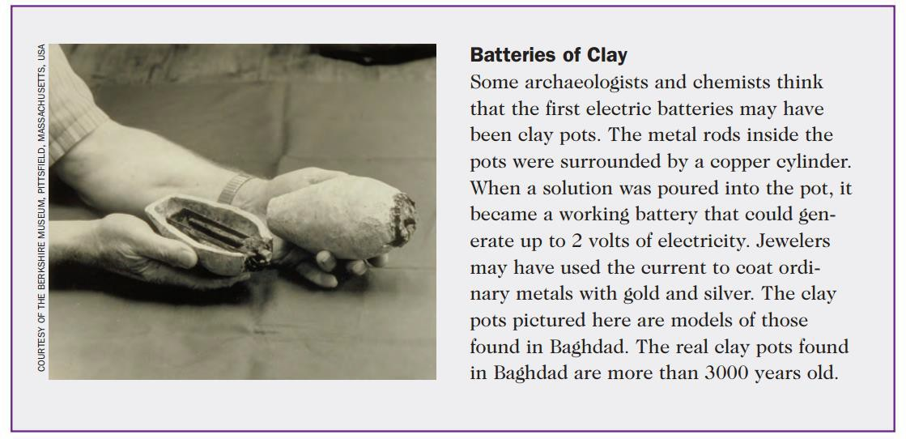



(This page intentionally left blank.)

Lesson 2a: Making a Simple Battery 44 4th Grade Circuits

Lesson 2b: Testing Battery Recipes

OBJECTIVES & OVERVIEW

After lesson 2a, students want to try other materials to make their own battery to light an LED. Things like squares of aluminum foil or other acids (i.e. lemon juice, vinegar, orange juice, salt water, tap water, distilled water). Students can redo the directions in lesson 2a testing other materials or other patterns. Also, students may want to make bigger/taller stacks to see what happens. Students will observe that materials must be in particular repeated patterns, the LED must be hooked up “the right way”, and that materials like plastic and cardboard do not work as a main ingredient. Students may wish to test what would happen if the battery were dried up or if the battery were left connected.
They could also set up and do these tests during this lesson as well.
- Students share observations about the voltaic pile (battery cell) that stores chemical energy.
- Students begin to make generalizations about what all batteries likely have inside that makes them work (and hypothesize about what might happen to make it stop working).

NEXT GENERATION SCIENCE STANDARDS (NGSS)
4-PS3-2. Make observations to provide evidence that energy can be transferred from place to place by sound, light, heat, and electric currents.
4-PS3-4. Apply scientific ideas to design, test, and refine a device that converts energy from one form to
another
Science and Engineering Practices (SEP):  Planning and Carrying Out Investigations  Make observations to produce data to serve as the basis for evidence for  an explanation of a phenomenon [phenomenon in this lesson: how a battery works] | Disciplinary Core Ideas (DCI):  PS3.A: Definitions of Energy - Energy can be moved from place to place by moving objects or through sound, light, or electric currents. (4- PS3-2)  PS3.D: Energy in Chemical Processes and Everyday Life - The expression “produce energy” typically refers to the conversion of stored energy into a desired form for practical use | Cross-Cutting Concepts (CCC): Cause and Effect – Mechanism and explanation. Events have causes, sometimes simple, sometimes multifaceted. A major activity of science is investigating and explaining causal relationships and the mechanisms by which they are mediated. Such mechanisms can then be tested across given contexts and used to predict and explain events in new contexts.  Energy and Matter - Energy can be transferred in various ways and between objects

MATERIALS

Available to students from kit:
Direction for making a voltaic pile 5 zinc washers
5 copper pennies (pre-1984) 5 small squares of white paper
1 LED holiday light with stripped ends Small cup of vinegar
Science notebook and pencil Paper towels
Disposable gloves
Required materials that may not be in kit:
- Liquids students want to test (elicited on student sheet in lesson 2a) see some ideas in lesson directions
- Metals or other materials students may wish to test such as other coins, aluminum foil, plastics, etc.

Lesson 2b: Testing Battery Recipes 45 4th Grade Circuits

Prior to the lesson: Gather (or have students bring) materials they wish to test. If these materials are different than the ones listed below check with your local science specialist to make sure there is no science safety concerns with combining the materials.

PROCEDURE
Possible materials students can use in a new battery:

SAFETY ALERT!

Liquids: lemon juice orange juice salt water tap water

distilled water Gatorade coffee
milk

Solids:
pennies zinc washers
nickels aluminum foil
dimes steel washers
quarters plastic discs cardboard

Only test materials included in the directions. Testing other items could result in toxic combinations and pose a safety hazard.

Making-a-battery: Testing Liquids

- Remind students about the directions card from lesson 2a. Explain that today students can test other materials and liquids following the same sandwich pattern we did yesterday. We will start with testing different liquids in our copper-zinc battery. Focal Question: What liquids work in a copper-zinc battery?

- Decide as a class which liquids they want to test (of the liquids you have ready for them to test). Assign a liquid to each table group or pair depending on the number of liquids they wish to test. Students will each test one new liquid using the same copper-zinc stacks and soaked paper pattern they used before. Then share out data on a class data table (copy on student data table). There should be 2-3 pairs (or more) testing each liquid.

TEACHER DECISION POINT

This lesson is super structured in how to organize students in testing liquids first and then solids. You could also open it up to having students “go for it” creating recipes of their choice (changing both liquids and solids) following the sandwich pattern. This would create a “need-to-know” about variables when they can’t definitively say whether it’s the liquid or the metals that work or don’t work. This may require additional class sessions.

- Have partners follow the same directions as lesson 2a to but using the liquid specified at their table group. Use the LED as an indicator as to whether the liquid worksor not. Prompt pairs to work together in their groups and help each other if needed.

Back-Pocket Questions

What happens if the paper is too dry? Why do you think the liquid is important?

Why do you think some liquids will work and others don’t?

4th Grade Circuits
© 2015, AmbitiousScienceTeaching.org

- Record findings in their data table for the liquid they tested. Do a quick share from each table group about each liquid tested and the result in whether or not the LED lit up. Complete the data table using data from the whole class.

- Clean up materials. Rinse off pennies and washers. Dry them. Wash hands. Throw away vinegar-soaked papers. Return rinsed and dried pennies, washers, and LEDs to
Lesson 2b: Testing Battery Recipes 46

materials table.

Making-a-battery: Testing Solids

- Now, students can test other solid materials following the same sandwich pattern we did yesterday but using a liquid we know works from the tests we did above. Focal Question: What solids work in battery design with a liquid we know works?

- Have partners decide what two solids they want to try given the materials you have ready for them to test and select one liquid we know works.

- Partners gather the materials they need from the materials table, perform their test, record their findings on the recording sheet.

- Partners compare their battery with other partners/groups.

- Discuss which solids seemed to work, which didn’t, and which we are unsure about.
  - Some uncertainty could happen if more than one pair tried the same materials and got opposite results – decide what can be done to settle the uncertainty (and do it.)
  - This is a good time to discuss variables. The materials students chose to test are called ‘manipulated variables’ and the results (whether the LED lit up or not) is the ‘responding variable.’

- Clean up by washing off the solids and drying them. Pouring everyday liquids down the sink and washing them down with water. (You could clean up prior to the discussion; however, students may want to show off and compare their batteries to help explain their results which they won’t have if they clean up prior to the discussion.)

Closing conversation
- After students find out which materials work to create a functioning battery, have students do some partner talk and writing about:
  - Why do you think only certain materials work and others do not?
  - What are you wondering about now? What additional information do you want about batteries?

Science vocabulary note: Students should be using: circuit, battery, acid, metals, liquids, solids

PLANNING NEXT STEPS
- Reflect on students’ ideas, experiences, and questions you heard in class about what students brought up about what they know about batteries as they were making one. Note questions you heard them ask and look ahead in the unit guide to see if they will find answers in the reading provided in lesson 3. You may decide to add in an additional lesson about chemical energy or batteries to help students answer their questions.
- Revisit ideas pertaining to energy and what’s going on inside the battery in the teacher background at the beginning of this unit guide.
- Use any questions students asked during lesson 2b to add resources or lessons to help students answer their own questions.

[This page intentionally left blank.]

Name: Date: Testing Battery Recipes

Manipulated variable: Liquid
Question: What liquids work in a copper-zinc battery?

- Use the same procedure from before except change the liquid you use. Test one new liquid. Combine your data with data from other students.

- In the table below record your observations and observations from other students about which liquids work in the copper-zinc battery and which do not.

Class Data Table: Which liquids work in a copper-zinc battery?
Solids | Liquid | Works | Does not work
Copper pennies + zinc washers | Vinegar | X
Copper pennies + zinc washers
Copper pennies + zinc washers
Copper pennies + zinc washers
Copper pennies + zinc washers
Copper pennies + zinc washers

- What liquid with copper and zinc did you use that made a working battery?
List the materials and sketch and label your battery stack in the box.
Draw and label the pattern of your battery:

Manipulated variable: solids
Question: Which solids work in a battery using a liquid we know works?

- Choose a liquid that worked in a copper-zinc battery. Use that liquid in this test.

- Choose 2 solid materials you want to test using the ‘sandwich’ pattern.

- In the table below record the solid materials you used, the liquid, and whether this combination worked or did not work.

Class Data Table: Which solids work in a battery using a liquid we know works?
Solids | Liquid | Works | Does not work
Copper pennies + zinc washers | Vinegar | X

- What materials did you use that made a working battery?
List the materials and sketch and label your battery stack in the box.
Draw and label the pattern of your battery:

Lesson 3: Learning about Chemical Energy

This lesson provides students with information about the chemical energy that is stored inside the battery that we cannot directly observe. Many students’ initial models may have shown something inside a battery and how it might change over time. In this lesson, students will learn about chemical energy and chemical reactions to explain what might cause a battery to stop working.

OBJECTIVES & OVERVIEW
- Students compare descriptions ofdifferent batteriesusing information from a reading
- Students learn about chemical reactions (a way to release energy) and chemical energy (a way to store energy) that are critical to understanding how batteries work.

READING INTEGRATION
This lesson contains a 2-pagereading that could be used during reading time as an integration option. The demo and video would be the science lesson portion of the day.

NEXT GENERATION SCIENCE STANDARDS (NGSS)
4-PS3-2. Make observations to provide evidence that energy can be transferred from place to place by sound, light, heat, and electric currents.
Science and Engineering Practices (SEP):  Obtaining, Evaluating, and Communicating  Information- Obtain and combine information from books and other reliable media to explain phenomena. | Disciplinary Core Ideas (DCI):  PS3.D: Energy in Chemical Processes and Everyday Life - The expression “produce energy” typically refers to the conversion of stored energy into a desired form for practical use | Cross-Cutting Concepts (CCC):  Energyand Matter - Energy can be transferred in various ways and between objects
MATERIALS

For the class demonstration: Baking soda (with spoon) Vinegar (and small cup) Large clear cups
Paper towels
YouTube video queued up: How Car Batteries Work
http://safeshare.tv/v/ss56527816be5f5
batteries
PROCEDURE
Per student:
Copy of the 2-page reading Science notebook and pencil

Introduce the lesson: Whole Group
- Begin by reviewing the prior activity (lesson 2a) where students built batteries using the summary table row. Explain that today students will learn about a variety of batteries to figure out what they have in common and to better understand how batteries work. Focal Question: What are some similarities between different kinds of batteries?
- Today students will use information from a reading, demonstration, and a short video to better understand how
work.

TEACHER DECISION POINT
Based on reading levels of your students you could decide to read the 2- page reading as a whole class, in partners, or do a jigsaw with different paragraphs.

Obtain information from a Reading:

What do all batteries have in common?

• Have positive(+) and negative(-) ends
• Some metals and acids
• Get used up over time
• Can run out
• Some can be recharged
• Dangerous to open them
• Different batteries have different kinds of chemicals inside

What is chemical energy?

• Stored in a battery and released when the battery is connected to a circuit
• Reaction releases chemical energy
- Have students engage with the reading to find any similarities across the different kinds of batteries described in the reading.
- After students have finished reading their portion (or all) of the reading, have a whole class discussion about what they learned about different kinds of batteries.
- Finally, ask them to answer today’s focal question: What are some similarities between all batteries? Think-Pair- Share. [Possible responses: +positive and –negative; some kind of metals; acid or other liquid around the metal; get used up over time] Create a list.
- Introduce the term “chemical energy.” Havestudents go back through the reading and find where the term “chemical energy” is used. Come up with a class definition. [Possible ideas include: energy stored inside chemicals, reaction between chemicals releases energy, in batteries acid reacts with metals to release energy].

Just-in-Time Content Instruction: Demonstrating a Chemical Reaction with Baking Soda & Vinegar
- Gather students so that they can see the demonstration table. Explain to students that theywill see a simple chemical reaction. The reading mentioned that chemical reactions happen inside the battery. So, what is a chemical reaction? (This is the question for this portion of the lesson. Students are not expected to know this ahead of time.)
- Have paper towels ready. In a large clear cup, mix a spoonful of baking soda and a little vinegar. Ask students: → What do you notice? Repeat with a new clear cup and add more or less of each chemical. Repeat again if necessary. [Possible student responses about observations: It’s bubbling; it stopped bubbling/reacting eventually; it went really fast; it was bigger or bubbled more when we had more of each thing]
- Tell students that inside batteries there are separators to keep chemicals from mixing (separators are described in the reading). If chemicals could mix inside the battery (like we just did), then the chemicals would react too fast and with too much power. By separating the chemicals, the chemical energy is only released slowly moving through the circuit when the battery is connected into a circuit and the circuit is turned on. Tell students that chemical energy is stored in the battery and we use that energy when we turn on a device.
- Revisit the term ‘chemical energy’ and add any other phrases or questions students want to add, particularly related to chemical reactions.
- Watch the YouTube video How Car Batteries Work (3 minutes) about car batteries, paying attention towhat it says about chemical reactions http://safeshare.tv/v/ss56527816be5f5
  - Video Note: It is not important students know all the technical terms like the names of the chemicals but get ageneral conceptualunderstanding that acarbattery hasa pattern ofmetals and acids and how it is similar to the battery we made. The video also mentions volts. Students may have noticed in lesson 1 that the D-cells say “1.5 v” on them meaning it has 1.5 volts. The video explains how a car battery is made of six 2-volt cells for a total of 12v. This may be a nice math connection that students can revisit in the next lesson when they see the effect of the number of batteries on the brightness of the bulb]

Creating a Summary Table of Activity: Whole Class
- OBSERVATIONS: Reconvene as a whole class and summarize what they just observed in the baking soda and vinegar reaction.
- LEARNING: What did we learn about all batteries from the reading? What do we think all batteries might have inside?
- CONNECTION: In our flashlightphenomenon, it stopped working. Think-Pair-Share: → What might have happened inside the battery to make the battery stop working? Write some ideas in the summary table under “connection to phenomenon.”

The summary table rows below may be similar to what the summary table row looks like from the class discussion. Students may have additional questions about batteries as this is just the first lesson in the series. Have students write Q’s on sticky notes and stick them on the ‘Questions’ chart or on the summary table. Check in with their questions during subsequent lessons to see if we have answers yet.

Name of Activity | Observations | What have we learned so far? | Connection to Phenomenon
Making a Simple Battery | - Our battery had acid (vinegar) and metals (zinc, copper)  - We had to follow a pattern to make it work  - It had to have enough acid (vinegar) to work | Both our battery and the lemon clock used acids and metals  Do all batteries have acids and metals? | The flashlight stops working if the battery died.  It might die because the acid dried up - Like our battery didn’t work if it wasn’t wet enough with  acid.
Learning about chemical energy  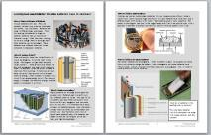 | - Mixing baking soda and vinegar is a chemical reaction  - It went fast and bubbled  - It eventually stopped | - batteries have metals separated from acids  - Chemical energy is stored in the battery  - Chemical energy is released when battery is connected  - Chemicals react in the battery eventually getting  used up | The chemicals in the flashlight batteries got used up faster because it was left turned on using up all the stored chemical energy.

Science vocabulary note: Students should be proficient with the terms battery and possibly circuit. New vocabulary from this lesson: chemical energy and chemical reaction

PLANNING NEXT STEPS
- Reflect on students’ ideas, experiences, and questions you heard in class as students discussed the reading and watched the video. Note questions you heard them ask and look ahead in the unit guide to see if they will find answers in upcoming lessons. You may decide to add in an additional lesson about chemical energy or batteries to help students answer their questions.

- Another short video clip you may decide to use with students is a 1 minute clip from Bill Nye comparing the chemical energy in a hot dog with the chemical energy in a battery http://safeshare.tv/v/ss5649933c936d7 Have students watch the clip twice. Think-Pair-Share about “How are batteries and hot dogs similar?” and “How does what we saw in this clip about batteries relate to what we read about batteries?”
- Revisit ideas pertaining to energy and what’s going on inside the battery in the teacher background at the beginning of this unit guide. You may also want to watch the following video (4 min 19 sec) to help with content: How Batteries Work – Adam Jacobson http://safeshare.tv/v/ss565278875222b You may decide to show this video to your students as well, particularly if they have questions about how recharging batteries works.

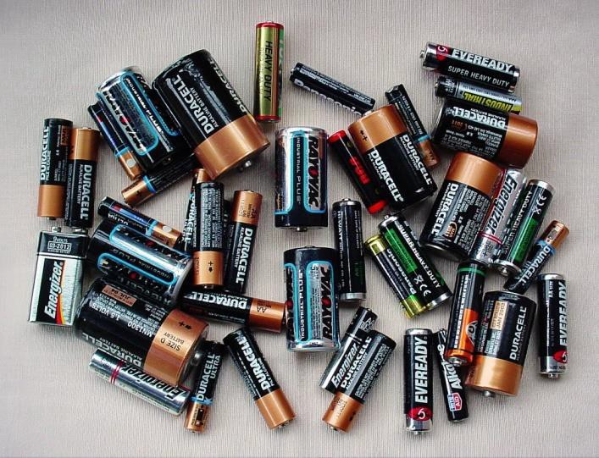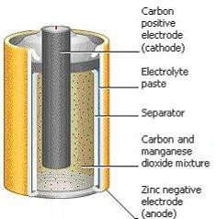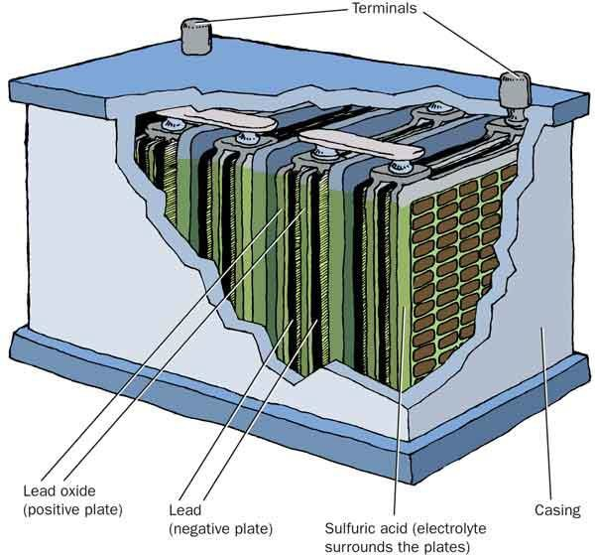Learning More about Batteries: What do batteries have in common?

Many Sizes and Shapes ofBatteries

We use batteries every day. They are portable, reliable ways to power flashlights, cell phones, cars, and radios. Batteries are made in different sizes and shapes. From tiny hearing aid batteries to large car batteries, batteries help us have power wherever we go. When they stop working, we have to change them or recharge them. Some batteries can be recharged. These batteries have different chemicals inside compared to disposable batteries.

What’s inside a D-Cell?

There are harmful chemicals inside D-cells. It would be dangerous to cut one open to see inside. The diagram at right labels the parts inside a D-cell. Some D-cells have metals like zinc and manganese and other acidic chemicals. There is a separator inside the D-cell to keep the chemicals from touching. If chemicals do touch, there would be a fast reaction which releases chemical energy. When a battery is hooked into a circuit it can release energy slowly. The chemical energy is changed into electrical energy when the battery is connected in a circuit.

What’s inside a car battery?
The car batteries on this page are for gasoline- powered cars. Batteries used in electric cars have different chemical inside. This type of 12-volt battery uses lead metal and sulfuric acid. Sulfuric acid is very dangerous and can cause burns on your skin. It is important not to touch corroded car batteries because when the battery corrodes the acid comes out of the battery and can hurt you. Car mechanics know how to handle these batteries safely. Car batteries are needed to start the car’s engine, power the radio, and light the headlights.

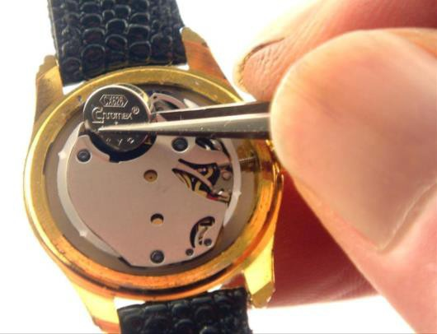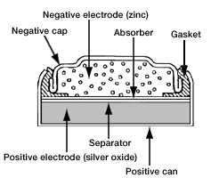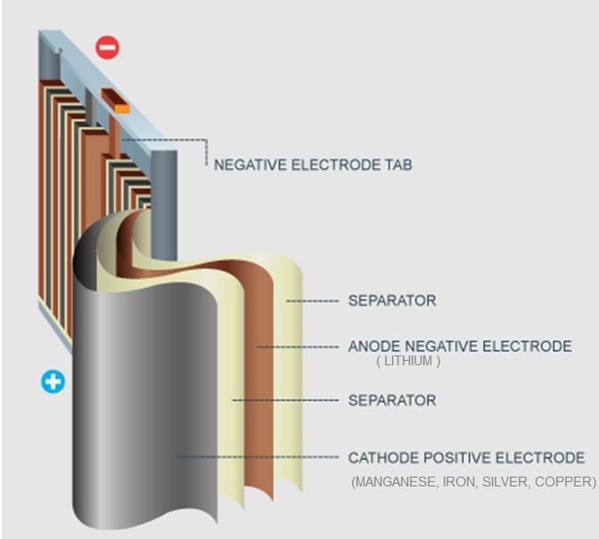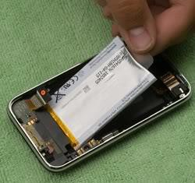
What’s inside a watch battery?
Watches use smaller, button-sized batteries. Can you imagine using a D-cell inside a watch? Your watch would be huge and heavy! So watch batteries have to be small and a different shape to fit inside a wrist watch. These batteries usually last a long time. The battery in the diagram uses zinc in the negative area and silver in the positive area, with a separator in between to prevent the chemical reaction while the battery is not in use.

What’s inside a cell phone battery?
Cell phone batteries are rechargeable. When the battery is dead, we plug the cell phone into a wall socket to charge the battery. Most rechargeable cell phone batteries have lithium inside. Lithium is paired with other metals such as manganese, iron, or nickel to make different cell phone batteries.

What do all batteries in this reading have in common?

How are these batteries similar to the battery we made with copper pennies and zinc washers?

Lesson 4: How batteries affect brightness

OBJECTIVES & OVERVIEW

In this lesson, students observe the effects of multiple batteries on the brightness of a bulb. This observation allows students to begin to understand how voltage with multiple batteries works and how this knowledge could apply to a flashlight design.
- Students observe effects of multiple batteries on the brightness of a bulb using a paper brightness meter and how it is related to the number of total volts from the combined batteries.
NEXT GENERATION SCIENCE STANDARDS (NGSS)
4-PS3-2. Make observations to provide evidence that energy can be transferred from place to place by sound, light, heat, and electric currents.
Carrying Out Investigations - Make observations to produce data to serve as the basis for evidence for an explanation of a phenomenon.  Scientific Knowledge is Based on Empirical Evidence - Science  findings are based on recognizing patterns. (4- PS4-1) | Disciplinary Core Ideas (DCI):  PS3.D: Energy in Chemical Processes and Everyday Life - The expression “produce energy” typically refers to the conversion of stored energy into a desired form for practical use | Cross-Cutting Concepts (CCC):  Energy and Matter - Energy can be transferred in various ways and between objects
MATERIALS

For each group of 4 students:
- 5 D-cell batteries
- 2 small light bulbs (only use 1 in the circuit)
- 2 brightness meters (folded paper)
- Several (5-7) pieces of wire
- 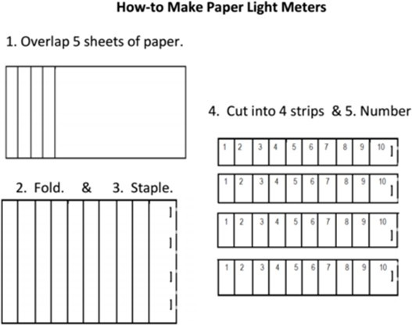Masking tape (optional but helpful)

PROCEDURE
Prior to the lesson:
How to makepaper light meters (makes 4 at atime) 1.) Overlap 5 sheets of copy paper about ¾ in.
2.) Fold over the papers to make 10 strips.
3.) Staple near fold in 4 places evenly to bind strips. 4.) Use a paper cutter to cut into 4 strips.
5.) Number each layer (1 = 1 layer of paper, etc.) How to use the light meter: Hold meter in front of a light source. This provides a numerical rating such that the next level completely blocks the light (i.e. if there is light shining barely through 5 but no light at 6, then the rating is a “5”). Measuring the intensity
of light is helpful when comparing brightness of bulbs in circuits as students increase the number of D-cells.
Per student:
Science notebook and pencil

Introduce the lesson: Whole Group
Display chart created in lesson 3 which may look similar to this one:

What is chemical energy?

- Stored in a battery and released when the battery is connected to a circuit
- Reaction releases chemical energy
- Type of energy

- Orient students to the purpose of today’s lesson:

  - In lesson 1, students may have noticed that the bulb was brighter if they used 2 batteries – if so, draw upon this experience; If not, move on.

  - Present the focal question to students. Give them time to think-pair-share about what they think will happen if they add or remove batteries from a simple light bulb circuit.

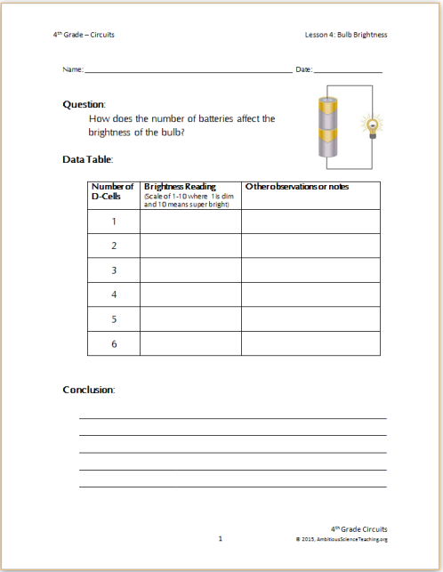
Focal Question: How does the number of batteries affect the brightness of a bulb in a simple circuit?

  - Have some students share out what they talked about with their partner. Use follow-up talk moves to get students to start thinking not only about what they think will happen, but also why they think adding or removing batteries would make that happen.

  - Remind students about what they began to learn about chemical energy in lesson 3 and as they work today ask them to think about how they can use the ideas about chemical energy to explain our results.

Collect Data from the Investigation:

- Remind students how to make a simple circuit referring to the chart from lesson 1.

- Give brief directions about how to use the light meter to collect data on the data table student handout.
  - Hold the meter in front of a light source. This provides a numerical rating such that the next level completely blocks the light (i.e. if there is light shining barely through 5 but no light at 6, then the rating is a “5”).
  - Have students practice measuring brightness of ceiling lights and having pairs check each other to make sure readings are somewhat accurate (if students can’t decide between levels, you can have them write a range like “5-6” or have a rule to round down and a 5-6 would be a “5”.)

Display chart from lesson 1 to remind students how to hook up bulb, wire, and battery in a simple circuit.
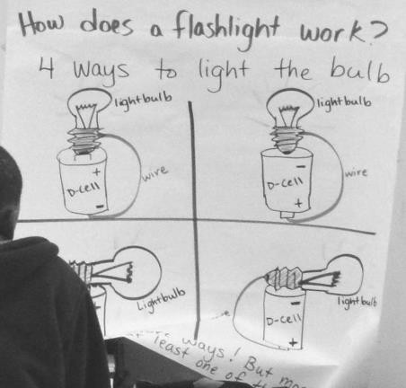

- Give safety reminder (see right). (Teacher note: Material tubs should have no more than 5 D-cells per group. This is because the small lightbulbs may fail beyond 6 batteries. This is an important finding for students; however, it is expensive as it ruins the bulbs. So if students want to test over 5 batteries do it as a classroom demonstration so as to limit destroying materials. Remember: Please do not to place faulty or blown bulbs back in the bag with working ones.)

- Pass out material tubs to table groups and have students follow the directions sheet and begin building circuits and using the light meter to collect data. Turn classroom lights off to more easily read the brightness meters without light interference from ceiling lights.

- As you circulate, remind students they can use masking tape to hold multiple D-cells in a row. Students may also need to twist wire pieces together if they need a longer wire if there are no long wires in the kit.

- Once students are underway with conducting tests and recording data, use the back-pocket question suggestions (at right) to get students thinking about the patterns they are observing.

- Give time for students to write a short conclusion using data from their table to answer the focal question.

- If students want results beyond 5 batteries, conduct this as a whole group demonstration. The bulb may fail between 6-9 batteries depending on if batteries are fully charged.
SAFETY ALERT!

If materials begin to feel hot or warm, put down the materials and disconnect the pieces.
This happens when students make a short circuit by connecting the wire to both ends of the battery with no bulb connected.

Back Pocket Questions

- What did you notice as you added more batteries?

- What do you think might be causing that to happen?

- What have you found out so far about how the batteries affect the brightness of the bulb?

- What if we used more than 6 batteries? Do you think there might be a limit? Why or why not?

- Remember the car battery video yesterday about volts? How many volts are in each circuit as we add more batteries? (Have students examine outside of battery to see
1.5 volts per D-cell).

Demonstration (Optional) – Whole Group
If students want to test more than 5 D-cells, do so now as a whole group demonstration. Small lightbulbs may fail beyond 5 batteries. This is an important finding for students; however, it is expensive as it ruins the bulbs. If students want to test over 6 batteries do it as a classroom demonstration so as to limit destroying materials. Remember: Please do not to place faulty or blown bulbs back in the bag with working ones
- Gather students so that they can see the demonstration table.
- Build a simple circuit and use masking tape to hold together multiple batteries in a long stick shape (you can also use battery holders that are provided in the kit, but these seem harder to use and manipulate than masking tape.) Try 5 D-cells and measure using light meter. Then go on to 6, 7, and perhaps 8 D-cells to see how brightness is affected. Add D-cells in this demonstration until the one demonstration bulb fails. (Please do not put the failed bulb back in the bulb bag.)
- Think-Pair-Share → What happened to the bulb’s brightness as we added more batteries?
- Think-Pair-Share → We notice that with batteries, the bulb stopped working (or went out). Why do you think that happened?

Just-in-Time Content Instruction: Volts

- Introduce the term volts and voltage with simpledefinitions provided at right.

Voltage is a kind of electrical force that makes electrical current (or electricity) move through a wire. We measure voltage in volts. The bigger the voltage, the more current will flow. So a 12-volt car battery will have more electrical force pushing the current than a 1.5-volt flashlight battery.

- Rewatch the YouTube video How Car Batteries Work (3 minutes) about car batteries, paying attention to what it says about volts and voltage. Students watched this video in lesson 3; however, we are watching it again to apply what we know about chemical energy and volts to explain the brightness of the bulb. http://safeshare.tv/v/ss56527816be5f5

- Pose the following task and give students some time on their own or with a partner to come up with a response. Remind students that just like in the car battery, volts can be added up across multiple cells (in this case, multiple D-cells).

How many volts did each D-cell have? As we added D-cells how did that affect voltage?

- Process new information: Give students time to complete the back of the handout by creating a model to explain what they think is going on that we can’t see that explains the difference in brightness using what they know so far about chemical energy, volts, voltage. [Possible student ideas: Students may be thinking about how volts and chemical energy are related or how volts help “push energy” and the more volts result in “a bigger push.” How the battery has volts in it to give a push – perhaps hypothesizing about how a dying battery can’t push as much as it used to, kind of like our vinegar + baking soda chemical reaction where the bubbles aren’t as bubbly as they were at the beginning.]

Creating a Summary Table of Activity: Whole Class
(See sample entry on next page)

- OBSERVATIONS: Reconvene as a whole class and summarize what they observed (refer students to their data tables to remind them what they observed.)

- LEARNING: What did we learn about volts and voltage from the video and from the definition of voltage provided (see above box)

- CONNECTION: In our flashlightphenomenon, itstopped working. Think-Pair-Share: → What might have happened with the batteries to make the bulb stop working? Or what would we need to have to make a brighter flashlight? Write some ideas in the summary table under “connection to phenomenon.

Science vocabulary note: Students should be proficient with the terms battery and possibly circuit. Chemical energy and chemical reaction are still relatively new. Today’s new vocabulary from this lesson: volts and voltage

PLANNING NEXT STEPS
- Reflect on student models the backside of student handout. Note questions you heard asked and look ahead in the unit guide to see if they will find answers in upcoming lessons. You may decide to add in an additional lesson about chemical energy, volts, or voltage to help answer their

questions.

SUMMARY TABLE
The summary table rows below may be similar to what the summary table row looks like from the class discussion. Students may have additional questions about batteries as this is just the first lesson in the series. Have students write Q’s on sticky notes and stick them onthe ‘Questions’ chart or on the summary table. Check in with their questions during subsequent lessons to see if we have answersyet.

Name of Activity | Observations | What have we learned so far? | Connection to Phenomenon
Making a Simple Battery | - Our battery had acid (vinegar) and metals (zinc, copper)  - We had to follow a pattern to make it work  - It had to have enough acid (vinegar) to work | Both our battery and the lemon clock used acids and metals  Do all batteries have acids and metals? | The flashlight stops working if the battery died.  It might die because the acid dried up - Like our battery didn’t work if it wasn’t wet enough with  acid.
Reading about Batteries | - Mixing baking soda and vinegar is a chemical reaction  - It went fast and bubbled  - It eventually stopped | - batteries have metals separated from acids  - Chemical energy is stored in the battery  - Chemical energy is released when battery is connected  - Chemicals react in the battery eventually getting  used up | The chemicals in the flashlight batteries got used up faster because it was left turned on using up all the stored chemical energy.
How batteries affect brightness  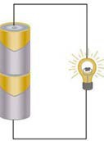 | - battery – brightness 2-3  - batteries – brightness 6  - batteries – brightness 7-8  - batteries – brightness 10  We found that 8 batteries was too powerful for the bulb and broke it ☹ | As the number of batteries increases, the brightness of the bulb increases.  The power of batteries is called volts. Each battery has 1.5 volts (written on the side) and they add together to get a total voltage. (Like in the car battery video where 6 x 2 v  cell = 12 v) | To have a bright flashlight you could have more than one battery. This also might make it last longer because it can still work it would just be dim.  Too many batteries would make the flashlight too heavy to use easily and could break the bulb.

(This page intentionally left blank.)

Lab Directions

Question:
How does the number of batteries affect the brightness of the bulb?

Materials:
- D-cell batteries
- Small light bulb
- Wires
- Masking tape
- Light meter(folded paper strips)
Procedure:
- Make a simple flashlight circuit using 1 D-cell, 1 wire, and 1 bulb.
- Use the brightness meter to measure how bright the bulb is glowing. Record on the data table.
- Repeat steps 1 and 2 adding more D-cells into the circuit (as shown below).

SAFETY ALERTS!

If circuit feels hot, disconnect the pieces and let them cool off. Do NOT use more than 5 batteries in your test.

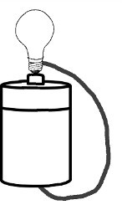
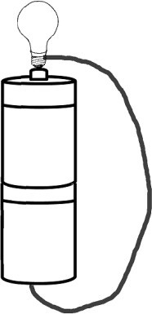
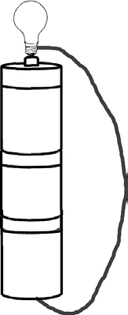
These drawings show how to connect multiple batteries in your flashlight circuit.
Use masking tape to easily hold batteries together. Only use 1 light bulb.
Test up to 6 batteries in your circuit. Do NOT try more than 6 batteries.

(This page intentionally left blank.)

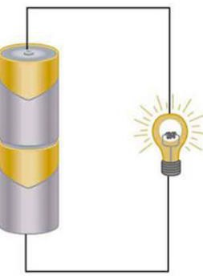
Name: Date:

Question:
How does the number of batteries affect the brightness of the bulb?

Data Table:

Number of D-Cells | Brightness Reading  (Scale of 1-10 where 1is dim and 10 means super bright) | Other observations or notes
1
2
3
4
5

Conclusion:

Explain the Findings: On the two models below, add the bulb and wire. Then, draw and write about what you think is going on inside the batteries, wires, and bulbs that we can’t see to explain the difference in brightness. Use what you know so far about chemical energy, light energy, voltage, and volts.

1 D-cell | 4 D-cells
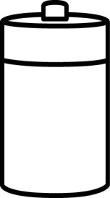 | 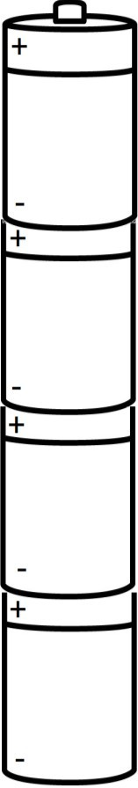

Usewordstoexplain: What doyouthink causes the difference in brightness of the bulbs comparing circuits with 1 D-cell and 4 D-cells?

Lesson 5: Revising ideas with evidence

OBJECTIVES & OVERVIEW
Note: This lesson can completed after lesson 6 instead of before.
In this lesson, students will use the summary table as well as data sheets from investigations to apply what they have learned and observed so far to revising their original ideas.
  - Students use evidence to support new or revised claims about how circuits work or stop working.
  - Students identify what made their thinking change (metacognition).
NEXT GENERATION SCIENCE STANDARDS (NGSS)
4-PS3-2. Make observations to provide evidence that energy can be transferred from place to place by sound, light, heat, and electric currents.
4-PS3-4. Apply scientific ideas to design, test, and refine a device that converts energy from one form to another.
Science and Engineering Practices (SEP)  Constructing Explanations – Use evidence (e.g., measurements, observations, patterns) that specify variables to construct an explanation of a phenomenon. | Disciplinary Core Ideas (DCI):  PS3.B: Conservation of Energy and Energy Transfer  - Energy is present whenever there are moving objects, sound, light, or heat. Light also transfers energy from place to place. (4-PS3-2)  - Energy can be transferred from place to place by electric currents, which can then be used locally to produce motion, sound, heat, or light. The currents may have been produced to begin with by transforming the energy of motion into electrical energy. (4-PS3-2),(4- PS3-4)  PS3.D: Energy in Chemical Processes and Everyday Life - The expression “produce energy” typically refers to the conversion of stored energy into a desired form for practical use | Cross-Cutting Concepts (CCC): Energy and Matter - Energy can be transferred in various ways and between objects
MATERIALS

Per student (or pair of students):
- Pencils (colors available)
- Summary table
- Blank and/or original model sheet
- Sticky notes
On wall:
    - Summary table
    - any charts from lessons

PROCEDURE
Prior to the lesson:
Make decisions about the two decision points explained here.
- Should students complete models today as individuals, in pairs, or in small groups?
  - If done in pairs, students have to talk about their ideas before drawing or writing them. But it doesn’t create an assessment artifact for individual understanding.
  - Individual revisions allows the teacher to compare the original individual model and see individual student progress, which has benefits for grading and assessment, but this

typically results in less student talk.

TEACHER DECISION POINT
- Modelling: individual, in pairs, or groups?
- Model template: blank one or revise on their originals?

- Should students fill in a blank model template and then compare with the original? Or use a colored pen/pencil and draw/write directly on the original model? Or use post-it notes?
  - Blank model scaffold then compare to original:
    - The benefit to this is that students can start fresh and the teacher can see where the student is currently at without being reminded of prior ideas. It is also less messy than writing on the original.
    - After students fill in the blank one, they can compare it to the original to
recognize points where their thinking has changed and places where it hasn’t.
  - Revise directly on original:
    - The benefit is that students start by reviewing their original ideas (rather than from a blank page). This can also be a drawback as it may remind some students of alternative ideas.
    - It gets messy using a colored pen/pencil to write on top. Sticky notes could be used instead of writing directly on the model using one color of things to add/change and another color (later in the lesson) to connect evidence with claims.
  - Color coded sticky notes stuck to original model. Students add (purple), remove (red/pink), change(yellow) an idea, or add a question (green) onto their original model using sticky notes to address their initial ideas.
The lesson below proposes individual modelling on a blank template; however, change the plan to fit whatever decisions you made for the points above.

Introduce the lesson: Whole Group
- Orient students to the purpose of today’s lesson:
  - So far in this unit students have been learning about the battery, its role in a circuit, and what’s going on inside the battery that they can’t see. Point at wall charts to remind students they can use them to remember what they have done and learned so far.
  - Explain that today we are going to take what we’ve learned so far to see how our
thinking has changed since the beginning of the unit.

Focal Questions: How hasour thinking changed? What evidencedo we have to supportournewor revised ideas?
Why would a flashlight stop working?
Our initial ideas

- The switch was left on so the battery drained and there isn’t enough left to turn on (it flickers or get lower and lower light)

- The battery ran out of energy, got low on juice, used up its “energy ball”, lost its fuel (like a car)

- bulb broke because it overheated

- bulb broke because I could have slammed the drawer too hard

- something got disconnected because I slammed the drawer shut too hard

- there are electric cells in the wire that move the energy around and maybe they ran out through the light bulb

- Direct students attention to the individual ideas chart created in lesson 1 (at right). Write-pair-share:
  - Have students read over the original ideas. Choose one that they think they know more about now based on things they’ve done or learned in class.
  - Students write in their science notebook or on a sheet of paper about how they would add to or change one of these initial ideas.
  - After a few silent minutes for writing, have students pair-share their responses.
- Tell students that they will have a chance to put down their current thinking about the flashlight phenomenon on a blank model scaffold sheet. After drawing and writing about their current ideas, they will use sticky notes to connect claims with evidence from our summary table.

- Provide directions to students about model revisions that are congruent with decisions made prior to the lesson at the “Teacher Decision Point”
Back Pocket Questions

Prompts if nothing is on the drawing:

- What might be going on inside the battery that we can’t see to make it work? or stop working?

- What have we learned about batteries that could apply to our flashlight?

Examples of responding to student ideas:

- I see you drew inside the battery. What have we done in class that makes you think that is what might be inside the battery?

- You said the battery makes the bulb light up. How does it do that?

Prompts to connect to activities:

- What activities did we do to learn about batteries? How can you add that information to your model?

- How can you incorporate what we learned from insert activity name here from the summary table into your model?

Students develop their own models: Individual Work
- Each student gets a blank model scaffold and begins to write and draw about how and why they think a flashlight works and what might happen that we can’t see that would make it stop working – paying particular attention to the role of the battery (since that has been the majority of instruction so far.)
- As you circulate, look at student drawing and writing and ask for clarification if something isn’t labeled or explained. (You will be looking over their models after class, so it’s best to ask now so you can hear their ideas and hopefully get them to add them to their model.)
  - If students are having difficulty drawing the parts refer them to the charts from prior activities, the summary table, and their science notebooks.
  - If students are drawing and writing about their ideas about the unobservable parts of what could be going on, try some of the back-pocket question suggestions atright.
- As students work, look for different ways students represent what’s inside the battery, wire, and light bulb. Prepare students to share out these ideas in the next part of the lesson to generate a list of hypotheses about what is going on that we can’t see that could cause the flashlight to stop working.
- During this time students can talk to each other and the teacher about their thinking, but each individual student records their individual thinking on their own paper.

Select parts of models to share publicly (whole group):
Prior to this step, as you circulate while students work on the model revisions, look for different ways students are representing what they think is inside the battery AND if/how they are connecting what they draw with evidence from class. (It is unlikely that most students will be explicitly attending to evidence from activities or data points yet, but if a few are, it is worth highlighting evidence since that is what students will do in the next part of the lesson.) Let those 2-4 students know you’d like them to share and which part of the model to share (not the whole thing).
- Whole group: Have students give their attention to the students presenting their piece of the models so they are listening to ask questions or offer comparisons to their work.
- Start with examples of a few models showing what’s inside the battery and then moving into any that connect claims with evidence.
- Give time to students to engage with some back-and-forth with presenting student and peers following classroom norms for discourse.

Connecting ideas with evidence:

- Direct students to examine their models and examine one idea they have put down and show them how to connect it with evidence on a sticky note.
  - For example, there is a chemical reaction inside the battery. If that’s my claim, what
evidence do I have that there is a chemical reaction happening inside the battery?
  - Have students help you work through this claim with evidence from the summary table.
Likely responses include “We did a reading and watched a video about it. The vinegar
+ baking soda showed us that reactions eventually run out kind of like how batteries run
out.”
  - Write evidence (including specific data if available) on a sticky note and stick it next to the idea on the model.
- Have students identify at least 2 claims and write at least 2 sticky notes connecting evidence from an activity from the summary table to the claims they made.

Lesson Closing: How has my thinking changed?

- Pass back original model scaffolds. Have students look at both and identify at least 1 place where their thinking has changed.
- On the back of their new model sheet, students write about how their thinking has changed and what activities helped their thinking change. Use the sentence starters below:

I used to think that… Now I think…
My thinking changed because…
- Gather original and new models to analyze after class using the what-how-why tracker or RSST.

PLANNING NEXT STEPS
  - Reflect on student models. Fill out an RSST (see lesson 1 for master copy of RSST template). What understandings do most students currently have about chemical energy, batteries, chemical reactions, etc. What gaps still exist in students understanding of chemical energy and how batteries work?
  - Save the set of students’ individual midpoint models as a formative assessment. Compare ideas in the models and compare it to the What-How-Why levels of explanation. Are students only labeling and saying what happens? Or are they also attempting to explain how or why something happens using causal statements and information from activities? If not, what changes can be made to better support students in doing this?

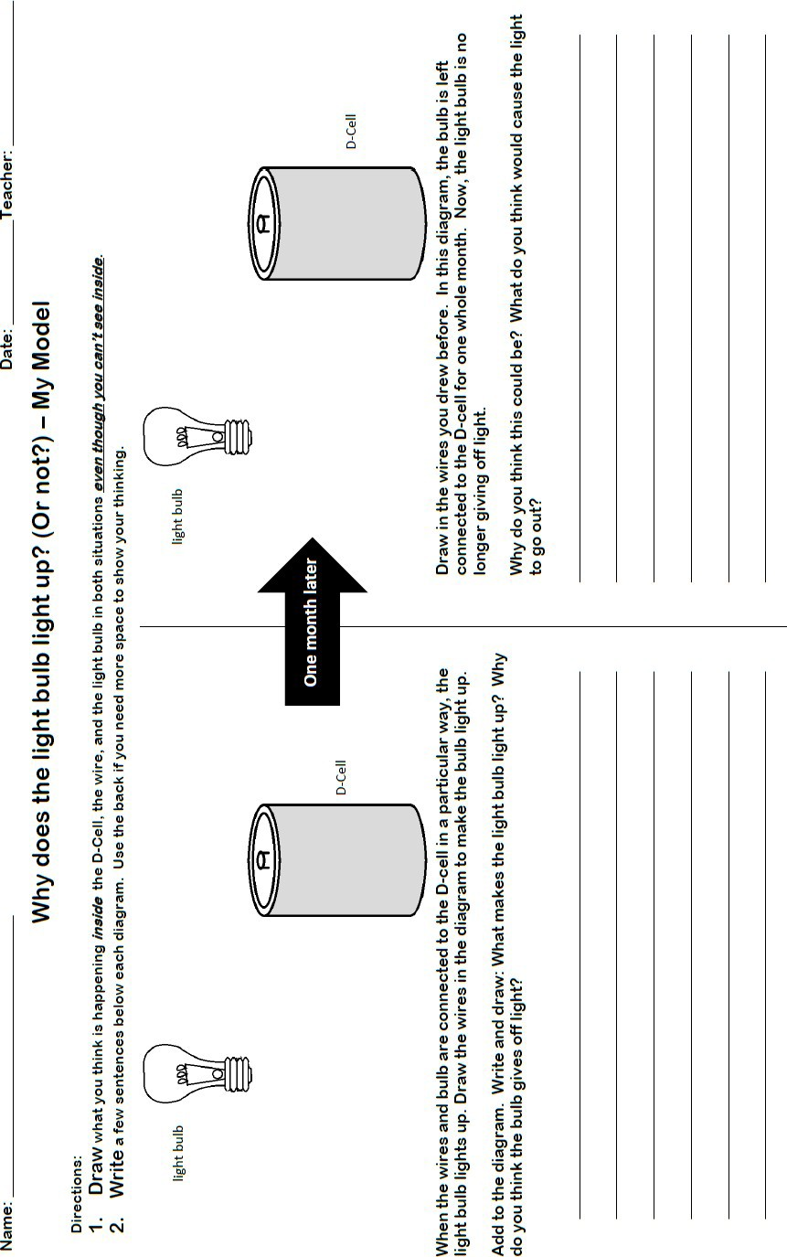

L
esson 5: Revising ideas using evidence 71 4th Grade Circuits
© 2015, AmbitiousScienceTeaching.org

(This page intentionally left blank.)

Lesson 6: Conductors and Insulators

In this lesson, students observe that some materials conduct electric current while others do not.

OBJECTIVES & OVERVIEW
    - Students observe and record data about materials that are conductors or insulators using a circuit tester.
    - Students learn about the role of electrons in electric current.
Teacher Note: Not all students will fully understand the ideas presented about electrons in this lesson. This explanation is beyond grade-level expectations; however, it is a good introduction for when students learn more about particles and charges in upper grades. It is included in this lesson because (1) students likely have questions about the + and – on the battery label, this is related to understanding the charges of electrons and how electrons behave, and (2) electrons explain why certain materials conduct electricity and others do not.

CONNECTION TO KIT

See Lesson 7: Conductors and Insulators Pgs 39-43

NEXT GENERATION SCIENCE STANDARDS (NGSS)
4-PS3-2. Make observations to provide evidence that energy can be transferred from place to place by sound, light, heat, and electric currents.
Carrying Out Investigations | Disciplinary Core Ideas (DCI):  PS3.B: Conservation of Energy and Energy Transfer  - Energy can be transferred from place to place by electric currents, which can then be used locally to produce motion, sound, heat, or light. The currents may have been produced to begin with by transforming the energy of motion into electrical energy. (4-PS3-2),(4- PS3-4)  PS3.D: Energy in Chemical Processes and Everyday Life - The expression “produce energy” typically refers to the conversion of stored energy into a  desired form for practical use | Cross-Cutting Concepts (CCC):  Energy and Matter - Energy can be transferred in various ways and between objects
- Make observations to
produce data to serve as
the basis for evidence for
an explanation of a
phenomenon.
Scientific Knowledge is
Based on Empirical
Evidence - Science findings
are based on recognizing
patterns. (4- PS4-1)
MATERIALS
For each pair of students:
- 2 circuit testers* (see pg 39)
- 1 bag of assorted materials
- You can have students construct these as part of lesson. If so, allow for extra time. Students can test materials in the simple circuit set-up (without holders)

Per student:
Science notebook and pencil Lab sheet handout (optional)
Videos:
Bill Nye clip (2 min) http://safeshare.tv/w/ss564023c9e24bd
Electricity 101 – Conductors and insulators (9m 37s) http://safeshare.tv/v/ss56528725bfe6a

Demo:
Act like an electron cards

PROCEDURE
Prior to lesson:
- Identify any student models or ideas related to wires, particularly ideas about why/how current flows (see examples below – Left: The zigzags represent energy that can go through wires to get to the light bulb; Right: ‘electricity cells going through the wire’ is similar to an electrons idea presented in the just-in-time instruction portion of this lesson).
- Look for any questions students have noted on the summary table to original models that pertain to materials that allow current to pass or not.
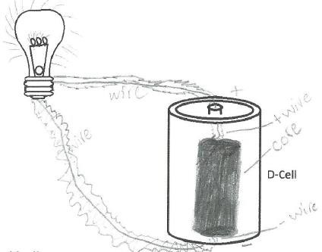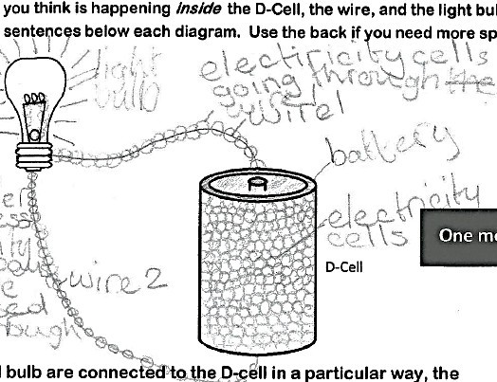

Introduce the lesson: Whole Group

  - Orient students to the purpose of today’s lesson:
    - Introduce this lesson by featuring 2-3 student ideas about what’s going on inside the wires that we can’t see that lets electricity pass through it or ideas about how electricity flows in a circuit.
    - Explain that today we will be testing several materials to see if they let current pass through them – these are called conductors. And seeing which materials don’t work in our circuit – these are called insulators.

Focus Question: Why are some materials conductors for electric current butothersare not?

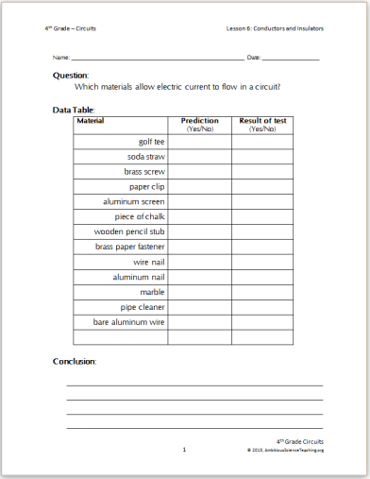
Collect Data from the Investigation:
- Remind students how to make a simple circuit referring to the chart from lesson 1 (or use the circuit tester set up shown on page 39 and 41). If using a simple circuit, place items in the bag between the bulb and a battery or between the wire and battery to see if it completes the circuit. Circuit testers (p 39) may be easier for students to manipulate but also take time to assemble.
- Give brief directions about how to test items and record data. Remind students about the safety alert

- Pass out material tubs to table groups and have students begin building circuits, testing materials, and collecting data
- Once students are underway with conductingtests and recording data, use the back-pocket question suggestions (at right) to get students thinking about the patterns they are observing.
- Give time for students to write a short conclusion using data from their table to answer the focal question.

Back Pocket Questions

- What do you notice about the kinds of materials that work and let current pass through (conductors)?

- Have any results surprised you so far?

- What other materials would you want to test? Based on the pattern in your data, what would you predict?
- Once most groups are finished collecting data, as a whole class, fill out the “Observation” box on the summary table including specific data from the investigation. Retest any materials that got mixed results.
SAFETY ALERT!

If materials begin to feel hot or warm, put down the materials and disconnect pieces.

Just-in-Time Content Instruction: Electrons

- Introduce the term electrons with simple definition provided atright.

Everything is made of tiny particles. All matter is made of tiny particles called atoms. Atoms are made of even smaller bits, one of which is an electron. Atoms have different numbers of electrons. Electrons are what allows electricity to flow through some materials but not others. Electrons are tiny particles inside matter with a negative charge. This is kind of like magnets where negative charges are attracted to positive charges and negative charges repel other negative charges

The terms atom and electrons will be in the video(s) students watch next.

- Learn from video: Watch the short clip from the Bill Nye video found here http://safeshare.tv/w/ss564023c9e24bd (It is queued up to 1:15 and will end at 3:32 – this portion is all you need to show). Have students use the back of their lab sheet to take notes. Replay as needed. OPTIONAL: If you’d like to show another video YouTube video “Electricity 101
– Conductors and Insulators” (9 min 37 sec) http://safeshare.tv/v/ss56528725bfe6a and have students use the notes sheet (on the back of the lab sheet if using the handout). If not using a handout, have students listen for and take notes about what the video says about electrons. (The video uses other terms, too, but just focus on electrons.)

- Act like an electron: Part 1 (whole class)
  - Have students stand in a circle, shoulder to shoulder in a circle. They are electrons in the copper atoms in a wire.
  - Select 1 student to be a D-cell and one student to be a light bulb. Students near the bulb and D-cell will touch the card with their finger at the critical contact point to complete the circuit.

  - Tell students that when the circuit is connected they will bump in one direction, leaving out of the – end of the battery and moving in a circle around to the + end. Try it. Notice that the electrons in the copper atoms in the wire are not moving very far (maybe ½ step) kind of like if they hopped to the next atom in the wire (like the video showed).
  - Now add in a person acting as a plastic spoon into the circuit. Will the current flow? No, because plastic is an insulator.
  - “Test” a few other items in the human circuit. Which ones let the electrons bump? Which ones don’t? (Use the data table from the investigation).

- Act like an electron: Part 2 (small group demonstration)
  - With students gathered on the carpet so they can see, have a group of 6 students volunteer and stand at the front of the room.
  - Assign 3 students to be a “copper atom”. Atoms of copper have 1 free electron. So each ‘copper atom’ student has 1 free electron standing near it moving around it in circles. As soon as the copper is in a circuit, then the electrons can move in one direction, hopping and figure-eight moving from one atom to the next (have students show this by atoms staying still and electrons moving from one atom to the next).
  - Now try this with a new set of 6 students. 3 students will be particles (molecules) of glass. Glass is an insulator and holds on tightly to its electrons (they are busy holding together other atoms in the molecule) and can’t move away. The students who are particles of glass link elbows with their electrons. When the glass is put into a circuit, no current will flow because the electrons can’t really move or hop from one to the next (like what happened in the copper).
- Give students time to complete the back of the data sheet.

Creating a Summary Table of Activity: Whole Class
(See sample entry on next page)
- OBSERVATIONS: Reconvene as a whole class and summarize what they observed from their insulators and conductors test, if you have not already done so (refer students to their data tables to remind them what they observed.)
- LEARNING: What did we learn about electrons? What do we know about electrons in conductors compared to electrons in insulator materials? How does this explain why conductors move electric current and why insulators do not?
- CONNECTION: In our flashlight phenomenon, Think-Pair-Share: → How does what we know about electrons explain how a flashlight circuit works? Write some ideas in the summary table under “connection to phenomenon.

Science vocabulary note: Students should be proficient with the terms battery, circuit, chemical energy, and chemical reaction. Volts and voltage are relatively new by students are familiar with them. New vocabulary terms for today are electrons, conductors, and insulators.

PLANNING NEXT STEPS
  - By the end of the unit, students are expected to identify examples of electrical conductors and insulators and know that conductors help transfer or transform energy in an electric circuit. Students in 4th grade do not need to fully understand the electron story. The just-in-time instruction in this lesson is all students at this level need to know but it is beyond grade level understanding. Knowing about electrons, however, helps students think about and represent the unobservable mechanisms of what’s going on inside the battery, wire, and bulb in the circuit.

SUMMARY TABLE
The summary table rows below may be similar to what the summary table row looks like from the class discussion. Students may have additional questions about batteries as this is just the first lesson in the series. Have students write Q’s on sticky notes and stick them onthe ‘Questions’ chart or on the summary table. Check in with their questions during subsequent lessons to see if we have answers yet.
Name of Activity | Observations | What have we learned so far? | Connection to Phenomenon
Making a Simple Battery | - Our battery had acid (vinegar) and metals (zinc, copper)  - We had to follow a pattern to make it work  - It had to have enough acid (vinegar) to work | Both our battery and the lemon clock used acids and metals  Do all batteries have acids and metals? | The flashlight stops working if the battery died. It might die because the acid dried up - Like our battery didn’t work if it wasn’t wet enough with acid.
Reading about Batteries | - Mixing baking soda and vinegar is a chemical reaction  - It went fast and bubbled  - It eventually stopped | - batteries have metals separated from acids  - Chemical energy is stored in the battery  - Chemical energy is released when battery is connected  - Chemicals react in the battery eventually getting  used up | The chemicals in the flashlight batteries got used up faster because it was left turned on using up all the stored chemical energy.
How batteries affect brightness  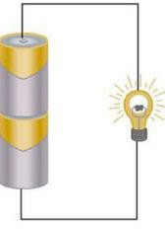 | - battery – brightness 2-3  - batteries – brightness 6  - batteries – brightness 7-8  - batteries – brightness 10  We found that 8 batteries was too powerful for the bulb and broke it ☹ | As the number of batteries increases, the brightness of the bulb increases.  The power of batteries is called volts. Each battery has 1.5 volts (written on the side) and they add together to get a total voltage. (Like in the car battery video where 6 x 2 v  cell = 12 v) | To have a bright flashlight you could have more than one battery. This also might make it last longer because it can still work it would just be dim.  Too many batteries would make the flashlight too heavy to use easily and  could break the bulb.
Conductors and Insulators | - Metals such as coins, paperclips, and foil make the circuit work (light turns on)  - Plastic and glass do not make the circuit work (light bulb does not turn on) | - All matter ismade of particles likeatoms.  - Conductors allow electric current to pass  - Conductors have free electrons that canbump and transferenergy.  - Insulators block or stop electric current because they hold on tightly to their  electrons. | A flashlight case can be made of metal or plastic. If made of metal it is important not to have it touch exposed parts of the flashlight circuit or it might short circuit. Plastic makes a better case because it’s light-weight, cheap and a non-conductor.

Examples of student work applying knowledge of electrons:

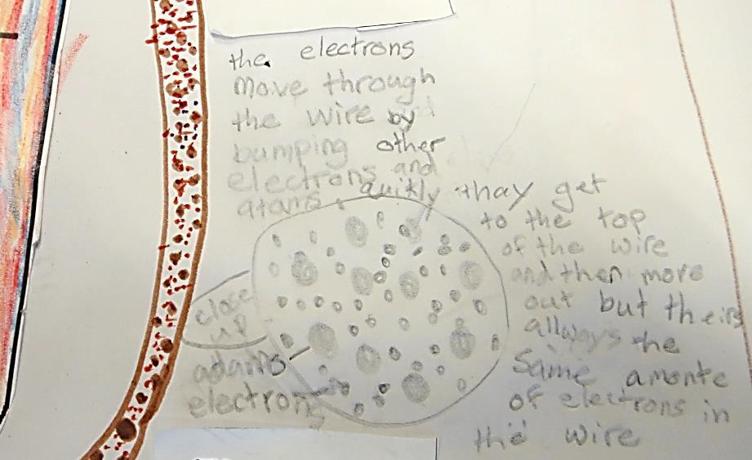

Explain why conductors work:

“The electrons move through the wire by bumping other electrons and atoms quickly they get to the top of the wire and then move out but theirs allways the same amonte of electrons in the wire”

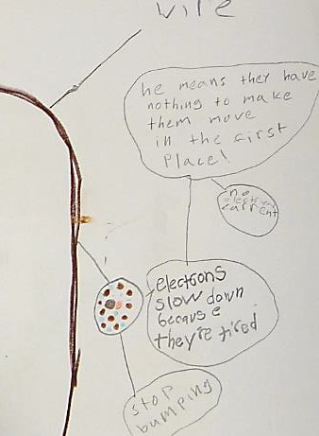

Explaining how electrons behave in a conductor if the battery is dead:

“He means they have nothing to make them move in the first place – no electric current – electrons slow down because they’re tired – stop bumping”

Name: Date:

Question:
Which materials allow electric current to flow in a circuit?

Data Table:
Material | Prediction  (Yes/No) | Result of test  (Yes/No)
golf tee
soda straw
brass screw
paper clip
aluminum screen
piece of chalk
wooden pencil stub
brass paper fastener
wire nail
aluminum nail
marble
pipe cleaner
bare aluminum wire

Conclusion:

Explain the Findings: Draw the differences between a conductor and insulator in a light bulb circuit. Then, draw and write about what you think is going on inside the conductors and insulators that we can’t see to explain how conductors and insulators work. Use what you know so far about conductors, insulators, and electrons.

Drawing of my ideas about conductors and insulators:
Use words to explain: Why are some materials conductors of electric current and others not?

Act Like an Electron Cards: Part 1 – Copy page and cut/fold as directed. Light bulb, cut and fold so that the student who is the light bulb can flip the card to indicate if the bulb is on or off. For the D-cell, cut out the card and have students in the wire (the copper electrons) touch the critical contact points when connected in the elbow-to-elbow or shoulder-to-shoulder circuit. Electron cards – copy and cut so all other students have an electron card.
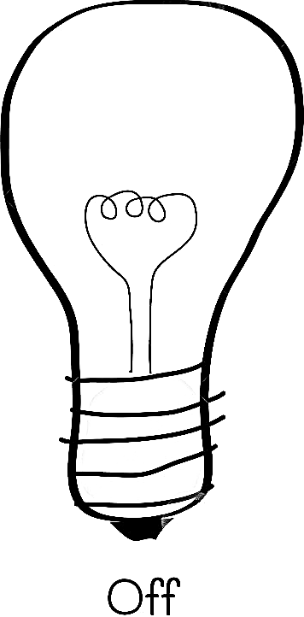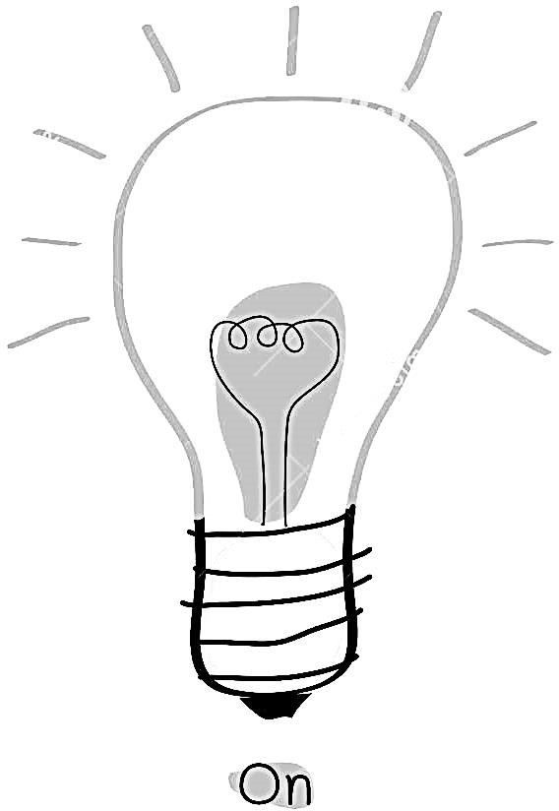

electron | electron
electron | electron


Lesson 7: What’s inside a light bulb?

In this lesson, students learn about light and heat energy. This lesson furthers student understanding about the relationship betweenvoltage and brightness (from lesson 4), the purpose of insulators (from lesson

OBJECTIVES & OVERVIEW
- and also adds on information about energy transformations.
• Students observe and record data about the relationship between voltage and bulb brightness using a household bulb.
• Students hypothesize about the role of the glass bead (in small bulb) and glass structure (in large bulb) between the support wires using what they know about conductors and insulators.
• Students begin to learn about light and heatenergy (which continues into the next lesson about filaments).

CONNECTION TO KIT

See Lesson 4: What is inside a Light Bulb? pgs 21-24

NEXT GENERATION SCIENCE STANDARDS (NGSS)
4-PS3-2. Make observations to provide evidence that energy can be transferred from place to place by sound, light, heat, and electric currents.
Carrying Out Investigations  - Make observations to produce data to serve as the basis for evidence for an explanation of a phenomenon.  Scientific Knowledge is Based on Empirical Evidence - Science findings are based on recognizing patterns. (4- PS4-1) | Disciplinary Core Ideas (DCI):  PS3.B: Conservation of Energy and Energy Transfer  - Energy can be transferred from place to place by electric currents, which can then be used locally to produce motion, sound, heat, or light. The currents may have been produced to begin with by transforming the energy of motion into electrical energy. (4-PS3-2),(4- PS3-4)  PS3.D: Energy in Chemical Processes and Everyday Life - The expression “produce energy” typically refers to the conversion of stored energy into a  desired form for practical use | Cross-Cutting Concepts (CCC):  Energy and Matter - Energy can be transferred in various ways and between objects
MATERIALS
- see p22 for materials list (household bulb, wires, 20 D-cell batteries, wooden holder for batteries)
- see p12 for removing the base from the bottom of a large light bulb (120v household light bulb)
- Student recording sheet (1 per student)

PROCEDURE
Introduce the lesson: Whole Group
  - Orient students to the purpose of today’s lesson:
    - Introduce this lesson by featuring 2 student ideas about what’s going on inside the light bulb that we can’t see that lets electricity pass through and change to heat and light. [Possible ideas such as: filament glows brighter with more power, filament gets red because it’s heating up, bulbs are made of glass to keep the heat/light/electricity inside, the glass part inside helps keep the wires separated, etc.]
    - Explain that today we will be making observations of a large lightbulb to figure out more about just what is happening inside the light bulb. The small bulbs are great for small tests, but to really look inside, we are going to use large bulbs today.
    - Focus Question: How do the parts inside the light bulb help it work?

Make Observations:
- Pass out student recording sheets.
- Hold up large light bulb so students can see it (place under document camera to make it larger or pass around a few intact bulbs for students to observe). Ask students what they notice inside the light bulb.
- Write-pair-share: Have students use what they learned about insulators and conductors to answer question 1 on the front of the recording sheet. Share responses in partners.

Collect Data:

Back Pocket Questions

- What do you notice about the brightness as we added more D- cells?

- Why do you think that happened?

- How was using multiple batteries to light this large bulb similarand different from our test with the small bulb? (From lesson 4, see summary table)

- What do you think the glass support inside the bulb does? Why is it there?
- In this demonstration, students use the recording sheet to note observations (if light bulb is bright enough in a dark room, use the paper light meters.)
- Follow directions on p 22-24 of binder guide showing how to have students help with the demonstration to light both the intact large bulb and the large bulb with base removed using up to 20 D-cells.
- Students record observations on their sheet. Use the back- pocket questions in the box at right to help students think about their observations prior to writing conclusions.
- Have students write a conclusion based on the data they collected to answer the investigation question on the lab sheet. [Possible conclusion could be: The bulb got brighter and brighter the more D-cells we added to the circuit. The bulb went from brightness 1 with 5 batteries to brightness 4 with 20 batteries. This happened because more batteries means more voltage.]
SAFETY ALERT!

Light bulb with base removed may have sharp wires or pieces so if you allow students to gently touch it, do so with care.

Just-in-Time Content Instruction: Heat and light energy
- Introduce the terms light energy and heat energy. Use the text below to support students in understanding these terms. Add them to a list of types of energy including chemical energy (from the battery) and electrical energy (from the wires when current is flowing).
Light and heat are forms of energy. Both heat and light can be moved from one place to another. For example, with a lamp we can feel the heat radiating from the bulb when we put our hands near it. The heat energy from the bulb moves into the air and then into our hand. Light energy can also be transferred from one place to another. Light energy is the only form of energy that we can actually see directly.
- Have students use what they know about conductors and insulators to talk about how different materials could help transfer or transform heat or light energy. Some examples:
  - At the beginning of the unit, we had a question on our question chart about why the filament was such a curly shape. We hypothesize that the funny shape helps it make light. How could we use our new terms of light energy and heat energy to describe what the filament does?
  - At the beginningof class Iheard Jasmine say that she thought the filament lets current to through it to make light because it is metal. What do we think about that idea? Do conductors help change electrical energy into another form?

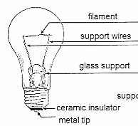Creating a Summary Table of Activity: Whole Class
(See sample entry as part of the summary table example below)
- OBSERVATIONS: Have students summarize what they observed from this lesson.
- LEARNING: What did we learn about light and heat energy?
- CONNECTION: In our flashlight phenomenon, Think-Pair-Share: → How dothe parts inside the light bulb help itwork? Writesome ideas inthesummarytable under “connection to phenomenon”
Science vocabulary note: Students should be proficient with the terms circuit, chemical energy, light bulb, conductor, and insulator. New vocabulary terms for today are light energy and heat energy.

PLANNING NEXT STEPS
• In the next lesson, students will have more time to reason about energy transfer and transformation so it is fine if all students are not comfortable talking about energy just yet. During this lesson, encourage students to make connections about what they know about conductors and insulators in how they think the light bulb works.

SUMMARY TABLE
Activity | Observations | What have we learned? | Connection to Phenomenon
Making a Simple Battery  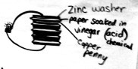 | - Our battery had acid (vinegar) and metals (zinc, copper)  - We had to follow a pattern to make it work  - It had to have enough acid(vinegar) to work | Both our battery and the lemon clock used acids and metals  Do all batteries have acids and metals? | The flashlight stops working if the battery died. It might die because the acid dried up - Like our battery didn’t work if it wasn’t wet enough with acid.
Reading about Batteries  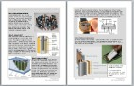 | - Mixing baking soda and vinegar isa chemical reaction  - It went fast and bubbled  - It eventually stopped | - batteries have metals and acids  - Chemical energy is stored in the battery  - Chemical energy is released when batteryis connected  - Chemicals react in the battery eventually getting used up | The chemicals in the flashlight batteriesgot used up faster because it was left turned on using up all the stored chemical energy.
How batteries affect brightness  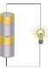 | - battery – brightness 2-3  - batteries – brightness 6  - batteries – brightness 7-8  - batteries – brightness 10  We found that 8 batteries was too powerful for the bulb and broke it ☹ | As the number of batteries increases, the brightness of the bulb increases.  The power of batteries is called volts. Each battery has 1.5 volts (written on the side) and they add together to get a total voltage. (Like in the car battery video where 6 x 2 v cell = 12 v) | To have a bright flashlight you could have more than one battery. This also might make it last longer because it can still work it would just be dim. Too many batteries would make the flashlight too heavy to use and could break the bulb.
Conductors and Insulators | - Metals such as coins, paperclips, and foil make the circuit work (light turns on)  - Plastic and glass do not make the circuit work (light bulb does not turn on) | - Allmatterismadeofparticleslikeatoms.  - Conductorsallowelectriccurrenttopass  - Conductorshavefreeelectronsthatcanbumpand transferenergy.  - Insulatorsblockorstopelectriccurrentbecause they hold on tightly to their electrons. | A flashlight case can be made of metal or plastic. If made of metal it is important not to have it touch exposed parts of the flashlight circuit or it might short circuit. Plastic makes a better case because it’s light-weight, cheap and a non-conductor.
What’s inside a light bulb? | - Support wires hold up the filament  - The filament glows to make light and heat  - The more D-cells we have the brighter the bulb  For a household light bulb:  - 1 D-cell = 1 brightness  - 20 D-cells = 4  brightness | - Light and heat are kinds of energy  - Light and heat energycan move from one place to another  - The more batteries means there’s more chemical energy to make the bulb bright and brightness is like more light energy | The flashlight bulb has parts like the bulb we looked at today like support wires, a filament, and glass structure to help it work.  Conductors like wires lets electrical energy travel but insulators like glass do not.

(This page intentionally left blank.)

Name: Date:

Focus Question:
How do the parts inside the light bulb make it work when it is part of a circuit?
Anatomy of a light bulb:
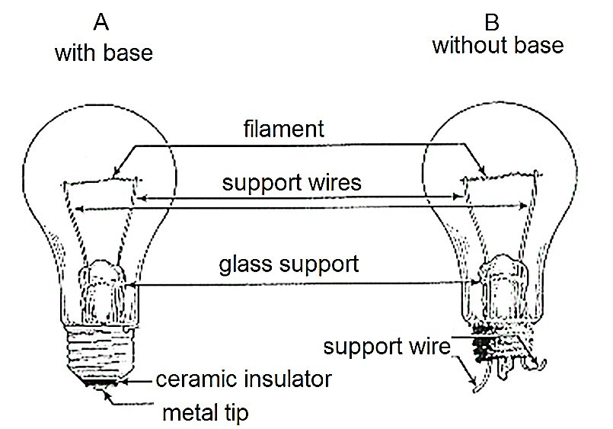

What does the filament look like? What does it do?

- The parts in a light bulb are made of metal, glass, and ceramic. Why do you think they use these specific materials? (Hint: Use what you know about insulators and conductors)

Investigation Question:

How does the number of batteries affect the brightness of a large light bulb?

Data Table:

Number of D-cells | Brightness of bulb
5
10
15
20

Conclusion:

Lesson 8: Making a Filament

In this lesson, students continue learning about light and heat energy and how energy is transformed from one form to another.

OBJECTIVES & OVERVIEW
• Students make a physical model of a light bulb to observe what a filament does.
• Students reason about how a filament can transform electrical energy into heat and light using what they know about conductors and what the read in the lesson.

CONNECTION TO KIT

See Lesson 8: Making a Filament
pgs 45-47

NEXT GENERATION SCIENCE STANDARDS (NGSS)
4-PS3-2. Make observations to provide evidence that energy can be transferred from place to place by sound, light, heat, and electric currents.
Carrying Out Investigations | Disciplinary Core Ideas (DCI):  PS3.B: Conservation of Energy and Energy Transfer  - Energy can be transferred from place to place by electric currents, which can then be used locally to produce motion, sound, heat, or light. The currents may have been produced to begin with by transforming the energy of motion into electrical energy. (4-PS3-2),(4- PS3-4)  PS3.D: Energy in Chemical Processes and Everyday Life - The expression “produce energy” typically refers to the conversion of stored energy into a desired form for practical use | Cross-Cutting Concepts (CCC):  Energy and Matter - Energy can be transferred in various ways and between objects
- Make observations to
produce data to serve as
the basis for evidence for
an explanation of a
phenomenon.
Scientific Knowledge is
Based on Empirical
Evidence - Science findings
are based on recognizing
patterns.
MATERIALS
- see p45-46 for materials (D-cell, battery holder, bulb, bulb socket, pieces of wire, clay, nicrhome wire)
- see p46 for model of student-constructed light bulb
- student readings
- chart with labeled parts of light bulb (support wires, filament, glass structure, etc.)
- chart with list of forms of energy
- optional: copy of diagram on p46 for partners/groups to refer to when attaching the filament in the circuit

PROCEDURE

Prior to the lesson: Recall what questions and ideas students had about the filament from lesson 7. These question and ideas can anchor today’s lesson. Also, try the experiment yourself. This activity may require some troubleshooting if the ends of the wires do not have a good connection.

Introduce the lesson: Whole Group
- Orient students to the purpose of today’s lesson:
  - Building off yesterday’s lesson where we looked closely at how the parts inside the light bulb help it work. Some of you were wondering why the filament (gesture at chart of labeled light bulb) glows but the support wires do not even though we think they are all made of metal. [Remind students of their questions and ideas from lesson 7 that only pertain to the filament – not about other parts of the bulb. If they did not have any questions or ideas, ask them now what they would like to know about the filament. Possible student questions: What makes it glow? Why does it break? Why does ithave

to be curly? Possible student idea: The filament glows because it’s thinner than the support wires so the electricity doesn’t have as much space to move so it gets stuck and rubs and gets hot.]
  - Explain that today students will be making our own filament glow in a simple light bulb circuit. (Show students the diagram on p 46).
  - Remind students about the safety alert (at right) when working with the materials today.

Make Observations: Pairs/Groups
- Have students work in partners to make the circuit
(shown in the diagram on p46) using the nichrome wire as the filament.
- Students sketch and label the circuit in their science notebooks, indicating the part of the circuit that glowed.
- As students are building and sketching, circulateto address any issues with materials and encourage students to help each other.
- At the end of this portion of the lesson, have students think and write briefly about this question in their science notebooks: What makes the filament glow? [Possible sentence starters: The filament glows because… The filament is made of metal so it glows because… The shape of the filament is thin and curly which makes it glow because…]

SAFETY ALERTS!

- Thin nichrome wire can cause cuts if it is pulled too hard.

- Nichrome wire gets hot when it glows. Remind students not to touch it until it has cooled.

- Hot nichrome wire can ignite flammable materials, such as paper.

Just-in-Time Content Instruction: Energy transformations
- Introduce theterm energytransformation by referring students to the list of forms of energy on the chart and explaining that when energy changes forms it’s called a transformation (If needed, review theterms lightenergy and heat energy from the text box in lesson 7.)

- Tell students that they will do some reading to get more information about energy transformations and how the filament works. Have students read the short articles about “Why do hot things give off light?” and “How do filaments work?” You could choose to use one or the other but both have a focus on energy transformations.
- In partners, have students locate information in the reading as evidence to answer the question about the question “What makes a filament glow?”
- As a class (whole group), come up with some ideas with evidence from the text and from student reasoning to explain how the filament helps transform or change electrical energy in the wire into heat energy and light energy. Use think-pair-shares during the whole class discussion so all students have time to talk about their ideas and listen to their peers. (Possible chart shown at right.)

READING INTEGRATION

This lesson contains readings that could be used during reading time and then revisited now during the science lesson.


- Has to be thin to  “The fatter the
let electricitypass conductor the easierfor through it but to electricity to flow”
make it harder to (Paragraph 2) go
  - “95 percent of the
- Thicker wire electrical energy that makes it easierfor goes into the filament electricity to flow is wasted as heat
energy” (paragraph 3)
- It gets hot because
of friction between  Not sure about friction electrons in tight from electrons, reading space in thin wire didn’t say

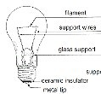Creating a Summary Table of Activity: Whole Class
(See sample entry as part of the summary table example below)
- OBSERVATIONS: Have students summarize what they observed about how the filament looks.
- LEARNING: What did we learn about filaments and energy transformation from the reading(s)?
- CONNECTION: In our flashlightphenomenon, Think-Pair-Share: → What makes the filament change electrical energy into heat and light energy? Write some ideas in the summary table under “connection to phenomenon”
Science vocabulary note: Students should be proficient with the terms circuit, chemical energy, light energy, heat energy. New vocabulary terms for today are energy transformation.

SUMMARY TABLE
Activity | Observations | What have we learned? | Connection to Phenomenon
Making a Simple Battery  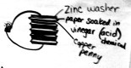 | - Our battery had acid (vinegar) and metals (zinc, copper)  - We had to follow a pattern to make it work  - It had to have enough acid (vinegar) to work | Both our battery and the lemon clock used acids and metals  Do all batteries have acids and metals? | The flashlight stops working if the battery died. It might die because the acid dried up - Like our battery didn’t work if it wasn’t wet enough with acid.
Reading about Batteries | - Mixing baking soda and vinegar isa chemical reaction  - It went fast and bubbled  - It eventually stopped | - batteries have metals and acids  - Chemical energy is stored in the battery  - Chemical energy is released when battery is  connected  - Chemicals react in the battery eventually getting used up | The chemicals in the flashlight batteriesgot used up faster because it was left turned on using up all the stored chemical energy.
How batteries affect brightness | - battery – brightness 2-3  - batteries – brightness 6  - batteries – brightness 7-8  - batteries – brightness 10  We found that 8 batteries was too powerful for the bulb and broke it ☹ | As the number of batteries increases, the brightness of the bulb increases.  The power of batteries is called volts. Each battery has 1.5 volts (written on the side) and they add together to get a total voltage. (Like in the car battery video where 6 x 2 v cell = 12 v) | To have a bright flashlight you could have more than one battery. This also might make it last longer because it can still work it would just be dim. Too many batteries would make the flashlight too heavy to use and could break the bulb.
Conductors and Insulators | - Metals such as coins, paperclips, and foil make the circuit work (light turns on)  - Plastic and glass do not make the circuit work (light bulb does not turn on) | - Allmatterismadeofparticleslikeatoms.  - Conductorsallowelectriccurrenttopass  - Conductorshavefreeelectronsthatcanbumpand transferenergy.  - Insulatorsblockorstopelectriccurrentbecause they hold on tightly to their electrons. | A flashlight case can be made of metal or plastic. If made of metal it is important not to have it touch exposed parts of the flashlight circuit or it might short circuit. Plastic makes a better case because it’s light-weight, cheap and a non-conductor.
What’s inside a light bulb? | - Support wires hold up the filament  - The filament glows to make light  and heat  - The more D-cells we have the brighter the bulb  For a household light bulb:  - 1 D-cell = 1 brightness  - 20 D-cells = 4 brightness | - Lightandheatarekindsofenergy  - Lightandheatenergycanmovefromoneplace  toanother  - The more batteries means there’s more chemical energytomakethebulbbrightandbrightnessis likemorelightenergy | The flashlight bulb has parts like the bulb we looked at today like support wires, a filament, and glass structure to help it work.  Conductors like wires lets electrical energy travel but insulators like glass do not.
Making a filament  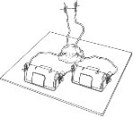 | The Nichrome wire glows when it’s a filament in a circuit powered by 2 D- cell batteries | We learned from the reading that the size of the conductor (short/long or thin/fat) can affect how electric energy moves through it.  Short, thin conductors make good filaments. | The flashlight bulb has a tiny filament that glows to make the light energy in the flashlight circuit. The filament transforms some of the electrical energy in the wire into light energy and heat energy.

PLANNING NEXT STEPS
Based on student writing and talk from today’s lesson, students will likely need more time thinking, talking, and writing about energy transfer and transformations before moving into telling the energy story on their final models of the flashlight phenomenon, spend another lesson and a suggestions below:
  - Watch and discuss. Use one or both of these short videos to help students be more comfortable identifying forms of energy and describing how they change forms:
    - Energy transformations (5 min 46 sec) http://safeshare.tv/v/ss56499646d27da (slower speaking pace, lots of labels, video summary at end, good for English Learners)
    - Types of energy (2 min 2 sec) http://safeshare.tv/v/ss564997f9834df (cartoon showing caveman experiencing and narrator naming different kinds of energy)
  - Tell the energy story of everyday events. Discuss some everyday events and examples and trace and name the energy forms and transformations. Students can discuss each example and then quickly sketch and label the types of energy and where the transformations occur. For example:
- A toaster turns bread into toast:
  - Plug the toaster into the wall socket to get electrical energy.
  - When the toaster is turned on, the filaments in the toaster transform the electrical energy into heat energy, and some light energy.
  - The heat energy changes the cold bread into toast.
  - Finally some of the electrical energy turns into energy of motion as the spring pops up the toast and a little bit turns into sound energy because we hear it pop up.
- A fire roasts marshmallows to make yummy s’mores:
  - The wood has stored chemical energy.
  - When the wood is burned, the chemical energy in the wood transforms into light and heat energy in the fire.
  - The heat of the fire transfers into the cold marshmallows, warming them up and melting them.
  - We eat the hot marshmallow on a s’more and get some chemical energy from the food we can use for energy of motion.
- 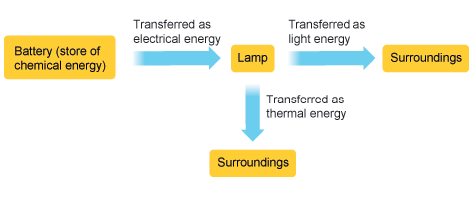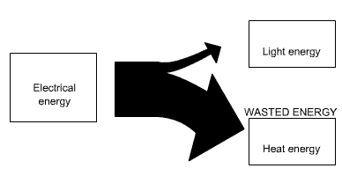Come up with other events and have students sketch and label energy transfers and transformations. Students may come up with their own ways to model energy using arrows (and size of arrows), here are some possibilities:

Why do hot things give off light?


Set fire to logs and you'll get a red glow and a warm feeling. People know that hot things give off light. But why do hot things give off light?

The burning wood reacts with oxygen in the air to change wood into carbon dioxide gas and water (steam). Doing this releases a lot of energy. Some of that energy is heat, some is light, and a little bit is sound energy, too (in the crackling and hissing of the logs).
Above: Burning logs react with oxygen to produce carbon dioxide gas, water (steam), and a lot of energy. Below: A candle burns over time using up the stored chemical energy in the wax, transforming the chemical energy to light and heat energy.

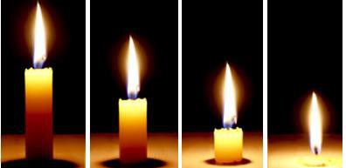
Candles used to be popular to have light. A candle has a flame by slowly changing the energy stored in the wax into heat and light energy. Candles will burn out eventually.
All the energy to make candlelight has to come from the wax, which slowly burns away.

Article modified from http://www.explainthatstuff.com/incandescentlamp.html

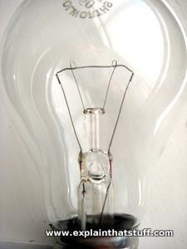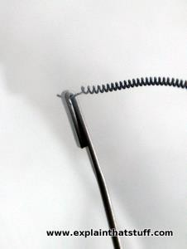How do filaments work?

Photo: A modern, electric incandescent lamp. Left: The filament is a length of tightly coiled tungsten metal stretched between two terminals that let the current flow

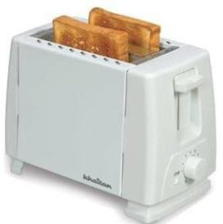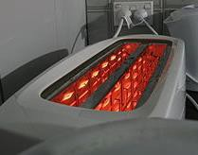Why do filaments glow? Electricity flows better through some materials than others. Metals let electricity flow easily. Some metals are better conductors than others. Silver is better than gold. Gold is better than copper. Copper is better than aluminum. Not all conductors are metals. Carbon is a good conductor and it is not a metal.

The filaments inside a toaster glow red hot to turn bread into toast. The filaments in a toaster are efficient at transforming electrical energy into heat

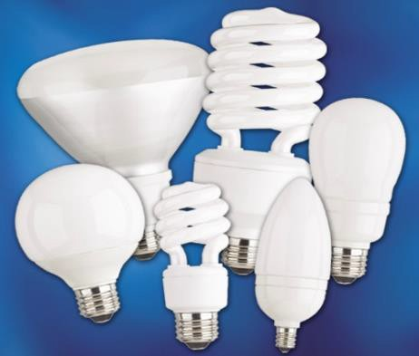Take a piece of a conductor and you can make electricity flow through it better by doing two things. First, make it shorter. The longer the piece of conductor, the more work electricity has to do to get through it. Second, make it thicker. The fatter the conductor, the easier it is for the electric current to flow. If you have a conductor that is both short and thin in the right shape, when you pass electric current through it, it will glow. You have just made a filament.

CFLs come in a variety of shapes. These light bulbs do not use a filament to transform electrical energy into light energy.

Incandescent light bulbs give off an incredible amount of heat energy to also make a decent amount of light.
Article modified from http://www.explainthatstuff.com/incandescentlamp.html

Copy and cut apart so each pair has 1 card to refer to when making their circuit with a Nichrome filament
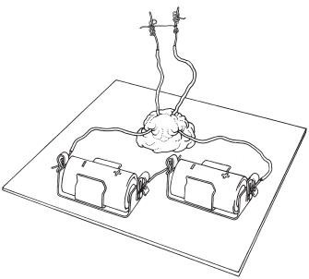

Lesson 8: Making a Filament (From pg 46 STC Electric Circuits) 4th Grade Circuits

Lesson 9: Telling the Energy Story (Revising Models)

OBJECTIVES & OVERVIEW
In this lesson students use all of the experiences and evidence they have accumulated in the unit (displayed on the summary table) to explain the phenomenon of a flashlight that eventually stops working (or other related phenomenon).
  - Students model evidence-based ideas about energy transfer and transformation in a circuit.
  - Students justify model decisions based on critique from peers and evidence from activities.
NEXT GENERATION SCIENCE STANDARDS (NGSS)
4-PS3-2. Make observations to provide evidence that energy can be transferred from place to place by sound, light, heat, and electric currents.
4-PS3-4. Apply scientific ideas to design, test, and refine a device that converts energy from one form to another.
Science and Engineering Practices (SEP)  Developing models - Collaboratively develop and/or revise a model based on evidence that shows the relationships among variables | Disciplinary Core Ideas (DCI):  PS3.B: Conservation of Energy and Energy Transfer  - Energy is present whenever there are moving objects, sound, light, or heat. Light also transfers energy from place to place. (4-PS3-2)  - Energy can be transferred from place to place by electric currents, which can then be used locally to produce motion, sound, heat, or light. The currents may have been produced to begin with by transforming the energy of motion into electrical energy. (4-PS3-2),(4- PS3-4)  PS3.D: Energy in Chemical Processes and Everyday Life - The expression “produce energy” typically  refers to the conversion of stored energy into a desired form for practical use | Cross-Cutting Concepts (CCC):  Energy and Matter - Energy can be transferred in various ways and between objects
Constructing Explanations –
Use evidence (e.g.,
measurements, observations,
patterns) that specify variables
to construct an explanation of
a phenomenon.
MATERIALS
- Model scaffold (1 per student)
- Pencils
- Colored pencils (optional)
- Summary table (displayed for student reference)
- Anchor charts from prior activities (displayed for student reference)

PROCEDURE

Prior to this lesson watch the video “Generalizable science ideas: Gotta have checklist” if you are not familiar with helping students create a ‘gotta have’ checklist http://safeshare.tv/v/ss56528ef384b13. This is a video for teachers with a classroom example.

- Re‐orient students to the focal models and hypotheses. Gesture to the summary table and science charts and ask: “This is what our groups have been thinking about—what is it we have been trying to represent? What are we trying to explain?”
  - Students may say, for example, “We are making a model of a flashlight,” but you need to re-name the model in terms of the underlying idea – in this case we are modeling the “relationship between energy transfer and properties of matter.” (And a story of energy

transformation, too!) This is important because models should do more than simply explain one phenomenon. A model can be used to explain multiple related phenomena.
  - Re‐articulate the original “why” question you posed as an essential question earlier in the sequence of lessons – Why does a flashlight eventually stop working?

- Prepare students to work on models: Develop a “gotta have” checklist. What are the 2-3 big relationships that you want to make sure students include? What are the ideas students think they should be including. Ask the following question and provide time for Think-Pair-Share and then share out to make a list of no more than 4 big ideas you and students think they need to remember to include.
Sample Explanation Checklist:

- Circuits transfer and transform energy for a particular reason or purpose

- Circuits have and need a power source

- Circuits have pathways to move the energy around

- Circuits have to be connected for energy to move

Question: If you were going to tell any circuit story - whether it’s our flashlight dying story or about a cell phone, battery-operated game, lemon clock - what would be some key ideas or concepts that we would have to or “gotta have” in order to explain how circuits and energy transformations work?”

- TEACHER DECISION POINT: Students can all model and explain the original flashlight dying phenomenon OR students could select a circuit of their choosing: cell phone, flashlight, alarm clock, lemon clock, Gameboy, TV remote, etc. to model and explain. The ‘gotta have’ checklist includes generalizable ideas such that students could explain different circuits and still check off these items. Students can draw models of other circuits on the back of the flashlight circuit model scaffold.

TEACHER DECISION POINT
Do you want all students to explain the flashlight phenomenon? Or would you like to provide choice?

Students develop their own models: Individual Work
How are you showing energy in your model?
What makes the energy change forms? How can you show that? In the model?
Why are certain materials conductors or insulators? How do we know? How can you add that to your model?
- I hear you are thinking about X and Y ideas, what about Z? How does it ﬁt in? I’ll be back in a few minutes to hear your ideas
-

-

-

- Each student gets a model scaffold sheet and begins to write and draw about how and why they think a flashlight works and what might happen that we can’t see that would make it stop working. You could encourage partner talk, it does not need to be silent.

- As you circulate, look at student drawing and writing
and ask for clarification if something isn’t explained.
  - Use the summary table for evidence.
  - If students are using symbols, ask that they add a key to explain their symbols.
- During this time students can talk to each other and the teacher about their thinking, but each student records their individual thinking on their own paper.
- As you circulate, look for parts of models you’d like to feature for the whole class. These

might be different ways of representing energy transformations or how a student has shown how electrons help energy move through conductors. Select 2-3 students whose models may emphasize different parts of the explanation.

Providing some peer feedback:

- Pause the class. Have the pre-selected students show the particular piece of their model you wanted to feature under the document camera. Have other students ask questions or talk about the models as they are presented.

Completing the model using the checklist:

- Resume individual model work and have students make sure they are attending to the items on the gotta-have checklist.
- Collect models at the end of class.

PLANNING NEXT STEPS
Look across models and see how students are incorporating the ideas on the ‘gotta-have’ checklist as well as how they are addressing the standards around understanding how energy is transferred and transformed. If you see places where students should add and strengthen their representation of the energy story, provide some time at the beginning of the next lesson to attend to this.

(This page intentionally left blank.)

Le
sson 9: Telling the Energy Story 99 4th Grade Circuits
© 2015, AmbitiousScienceTeaching.org

(This page intentionally left blank.)

Lesson 10: Evidence-based explanation

OBJECTIVES & OVERVIEW

In this lesson, students focus on writing an evidence-based explanation for several ideas in their model. Writing allows them to use more details and connect their ideas to evidence which they may not have identified in their model.
  - Students connect appropriate evidence with claims using the summary table.
  - Students write an evidence-based explanation of the energy story in a circuit.
NEXT GENERATION SCIENCE STANDARDS (NGSS)
4-PS3-2. Make observations to provide evidence that energy can be transferred from place to place by sound, light, heat, and electric currents.
Science and Engineering Practice (SEP):  Developing and Using Models - Develop a model to describe unobservable mechanisms.  Creating Explanations - Identify the evidence that supports particular points in an explanation | Disciplinary Core Ideas (DCI):  PS3.B: Conservation of Energy and Energy Transfer  - Energy is present whenever there are moving objects, sound, light, or heat. Light alsotransfers energy from place to place. (4-PS3-2)  - Energy can be transferred from place to place by electric currents, which can then be used locally to produce motion, sound, heat, or light. The currents may have been produced to begin with by transforming the energy of motion into electrical energy. (4-PS3-2),(4- PS3-4)  PS3.D: Energy in Chemical Processes and Everyday Life - The expression “produce energy” typically refers to the conversion of stored energy into a desired form for practical use | Cross-Cutting Concept (CCC):  Cause and Effect - Mechanism and explanation. Events have causes, sometimes simple, sometimes multifaceted. A major activity of science is investigating and explaining causal relationships and the mechanisms by which they are mediated. Such mechanisms can then be tested across given contexts and used to predict and explain events in new contexts.
MATERIALS

For class reference:
    - Summary Table poster filled in with some (ideally all) activities
    - What-How-Why writing examples sheet (in this lesson)
    - Explanation checklist(createdwith students in lesson 9)
For each pair:
•Revised Model (from lesson 9)
- writing support strip with sentence starters
- Notebook paper
- Pencil with eraser
- Sticky notes

PROCEDURE
If needed, provide time for students to address some feedback from their models in lesson 9. For
example, if there is a particular item or idea you noticed that a majority of students did not include, pass back models and give about 5-7 minutes to address those 1-2 ideas.

Pre-writing task: Helping students write with evidence
- Whole group: Explain to students that a claim is a statement that we believe to be true based on our experiences and thinking. A claim in our unit might be something like: A battery has stored chemical energy. It’s a statement we think is true based on what we know. Now you will identify some claims you made on your models yesterday. What are at least 3 things you

claimed? Put a star by them.

- Individually, identify claims: Have students put a star by the claims they have made on their model (at least 3 on each side of the circuit model scaffold if they used that side – or if they drew their own, at least 3). Clarify as needed about what counts as a claim. Have students share in partners just one of the claims they starred.
- Whole group: But how do we know for sure? Did we do something to get some evidence to learn about this? We did a reading about batteries. So this reading is evidence for our claim. I can find the reading in my science notebook if I need to remember what it said. So on my
sticky note I will write “Battery Reading: The chemicals in the battery react to release chemical energy” and stick that note next to my claim on my model. Do this for at least 3 claims.
- Individually, matching evidence: Have students use 3 sticky notes to write about evidence that supports 3 of their claims.

Writing Task: Supporting extended responses using evidence

- Tell students that we are going to put our claims and evidence together now by writing our circuit story. Say that we are aiming for a deep level of explanation to really show everything we have learned in this unit and how we know it to be true.
- What-how-why levels: Show the sheet explaining what-how-why levels and how you expect
students to write beyond a ‘what’ level.
- If you think it is needed: pass out the writing support strips.
- Have students write individually, skipping lines, about how and why a circuit works incorporating at least 3 claims and the evidence they just identified.

Optional: Peer conference

When students have completed their draft, or a substantial portion of the draft. Have students pair up
and give each other feedback using the ‘gotta have’ checklist and looking at how they used evidence.

PLANNING NEXT STEPS
Use the what-how-why levels of explanation sheet in the unit guide to evaluate student models and writing to assess to what extent students have demonstrated understanding on the core science ideas and how they are progressing on modelling and explanation as scientific practices. The what- how-why levels of explanation trackers on pages 5-11 of this guide help track student and class understanding over time.

Remember to try to write a “WHY” level explanation. This is difficult to do, so use the evidence tables in your notebook as well as posters in the classroom to help remind you of all the evidence we have collected about circuits.
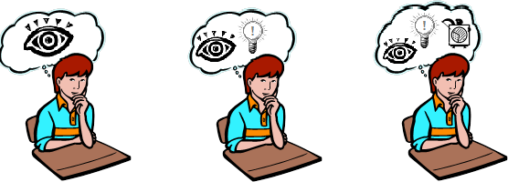

“What” Level

I observe that…

In science class we…

“How” Level

I observe that…

In science class we… which showed me evidence that…

“Why” Level

I observe that…

In science class we… which showed me evidence that…

Even though I can’t observe I think it is happening because…

If you write at the “What” level you only describe what happens like observations and what you did in experiments.

Short Example:
When the wires are connected to the battery and bulb in the right way, the bulb lights up. If the battery is dead, the bulb will not light up. If the wires aren’t in the right places, it won’t light up.
If you write at the “How” level you describe observations PLUS how you think the things you observe happened using evidence.

Short Example:
When the wires are connected to the battery and bulb in the right way, the bulb lights up. This is because the wire is a conductor which is a pathway for energy. I know wire is a conductor because we did an experiment that showed…
If you write at the “WHY” level you explain why something happened. You tell the full story using observations and evidence and make claims about what is happening we can’t observe.

Short Example:
When the wires are connected to the battery and bulb in the right way, the bulb lights up. This is because the wire is a conductor which is a pathway for energy. I know wire is a conductor because we did an experiment that showed…… I also know that inside a conductor there are electrons which… In an insulator, electrons……which means that…

Writing support strips: Copy, cut apart and provide to students to support their writing.

WRITING AN EXPLANATION ABOUT: WHY DOES YOUR CIRCUIT WORK?

In your writing, you need to:
- Describe where electric current flows in your circuit. (Also, share why you think it can flow where it does and why current does not flow through all materials.)
- Describe what energy transformations happen in your circuit and where they happen. (Also, share why you think these transformations happen where they do.)
- Use evidence from the summary table to support your ideas.

For each idea you state in your explanation, what evidence do we have to support it?

- My evidence for this idea is …

- This idea is supported by the activity where we …

•When we watched the video about , it stated that which supports my idea.

•When we did , it showed us that so therefore that supports my idea about because .

Write a “WHY” level explanation.

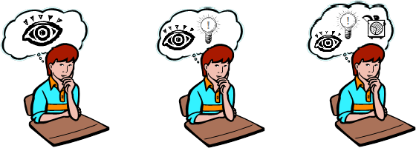

WHAT HOW WHY
happens? does it happen? does it happen?
WRITING AN EXPLANATION ABOUT: WHY DOES YOUR CIRCUIT WORK?

In your writing, you need to:
- Describe where electric current flows in your circuit. (Also, share why you think it can flow where it does and why current does not flow through all materials.)
- Describe what energy transformations happen in your circuit and where they happen. (Also, share why you think these transformations happen where they do.)
- Use evidence from the summary table to support your ideas.

For each idea you state in your explanation, what evidence do we have to support it?

- My evidence for this idea is …

- This idea is supported by the activity where we …

•When we watched the video about , it stated that which supports my idea.

•When we did , it showed us that so therefore that supports my idea about because .

Write a “WHY” level explanation.

WHAT HOW WHY
happens? does it happen? does it happen?
O

Sample of Student Writing about a Student-designed Circuits Or a Circuit of their Choice – Student A
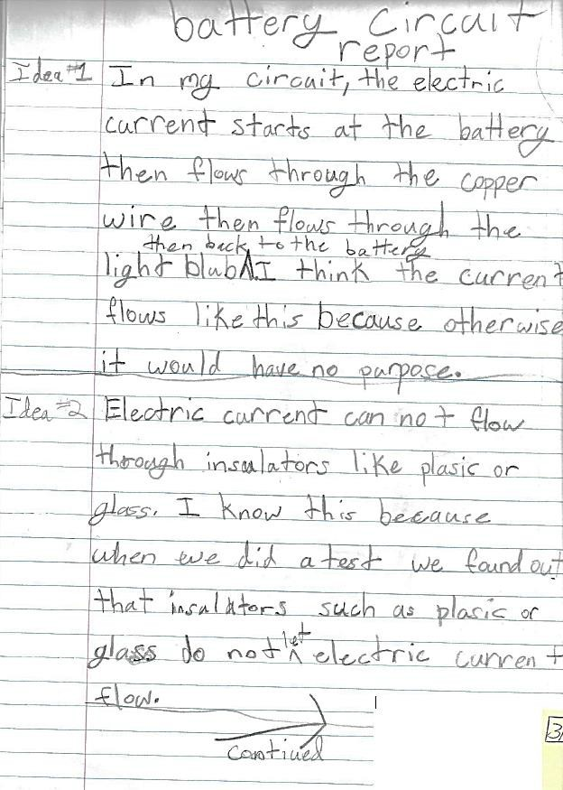
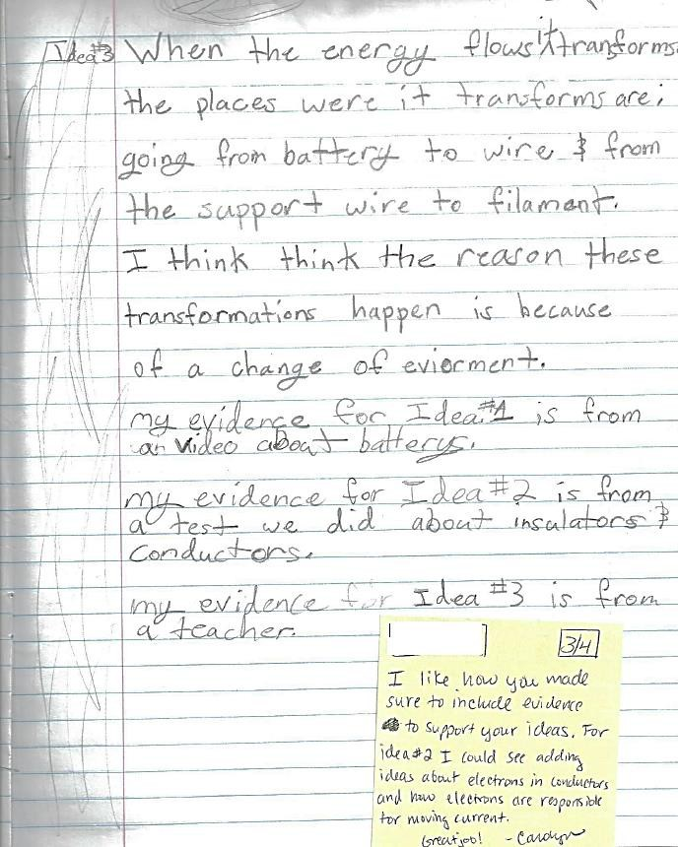

Sample of Student Writing about a Student-designed Circuits Or a Circuit of their Choice – Student R
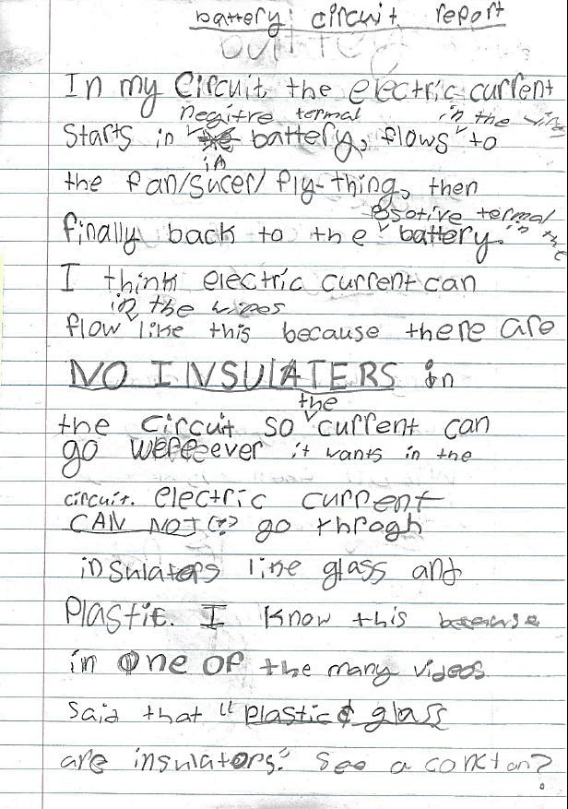
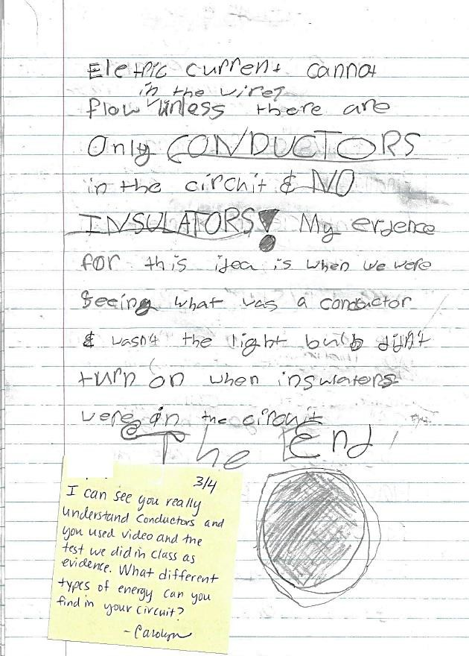

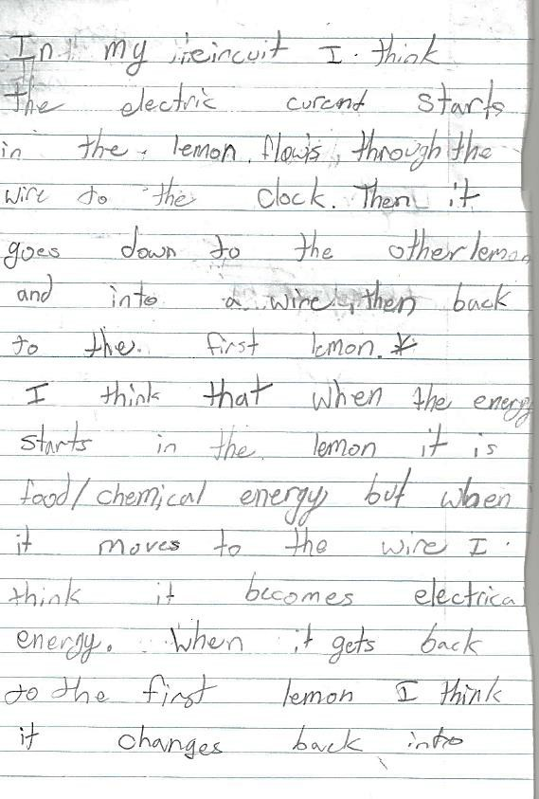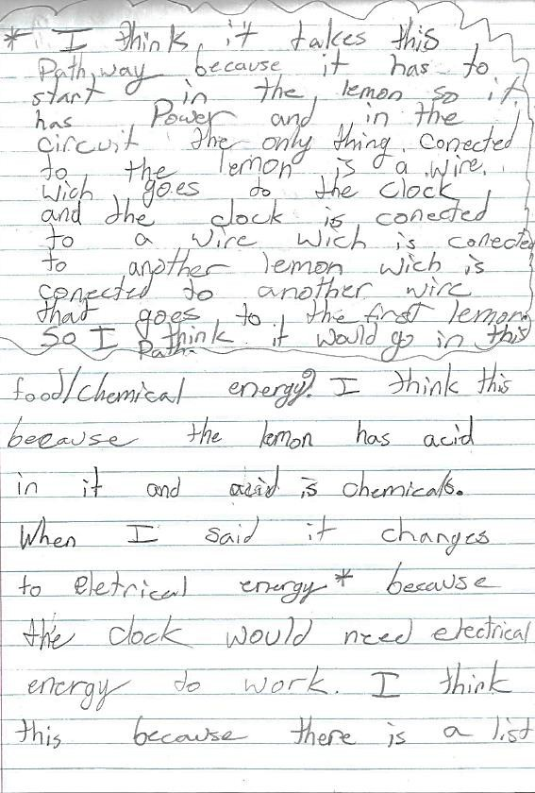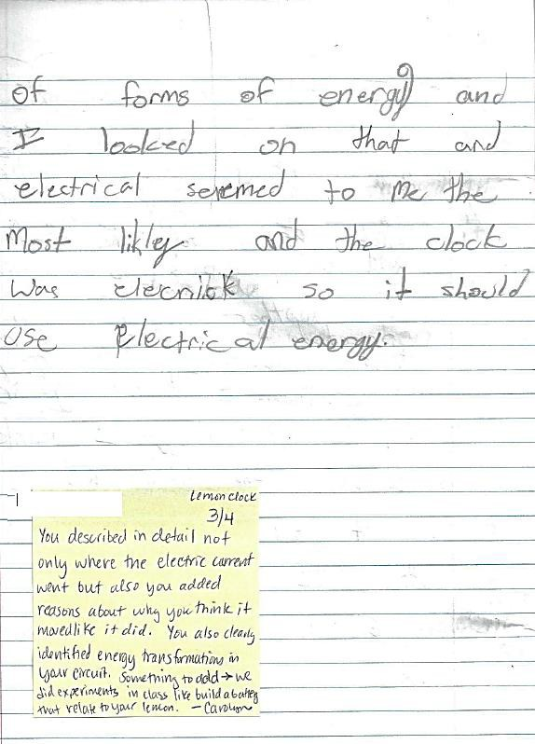
Sample of Student Writing about a Student-designed Circuits Or a Circuit of their Choice – Student S

(This page intentionally left blank.)

Lesson 11: How do switches work?

In this lesson, students will create a switch to easily turn the circuit on and off using what they know about conductors and insulators

OBJECTIVES & OVERVIEW
• Students create a circuit which includes a student-engineered switch out of conductive materials.

CONNECTION TO KIT

See Lesson 12: Learning about Switches Pgs 65-68

NEXT GENERATION SCIENCE STANDARDS (NGSS)
4-PS3-2. Make observations to provide evidence that energy can be transferred from place to place by sound, light, heat, and electric currents.
Science and Engineering Practices (SEP) Constructing Explanations and Designing Solutions Apply scientific ideas to solve design problems. (4- PS3-4) | Disciplinary Core Ideas (DCI):  PS3.B: Conservation of Energy and Energy Transfer  - Energy can be transferred from place to place by electric currents, which can then be used locally to produce motion, sound, heat, or light. The currents may have been produced to begin with by transforming the energy of motion into electrical energy. (4-PS3-2),(4- PS3-4)  PS3.D: Energy in Chemical Processes and Everyday Life - The expression “produce energy” typically refers to the conversion of stored energy into a  desired form for practical use | Cross-Cutting Concepts (CCC):  Energy and Matter - Energy can be transferred in various ways and between objects
MATERIALS
- See pg 65 of curriculum guide for materials to make switches using brass paper fasteners and cardstock
- Make a demonstration switch using cardstock, clips, battery holders, etc. shown on page 66.

PROCEDURE

Introduce the lesson: Whole Group
  - Orient students to the purpose of today’slesson:
    - Revisit what students learned about conductors and insulators by looking at the summary table. Today students will build a switch for a simple circuit and will need to remember properties of particular materials.

Focus Question: How can we create a switch to easily turn our circuit on and off?
    - Remind students of the safety alert before proceeding.

SAFETY ALERT!

If materials begin to feel hot or warm, put down the materials and disconnect pieces.

Building a switch:

  - Show students your demonstration switch and show them that it turns the bulb on and off. Tell students they will make their own switch using these materials. Ask students and discuss:

- Why do you think my switch is made of metal (paper clip)?
- What would happen if the index card were made of aluminum foil? Would it still work, why/why not? (How is paper different than foil as part of a circuit?)

  - Give time for students to construct switches according to the directions in the diagrams on pg 66 and 67 and your example. Encourage students to help each other in making functional switches and in using the battery holder and wire clips (these can be tricky for small fingers.)

  - If time permits, let students create and test their own switch designs that are different than the one provided. Knowledge of insulators and conductors is necessary for this. Reiterate safety warning.

PLANNING NEXT STEPS
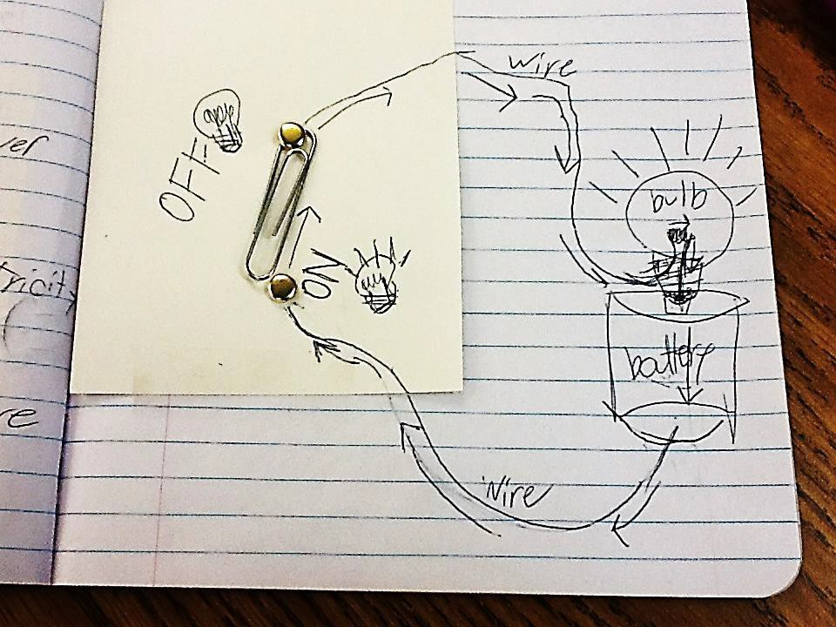• Students will need the switches they create in this lesson for lesson 13 where students communicate using a circuit by flashing a light or making a buzzer make sound. Students may want to redesign their switch tomorrow to make their signals easier to make.

Photo from student science notebook of how the switch works in a simple flashlight circuit.

Lesson 12: Using circuits to communicate

In this lesson, students apply what they’ve learned about circuits to create a device that allows for communication over distances.

OBJECTIVES & OVERVIEW
  - Students learn about ways to transfer information across distances (such as Morse code using light or sounds).
  - Students design and build a circuit and communicate messages to their peers using an established code or a system they create.
  - Students compare their solutions and provide feedback.

READING INTEGRATION
This lesson contains a reading that could be used during reading time as an integration option.

NEXT GENERATION SCIENCE STANDARDS (NGSS)
4-PS4-3. Generate and compare multiple solutions that use patterns to transfer information. [Clarification Statement: Examples of solutions could include drums sending coded information through sound waves, using a grid of 1’s and 0’s
representing black and white to send information about a picture, and using Morse code to send text.]
Science and Engineering Practices (SEP): Constructing | Disciplinary Core Ideas (DCI):  PS4.C: Information Technologies and Instrumentation  - Digitized information can be transmitted over long | Cross-Cutting Concepts (CCC): Patterns - Patterns of
Explanations and | distances without significant degradation. High-tech | change can be used
Designing Solutions - | devices, such as computers or cell phones, can receive | to make predictions.
Generate and compare | and decode information—convert it from digitized
multiple solutions to a | form to voice—and vice versa. (4-PS4-3)
problem based on how | ETS1.C: Optimizing The Design Solution - Different
well they meet the | solutions need to be tested in order to determine
criteria and constraints of | which of them best solves the problem, given the
the design solution. | criteria and the constraints. (4-PS4-3)
MATERIALS

Per student:
- Science notebook
- Copy of reading
- Copy of student handout
Building a communication circuit:
- Have materials from kit available to students to use.
- switches students created
Providing feedback:
- feedback sheet
- Pencil

Additional resources to use with students:
- Copies of Morse code alphabet (copy and cut apart so each student has a strip)
- YouTube video “The History of Morse Code” uploaded by JEBfive (5 min 23 seconds)
http://safeshare.tv/v/ss56566eb790d88
- YouTube video “Morse Code & The Information Age” uploaded by the Art of the Problem (10 minutes) http://safeshare.tv/w/ss56566db21a091
- YouTube video “Morse code music… The rhythm of the code” uploaded by Phil K (3 mins)
http://safeshare.tv/w/ss56566dd71d465 – helps learning and hearing letters

PROCEDURE
Introduce the lesson: Whole Group
- Gather students on carpet area. Review lesson 12 by doing a think-pair-share about switches. Last lesson students created switches for their circuits. Think-Pair-share: Think of the switch you made (hold one up). What did the switch let us do?
- Explain that in this lesson students will use what they’ve learned about circuits and

switches to use circuits to communicate in secret messages. Focal Question: How can a circuit communicate messages?

Just-in-Time Instruction: Morse Code
- Have student complete the reading in this guide. Some students may have already heard of Morse code or may know SOS as it’s a common message featured in cartoons and movies. After completing the reading, students can practice Morse code by encoding and decoding messages to each other.
- Have students watch a one or more videos in the materials list. As students watch, think about how they can build a circuit that would be able to communicate messages in Morse code.
- Close the just-in-time instruction by saying that Morse code is one example of a code that can communicate messages through patterns of sounds or by flashing lights in a pattern. Students can use this code or invent their own code as part of the engineering task that follows.

Designing, building, and testing the circuit: In Partners
- Have students work in partners to design and build a circuit, using materials available, that is capable of transmitting messages in Morse code (or a code students invent – if invented, they must write the code on the back of their paper).
- Partners build and test their communicating circuit using their code. Prepare to share your design and code with others.

Partner Feedback: In groups
- Once partners have built and tested their communication circuits, have partners pair- up in small groups and learn about how another pair designed and tested their circuit.
- Pairs use and fill out the feedback sheet as a guide for giving and receiving feedback.

Engineering Debriefing (whole group)
- Gather in the carpet area. Have students share some similarities or differences they observed when they compared their solutions during group feedback.
- As a whole class, debrief this engineering process. What was easy about using the circuit to communicate? What was challenging? What difficulties did you overcome in the design or in the code? What difficulties still remain?
- Compare our solutions to everyday ways we communicate using signals such as text messaging and email. What is similar? What makes sending text messages hard?
Easy? How can engineers make text messaging easier and more efficient?
  - If desired, play a clip from the Jay Leno show from 2005 with a race between a telegraph and a flip-phone text messaging (30 seconds) http://safeshare.tv/v/ss56566f16c2293
  - Text messaging has gotten faster and easier now that phones have full keyboards and touch screens compared to the phone in the video where users had to cycle through letters to find the one they wanted.
  - Have students talk in partners about what’s easy or difficult about text messaging and how they think it could be improved.

READING CONNECTION

A short reading is included in this lesson about Morse code.

Supplement this reading by checking out books from the library about Semaphore, smoke signals, drum signals, Braille, Morse Code or other codes. These codes are not just used by humans; animals also use codes across distances to communicate about location of food or water, to attract mates, or to warn of danger.
- Fireflies: http://earthsky.org/earth/bugs-firefly-light and http://www.amnh.org/ology/features/talkingtofireflies/
- Elephants: http://www.elephantsforever.co.za/elephant- communication.html#.Vj_0F7erSUk
READING INTEGRATION
Short reading about Morse code.

-
After reading this, some students may want to learn and practice Morse Code. For interested students, recommend that they practice at this website: https://www.nsa.gov/kids/games/gameMorse.swf

(This page intentionally left blank.)

What is Morse Code?
When you think of codes, you probably imagine spies and secret agents reading and writing secret coded messages. However, did you know that there’s a special code that anyone can learn?
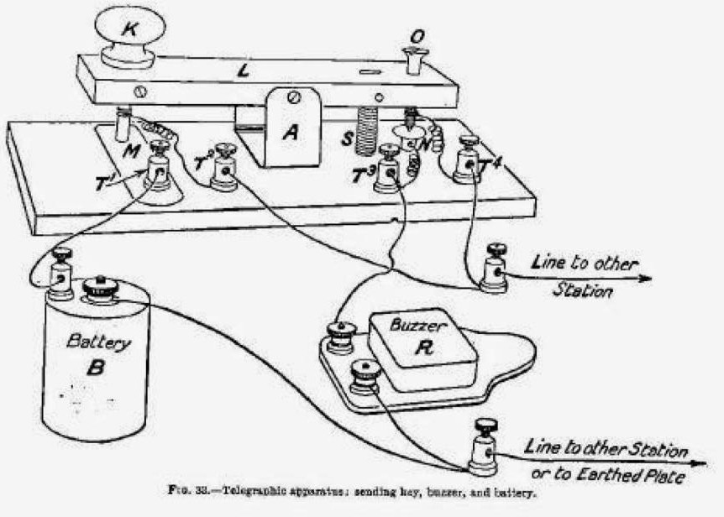Good listening skills are all you need to understand this special cipher. This special code is called Morse code. It’s been around since 1836. It is used by the military, emergency support groups, and by people all over the world.
Telegraphic apparatus; sending key, buzzer and battery

An electric telegraph uses an electric
current to send messages along a wire
that | go into | a | buzzer | which | emits
patterns of sounds. The drawing of
the | circuit | (at | right) | shows | wires
connecting a battery (B), a switch (K),
and a buzzer (R) to send and receive
signals between two stations.

In order to communicate, there is a
code for each letter of the alphabet. A
person sending a message uses a
series | of | dits | (.) | and | dahs | (-) | to
represent each letter of the message.

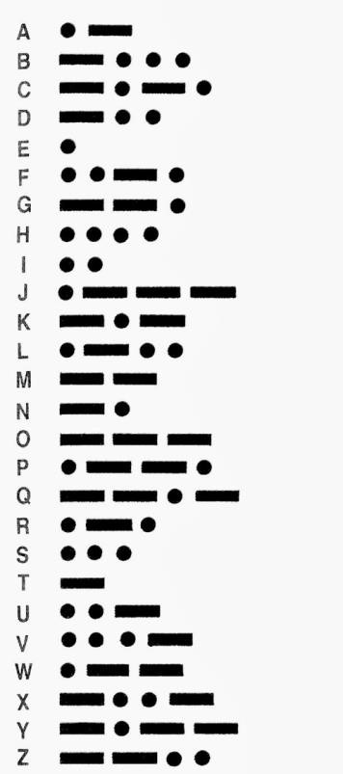The code is shown below.

Try it!
Morse code can be used by sending an auditory signal with a telegraph machine or radio. Morse code can also be sent using flashing lights. Either way uses a system of dits and dahs or a series of short and long. Use the code to translate the messages below.
Message translated to English (Hint: 4 words)
_ . . . . . . . . .
_._. ._ _. _.. _ _ _
Morse Code Message

_ . _ _ _ _ _ . . _

Communicate with a Partner
Use Morse Code symbols to encode a short secret message. Trade papers with a partner to decipher your message.

Morse Code Message #1:

Decode Message #1 into English

Morse Code Message #2:

Decode Message #2 into English

Morse Code Message #3:

Decode Message #3 into English

What makes it easy to read a message?

What was challenging about deciphering the code?

Name: Name: Date:

Challenge: Design a circuit that can send coded messages to a partner over a distance

Requirements: Your design must be able to…

Send accurate messages to a partner across a distance.
- Use only the available materials from the materials table.
-
-

Design the circuit: Draw and label a circuit below that you will build to communicate messages to a partner using batteries, wires, bulbs or buzzers, and switches.

Code: On the back of this page, write out your code.
  - How will letters or words be represented?
  - What is the translation into English (or another language you and your partner know) so that your message can be understood by a partner?

Build it and test it out!:
Using materials available, build your circuit. Then practice sending and receiving messages with a partner.

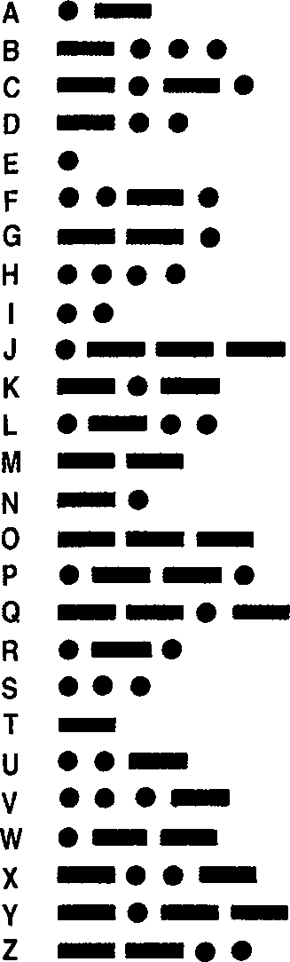
Write your code in the blank space below or decide to use another code such as Morse code.

Name: Name: Date:

Who did we interview?

Peer Feedback: Using Circuits to Communicate
Directions: Pair up with another group. You will be interviewed by your new pair about your circuit and secret code. Explain and present your circuit and demonstrate sending an encoded message. Evaluate the pair’s design based on the engineering criteria.

Requirements: Evaluate the other team’s design using the criteria and placing an X in the box next to each criteria based on how well it worked in their design.

Criteria | 1 ☹ | 2 | 3 | 4 ☺
Send accurate messages
to a partner across a distance.
Use only the available materials from the materials table.
Other criteria:
Other criteria:

Positive Feedback - What did they do well?

Constructive Feedback - What could they improve on?

(This page intentionally left blank)


4
58
Lesson 21: Big Talkers (1 of 6)

© 2005 by Stephanie Harvey and Anne Goudvis from The Comprehension Toolkit (Portsmouth, NH: Heinemann). This page may be reproduced for classroom use only.
From National Geographic for Kids, Big Talkers, © 2001. Reprinted by permission.

© 2005 by Stephanie Harvey and Anne Goudvis from The Comprehension Toolkit (Portsmouth, NH: Heinemann). This page may be reproduced for classroom use only.
5
59
Lesson 21: Big Talkers (2 of 6)
From National Geographic for Kids, Big Talkers, © 2001. Reprinted by permission.

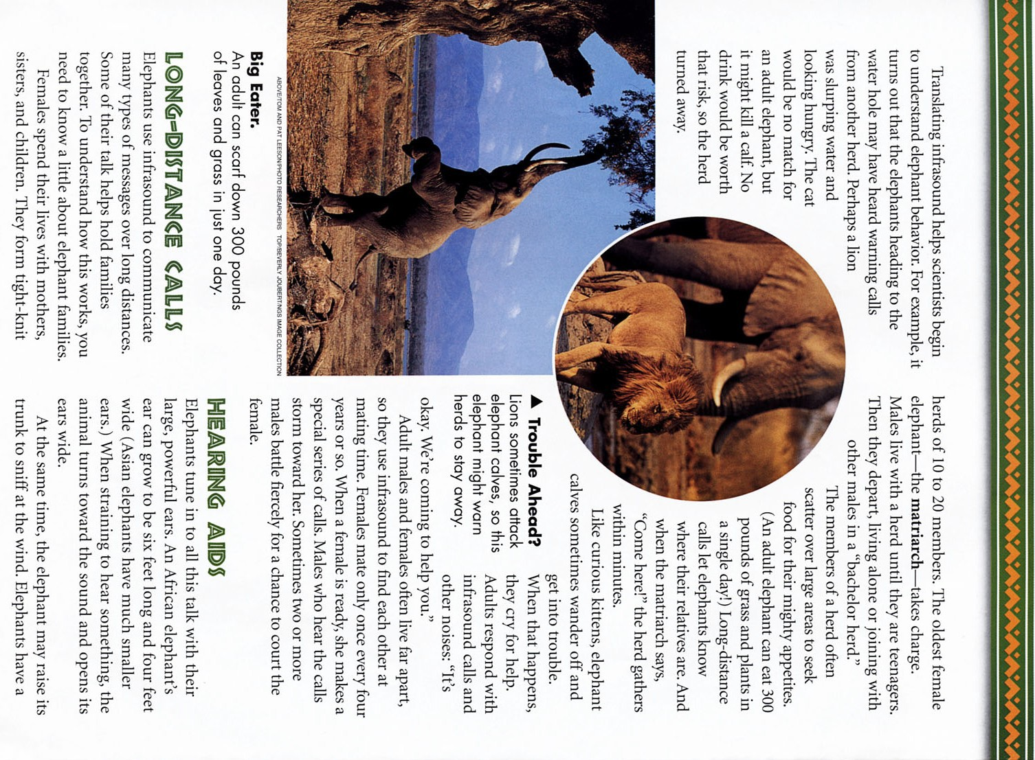
6
60
Lesson 21: Big Talkers (3 of 6)

© 2005 by Stephanie Harvey and Anne Goudvis from The Comprehension Toolkit (Portsmouth, NH: Heinemann). This page may be reproduced for classroom use only.
From National Geographic for Kids, Big Talkers, © 2001. Reprinted by permission.

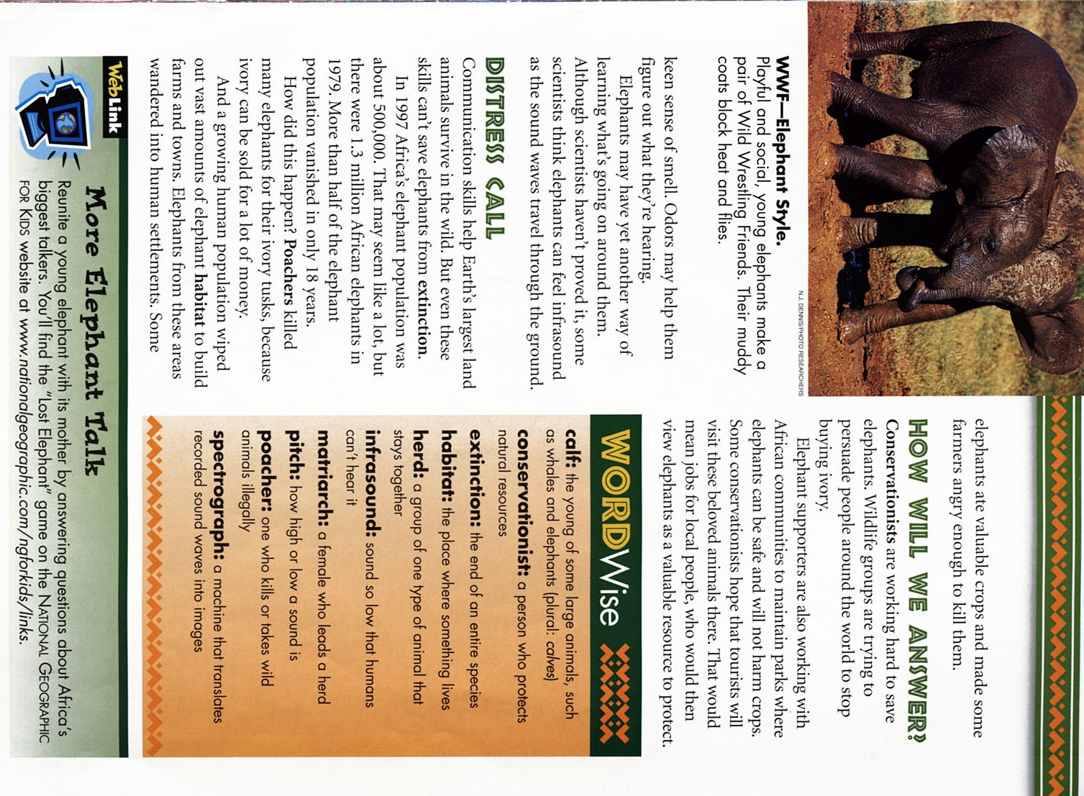© 2005 by Stephanie Harvey and Anne Goudvis from The Comprehension Toolkit (Portsmouth, NH: Heinemann). This page may be reproduced for classroom use only.
7
61
Lesson 21: Big Talkers (4 of 6)
From National Geographic for Kids, Big Talkers, © 2001. Reprinted by permission.


8
62
Lesson 21: Big Talkers (5 of 6)

© 2005 by Stephanie Harvey and Anne Goudvis from The Comprehension Toolkit (Portsmouth, NH: Heinemann). This page may be reproduced for classroom use only.
From National Geographic for Kids, Big Talkers, © 2001. Reprinted by permission.

© 2005 by Stephanie Harvey and Anne Goudvis from The Comprehension Toolkit (Portsmouth, NH: Heinemann). This page may be reproduced for classroom use only.
9
63
Lesson 21: Big Talkers (6 of 6)
From National Geographic for Kids, Big Talkers, © 2001. Reprinted by permission.

