Ambitious Science Teaching
Book + Video Connections

Print-and-stick labels to easily locate and view video examples from the AST website while you read the AST Book
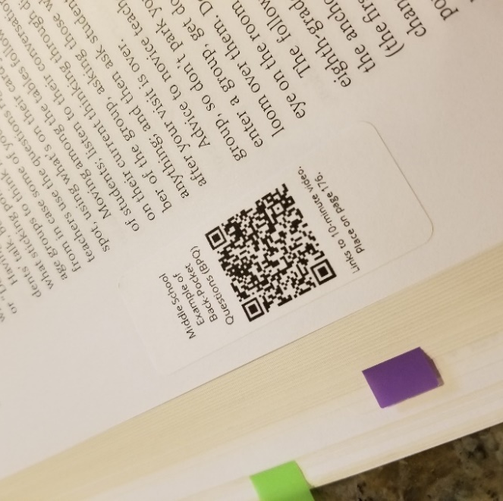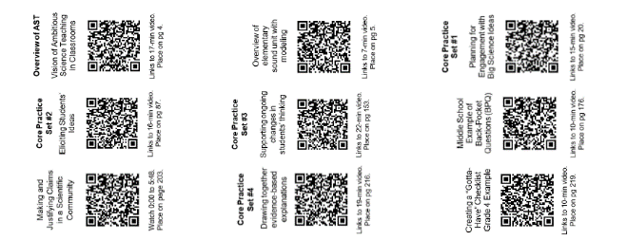
Set of 9 labels!
Directions
- Print on address labels (1” x 2-5/8” address labels). Print a test page first to see that it aligns with your brand of labels. [Page 2 has three sets of labels. Keep one for yourself and share with your colleagues! Page 3 has one set of labels.] Don’t have peel-and-stick address labels? Print on regular paper, cut apart, and affix with a glue-stick.
- Place each code on the suggested page noted on the bottom of each label. These labels fit comfortably in the margins of your AST book.
- Scan after reading a section. Each QR-code links to a video that corresponds to nearby text.
See this in action! https://bit.ly/2l3f9S5
New to using QR codes?
- Download a free QR code reader app on your SmartPhone or Tablet.
- Use the app to scan the QR code on any of the labels.
- The app will pop-up with a link to click and/or automatically redirect your browser to take you directly to the related video.
- Watch the video and make connections with the text.

Labels created by: Carolyn Colley carolyn.j.colley@gmail.com
To be used with the book: Windschitl, M., Thompson, J.J., & Braaten, M. L. (2018). Ambitious science teaching. Cambridge, Massachusetts: Harvard Education Press.
Links to the website: www.AmbitiousScienceTeaching.org
 |  | 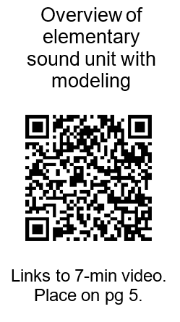 |  | 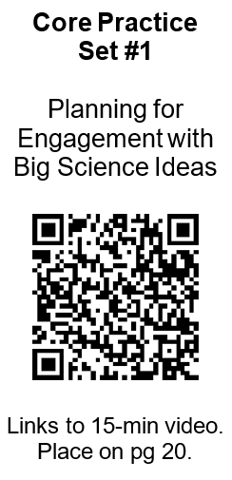
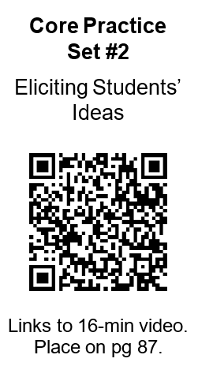 |  | 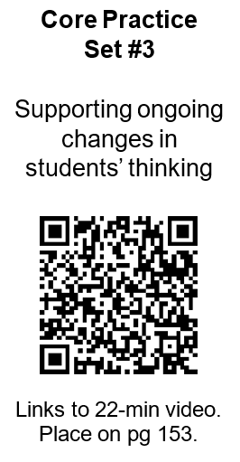 |  | 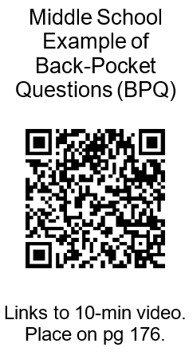
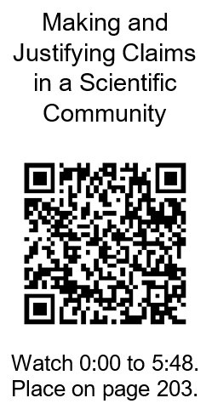 |  | 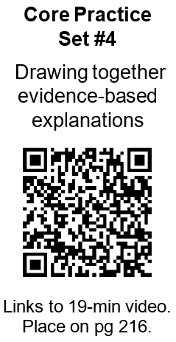 |  | 