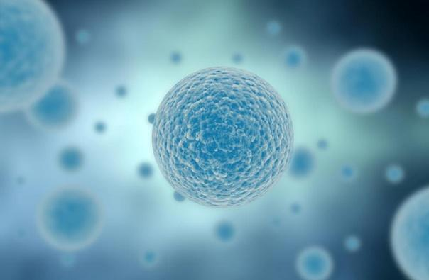

General Topic (i.e. Biology): Specific Topic
Grade Level
Authors First and Last Names
Citation if adapted from another teacher/school/resource
School, School District

Anchoring phenomenon:

Essential question about phenomenon/unit:

Big science ideas:

i
NGSS Performance Expectations addressed in this unit:
Standard | PE | DCI | CCC

Summary Table of Activities in Unit
Activity  (name and brief description) | Learning Target | Evidence Students  Could Gain | Connection to Phenomena
Activity 1:

Initial Model
Activity 2:
Activity 3:

Activity 4:
Activity 5:
Activity 6:
Activity 7:
Activity 8:
(Add Rows as Necessary)

Model Template

Student Work:

Images of complementary tools

Additional Documents

